MOdular led lamp
User manual

2014-06-08
Table of contents
1 Introduction 1
2 Functions and Features 2
3 Technical Parameters 3
4 Installation and Maintenance 4
5 Infra-red Control System 5
6 Troubleshooting 6
7 Safety Issues 7
8 Guarantee & Manufacturer Info 8

Introduction
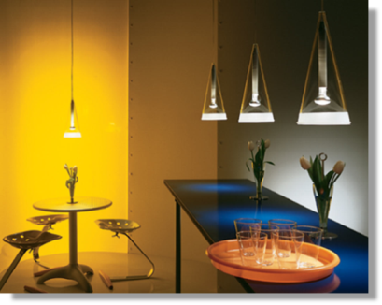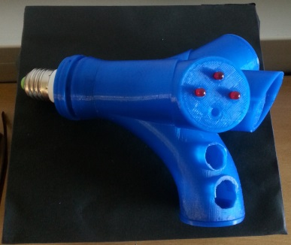
Thank you for obtaining our high sustainable product. We are glad to serve you with Modular LED lamp.
Now, you can enjoy better durability of a LED lamp, which is more efficient in recycling than an incandescent lamp. It saves energy with an automatic brightness system and digital technologies that are used (dimmer, ultrasonic sensor, especially composed drivers).
For wireless communication with device is responsible an Infra-Red remote control.
LED lights are free of toxic chemicals, ergo your mood and wellbeing will be on the highest available level.

Functions and Features
These are the main features of the Modular LED lamp:
- Fits to E27 lamp socket
- Changes colours
- IR remote control
- Automatic dimming system
- Reduces the energy intensity up to 10%
- Easy construction to replace the LED
The Modular LED lamp has fancy nature inspired shape and modernistic design which allows for decoration of your rooms and other inner areas. It has similarity with wood branch.
 | 
In the design, there is one main tube where three other tubes are coming out. Three tubes are meant for LED and one for ultrasonic sensor to sense movements.

Technical Parameters
There are presented the most important technical parameters for the Modular LED lamp:
Parameter | Value
Voltage [V] | 12
Luminous flux [lm] | 27
Power consumption [W] | 5
IR range [m] | 10
Ultrasonic range [m] | 4

Installation and Maintenance
It is quite easy to screw in and unscrew the bulb, because it fits to universal socket E27. All you have to do is to decide which room you want to use the lamp in and install it in proper way.
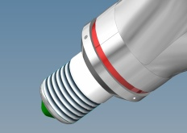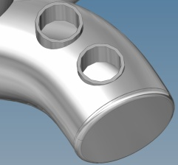
Please remember not to cover the ultrasonic receiver holes nor put any objects in range of sensor which would be able to block out the wireless connection.
The maximum radius for IR waves of the device is up to 10 m.
Maximum radius for automatic brightness system is 4 m.
How does the automatic brightness system work?
If you come closer to the device’s sensor, then the light will brighten up. If you go away the room, the light will be dimmed. That allows to reduce the cost of electricity in your house.
How to replace the LED?
There are LED-shape holes in the bottom of tube where you can simply bring out and press the new LED.
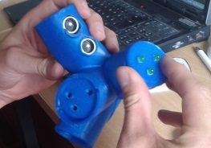

Infra-red Control System
The infra-red remote control has several functionalities. It offers different operating modes and can be configured by the user.
Remote control allows to choose and change colours like red, orange, yellow, green, blue, cyan, white.

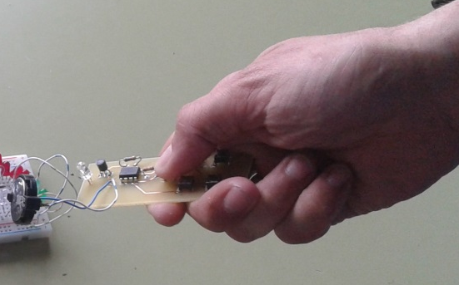

It has 5 different buttons for different application:

Button | Function
Increase brightness | It is possible to increase brightness manually
Decrease brightness | It is possible to decrease brightness manually
Static mode | It is possible adjust fixed colour manually
On / Off | Turns on and turns on the lamp
Brightness sensor on/off | Turns on and off the brightness sensor

Troubleshooting

Problem | Remedy
The lamp does not light | - Check if a lamp is screwed in proper way  - Check your electrical circuit
Remote control does not work | - Replace the batteries

Safety Issues
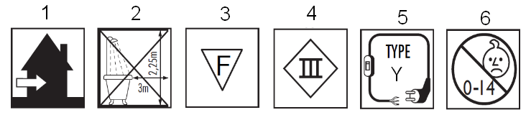
ATTENTION:
Below you will find all the explanations with numeric reference to the icons respectively in front of these safety instructions:

1 - This fitting should only be installed indoors.
2 - The fitting is not suitable for installation in bathrooms at least not in the specified zone.
3 - The fitting is suitable for fixing to normal flammable surfaces. Recessed luminaires should under no circumstances be covered with insulation material or other similar materials.
4 - Protection class III: the fitting is only suitable for very low voltage supply (e.g. 12V).
5 - Y-connection: In case of damage to the wire, it has to be replaced only by the manufacturer, distributor or by an expert, to avoid risks.
6 - This product is not suitable for children under 14 years.

Guarantee & Manufacturer Info
Your product is warranted for its whole life-time period.
Below you can find addresses and phone numbers to our Customer Service Department.
If you have any doubts, please feel free to contact us:
Modular LED Lamps LEDAR
Ruã St. Tomé 1234
4200-100 Porto, PT

Phone: +351-228-340-500
Fax: +351-431-1111-40

http://www.ledar.tk

