MATERIAL LIST
Name | Picture | Quantity | Website | Company | Description | Price €
Micro Controller | 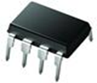 | 3 | http://pt.mouser.com/ProductDetail/Microchip-Technology/PIC12F675-E-P/?qs=sGAEpiMZZMvqv2n3s2xjsXReEaAKUmyL5xX0Sv39SNA%3d | Microchip Technology | Microcontroller de 8 bits - MCU 1.75KB 64 RAM 6 I/O Ext Temp PDIP8 | 1.06 €
Mosfet | 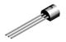 | 5 | http://pt.mouser.com/ProductDetail/Fairchild-Semiconductor/2N7000/?qs=sGAEpiMZZMshyDBzk1%2fWi9bHELEahoDnY1fyKF6A6Ko%3d | Fairchild Semiconductor | MOSFET N-CHANNEL 60V 200mA | 0.34 €
Connector | 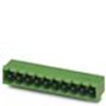 | 1 | http://pt.mouser.com/ProductDetail/Phoenix-Contact/1757255/?qs=sGAEpiMZZMsDddcp1dBDJOrXMrFmZFLlFAdTuZkvVZ8%3d | Phoenix Contact | Pluggable Terminal Blocks 3 Pos 5.08mm pitch Through Hole Header | 0.72 €
Connector | 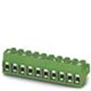 | 1 | http://pt.mouser.com/ProductDetail/Phoenix-Contact/1934874/?qs=sGAEpiMZZMsDddcp1dBDJOrXMrFmZFLlqQAEbthOj0A%3d | Phoenix Contact | Pluggable Terminal Blocks 3 Pos 5mm pitch Plug 26-14 AWG Screw | 0.45 €
Connector | 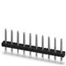 | 1 | http://pt.mouser.com/ProductDetail/Phoenix-Contact/1945106/?qs=sGAEpiMZZMsDddcp1dBDJOrXMrFmZFLlwz4SwBvZXbg%3d | Phoenix Contact | Pluggable Terminal Blocks 3 Pos 3.5mm pitch Thru Hole Pin Strip | 0.15 €
Transistor | 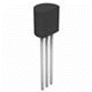 | 2 | http://pt.mouser.com/ProductDetail/Micro-Commercial-Components-MCC/BC547B-AP/?qs=sGAEpiMZZMshyDBzk1%2fWiyxEgh | Micro Commercial Components (MCC) | Transistors Bipolar - BJT Med Pwr Biplar Trans 45V, 100mA | 0.36 €
Switch | 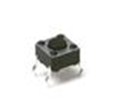 | 5 | http://pt.mouser.com/ProductDetail/CK-Components/PTS645SL43-2-LFS/?qs=sGAEpiMZZMsgGjVA3toVBAOa31dqKfOfSl%2fLv | C&K Components | 4.5 x 4.5 mm footprint  0.55 mm height  Top actuated  Gullwing termination | 0.11 €
Infrared | 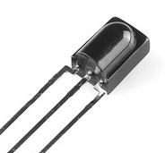 | 2 | http://pt.mouser.com/ProductDetail/Lumex/SSL-LX5099IEW/?qs=%2fha2pyFadui7ivFq1vSLBwRk4z6P3eQ4cmT8FK0OlCXx38OKoOM6XQ%3d%3d | Lumex | Infrared, Red  940 nm, 635 nm  20 mA  1.4 V, 2 V | 0.536 €
IR receiver | 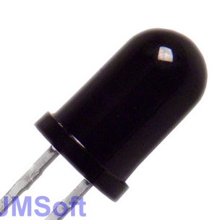 | 1 | http://pt.mouser.com/ProductDetail/Vishay/TSOP1738TB1/?qs=%2fha2pyFaduhbG%252bpuSdzjM3g%252bwF4rOmogn1ck5xk3vA7FwoWQD6S6NQ%3d%3d | Vishay | 38 kHz  35 m  4.5 V to 5.5 V  5 mA | 0.536 €
Ultra sonic sensor | 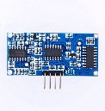 | 1 | http://www.inmotion.pt/store/ultrasound-sensor-hc-sr04 | Arduino | 5 V  2 mA  2 cm - 4cm | 9,95 €
RGB LEDs | 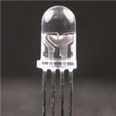 | 7 | http://pt.mouser.com/ProductDetail/Kingbright/WP154A4SUREQBFZGC/?qs=sGAEpiMZZMtmwHDZQCdlqakguNLvCrcaODiZmnwtxbI%3d | Kingbright | Led standard RGB 630/525/465 nm 750/420/750 mcd 60 deg | 1.22 €
Battery | 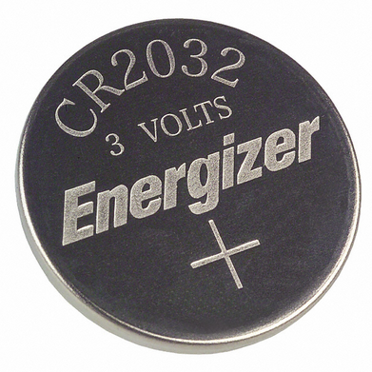 | 1 | http://hu.mouser.com/Search/ProductDetail.aspx?qs=%2fcnINApUglPgybvG%2fLSG7w%3d%3d | http://www.panasonic.com/industrial/batteries-oem/  Data Sheet | 3V CR2032 | 1.25 €
Resistor | 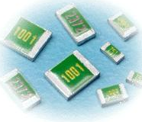 | 4 | http://pt.mouser.com/ProductDetail/KOA-Speer/RN73H2BTTD3520F50/?qs=sGAEpiMZZMu61qfTUdNhG50pnceRs4Vs6i8jktUkZLg%3d | Data sheet | Resistencia : 352 Ohms  Régimen de potencia : 250 mW  Tolerancia : 1%  Coeficiente de temperatura : 50 PPM  Voltaje : 150 V | 0.256 €
Resistor |  | 4 | http://pt.mouser.com/ProductDetail/KOA-Speer/RN73H2BTTD2000F50/?qs=sGAEpiMZZMu61qfTUdNhG50pnceRs4VsQBhsM%252b9TRWQ%3d | Data Sheet | Resistencia : 200 Ohms  Régimen de potencia : 125 mW  Tolerancia : 0.1%  Coeficiente de temperatura : 25 PPM  Voltaje : 150 V | 0.4 €
Resistor |  | 4 | http://pt.mouser.com/ProductDetail/KOA-Speer/RN73H2BTTD1910F50/?qs=sGAEpiMZZMu61qfTUdNhG50pnceRs4VsF0kcJf%252bBZCg%3d | Data Sheet | Resistencia : 191 Ohms  Régimen de potencia : 250 mW  Tolerancia : 1%  Coeficiente de temperatura :50 PPM  Voltaje : 150 V | 0.256 €
Resistor |  | 4 | http://pt.mouser.com/ProductDetail/KOA-Speer/RN73H2BTTD5601F50/?qs=sGAEpiMZZMu61qfTUdNhG50pnceRs4VsamgTDbJqe3k%3d | http://pt.mouser.com/  Data Sheet | Resistencia : 5.6 kOhms  Régimen de potencia : 250 mW  Tolerancia : 1%  Coeficiente de temperatura :50 PPM  Voltaje : 150 V | 0.256 €
Resistor |  | 4 | http://pt.mouser.com/ProductDetail/KOA-Speer/RN73H2BTTD3902F50/?qs=sGAEpiMZZMu61qfTUdNhG50pnceRs4VsDMetlZIiXCY%3d | http://pt.mouser.com/  Data Sheet | Resistencia : 39 kOhms  Régimen de potencia : 250 mW  Tolerancia : 1%  Coeficiente de temperatura :50 PPM  Voltaje : 150 V | 0.256 €
Power supply | 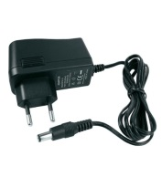 | 1 | http://www.inmotion.pt/store/power-supply-12vdc-15a-eu | Inmotion | Input Voltage: 90 to 264V ac  Input Frequency: 47 to 63 Hz  Output Current: 1.5A  Output Voltage: 12V dc  Cable Length: 150cm  Power Rating: 18W  Efficiency: > 78%  Overcurrent protection: continuous, auto restart | 9.95 €
Capacitor | 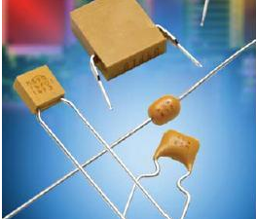 | 2 | http://hu.mouser.com/Search/m_ProductDetail.aspx?AVX/SR295E104MART/&qs=sGAEpiMZZMsh%252b1woXyUXj1sisocaq0hzCO0KHEWCJIc= | http://www.avx.com  Data Sheet | Capacitance: 0.1 uF  Voltage rating: 50 V  Tolerance 20 % | 0.088 €
Capacitor | 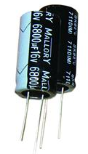 | 2 | http://hu.mouser.com/Search/m_ProductDetail.aspx?Cornell-Dubilier/SK470M016ST/&qs=sGAEpiMZZMvwFf0viD3Y3Qq%252bfwVnism6Z2i/L0/hnMM= | http://www.cde.com  Data Sheet | Capacitance: 47 uF  Voltage rating: 16 V  Tolerance 20 %  Load Life: 2000 h | 0.112 €
Battery socket | 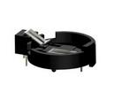 | 1 | http://hu.mouser.com/Search/ProductDetail.aspx?qs=TMDrOSIpnUfyx7dWA5t7YA%3d%3d | http://www.keyelco.com/  Data Sheet | Product: Battery Holders  Battery Cell Size: BR2025, CR2032  Number of Batteries: 1  Material: Phosphor Bronze  Mounting Style: Through Hole | 1.45 €
Regulator | 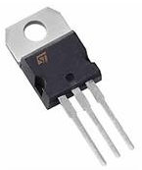 | 2 | http://hu.mouser.com/ProductDetail/STMicroelectronics/L7805CV/?qs=sGAEpiMZZMsMIqGZiACxISsdOc2pc405xV7Xu93p5sI%3d | http://www.st.com/web/en/home.html  Data Sheet | Output Type: Fixed  Output Voltage: 5 V  Output Current: 1.5 A  Load Regulation: 100 mV  Input Voltage MAX: 35 V  Line Regulation: 100 mV | 0.472 €
Diode | 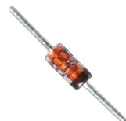 | 2 | http://hu.mouser.com/Search/m_ProductDetail.aspx?Vishay-Semiconductors/1N4148TR/&qs=sGAEpiMZZMsc4/H%252bM6WdN%252bFfeaA%252bZFte | http://www.vishay.com/  Data Sheet | Forward Continues Current: 0.3 A  Max Surge Current: 2A  Max Power Dissipation 500 mW  Max Diode Capacitance: 4pF | 0.064 €

Resistor | 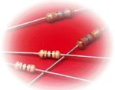 | 3 | http://pt.mouser.com/ProductDetail/KOA-Speer/MF1-4DCT52R1200F/?qs=sGAEpiMZZMsPqMdJzcrNwuBnmYaxrx0H9G5DraXNUp4%3d | http://www.koaspeer.com/  Data sheet | Resistance : 120 Ω  Power Rating : 250 mW  Tolerance : 1%  Temperature Coefficient :100 PPM  Voltage : 100 V | 0.048 €
Resistor |  | 4 | http://pt.mouser.com/ProductDetail/KOA-Speer/MF1-4DCT52R1800F/?qs=sGAEpiMZZMsPqMdJzcrNwuBnmYaxrx0H%2fdQ4NOPABHE%3d | http://www.koaspeer.com/  Data Sheet | Resistance : 180 Ω  Power Rating : 250 mW  Tolerance : 1%  Temperature Coefficient :100 PPM  Voltage : 100 V | 0.048 €
Cable | 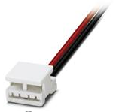 | 10 | http://pt.mouser.com/ProductDetail/Phoenix-Contact/1826091/?qs=sGAEpiMZZMsAnMfEB9lOQAK%2f5dP8fsLEeK%252buQ95E3tTqVdpGbhZ4VA%3d%3d | Phoenix Contact  Data Sheet | Type: LED Flex Strip Connector  Contact Plating: Silver  Current Rating: 10 A  Voltage Rating: 25 V | 2.14 €
LEDs Green | 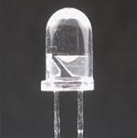 | 3 | http://pt.mouser.com/ProductDetail/Kingbright/WP7113ZGCK/?qs=c%2fvLmDlhOp%2fh%252bcYrnJwJWA%3d%3d | http://www.kingbrightusa.com/  Data Sheet | Illumination Colour: Green  Wavelength/Colour Temperature: 625 nm  Lens Colour/Style: Water Clear  Forward Current: 20 mA  Forward Voltage: 3.3 V  LED Size: 5 mm | 0.376 €
LEDs Red |  | 4 | http://pt.mouser.com/ProductDetail/Kingbright/WP7113SECK-J3/?qs=sGAEpiMZZMtmwHDZQCdlqXeTf7oKwjkNUJFODxS22hA%3d | www.kingbrightusa.com/  Data Sheet | Illumination Colour: Red  Wavelength/Colour Temperature: 625 nm  Viewing Angle: 20 deg  Lens Colour/Style: Water Clear  Forward Current: 20 mA  Forward Voltage: 2.2 V  LED Size: 5 mm | 0.384 €
LEDs Blue |  | 3 | http://pt.mouser.com/ProductDetail/Avago-Technologies/HLMP-CB1A-XY0DD/?qs=sGAEpiMZZMtmwHDZQCdlqRrJldOdl3TKeUymKq44QTU%3d | http://www.kingbrightusa.com/  Data Sheet | Illumination Colour: Blue  Wavelength/Colour Temperature: 470 nm  Viewing Angle: 23 deg  Lens Colour/Style: Non-Diffused  Forward Current: 20 mA  Forward Voltage: 3.2 V | 0.84 €

