led leadS you to a green future
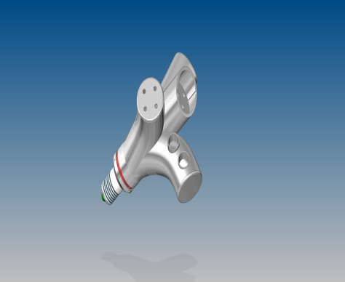

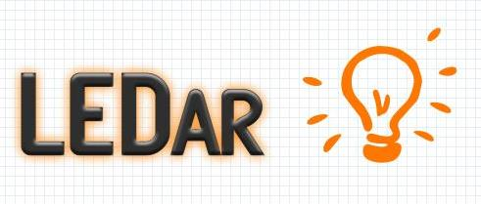

Modular LED Lamps
Rua St. Tome 1234

Phone: (+351-228-340-500)
Fax: (0431-1111-40)
http://www.ledar.tk


Your Experts for intelligent LED Lamps

Modular LED Lamp

Modular LEd Lamp



who are we?

- Innovative multicultural team
- Excellent customer realationship
- Eco-friendly company
- Sustainable products

whY US?
- Saving energy through an intelligent dimming system
- Easy to replace LED

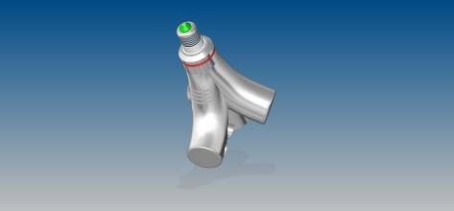
led leadS you to a green future

What is a LED Lamp?

LED light bulbs deliver exceptionally long life, significant energy savings and are mercury free. Use LED lights to transform any space into a cozier environment.

