

Interim Report
Modular LED Lamp
Andra Aedma, Nils Petersen, Piotr Rzeznik,
Norbert Ritter, David González Alen
Supervisors: Manuel Silva, Abel Duarte , Fernando Ferreira, Maria Benedita Malheiro, Maria Cristina Ribeiro, Paulo Ferreira, Pedro Barbosa Guedes
June, 2014

Abstract
The aim of this project is to analyse issues that are related to energy-saving LED lighting and to develop an innovative product that meets the objectives which were given. LED lamp should change colours, fit to the universal socket, has low cost and innovative design. In particular, the analysis included the currently used technologies and similar products placed on the market. The result is a Modular LED lamp prototype which is able to change colours and brightness. Besides this, the project contains the topics that are necessary for launching the final product into the market, e.g. schemes, branding and other problems connected with sales. The new LED lamp allows potential customers to run their business complying with sustainability policy requirements related to energy consumption, environmental and ethical issues, as well as with people’s well-being.

Acknowledgement
After 5 month of hard and interesting work we would like to say thank you to all involved teachers, supervisors, ISEP supporters and institutions. It was a pleasure to be a part of this project and we are glad of the oppurtunity to study at the “ Instutito Superior de Engenharia do Porto”.
We would like to give extra thanks to all the supervivors for the great support during the entire project and being so patient with us by solving the problems: Maria Benedita Malheiro, Manuel Santos Silva, Pedro Barbosa Guedes, Paulo Ferreira, Maria Christina Ribeiro, Fernando Ferreira and Abel Duarte. Also we would like to thank Diogo Regalado Pinto for helping us 3D print designed bulb.

Table of Contents

List of tables 8
List of figures 9
Glossary 11
1. Introduction 12
1.1 Presentation 12
1.2 Motivation 13
1.3 Problem 13
1.4 Objectives 14
1.5 Requirements 14
1.6 Functional Tests 15
1.7 Project Planning 15
1.8 Report Structure 16
2. LED Lighting Solutions 18
2.1 Introduction 18
2.2 Different LEDs 18
2.2.1 Miniature 19
2.2.2 High-power 19
2.2.3 Application-specific LED lights 20
2.2.4 Advantages and disadvantages of LED 23
2.3 Related products 25
2.4 Remote controls 27
2.4.1 WIFI 27
2.4.2 Bluetooth 28
2.4.3 Infrared 29
2.4.4 Advantages and disadvantages of remote controls 30
2.5 Brightness sensors 30
2.5.1 Ultrasonic sensor 30
2.5.2 Laser sensor 32
2.5.3 Comparison 33
2.6 Conclusion 33
3. Marketing Plan 35
3.1 Introduction 35

3.2 Market Analysis 36
3.2.1 Macro Environment 36
3.2.1 Micro Environment 39
3.3 SWOT Analysis 50
3.5 Segmentation 51
3.5.1 Segments descriptions 53
3.6 Strategy/Positioning 57
3.7 Adapted Marketing-Mix 59
3.7.1 Product 59
3.7.2 Price 61
3.7.3 Promotion 62
3.7.4 Place 64
3.8 Budget 65
3.9 Strategy Control 66
3.10 Conclusion 66
4. Eco-efficiency Measures for Sustainability 68
4.1 Introduction 68
4.2 Environmental 68
4.2.1 Materials 68
4.2.2 Processes 69
4.2.3 Technology 70
4.2.4 Transportation 70
4.2.5 Energy 70
4.3 Economical 70
4.3.1 The financial performance of a company 71
4.3.2 Intangible assets 71
4.3.3 Influence on the wider economy 71
4.4 Social 71
4.4.1 Definition 71
4.4.2 Supporting the society 72
4.4.3 Care about surrounding 73
4.4.4 Well-being of customers 73
4.4.5 Employees healthcare and working conditions 73
4.4.6 Consistent improvement of skills 74
4.4.7 Equality in diversity 74
4.4.8 Corporate culture 75
4.5 Life Cycle Analysis 75

4.5.1 Material Processing, part manufacturing and assembly 76
4.5.2 Product use 77
4.5.3 End of life 77
4.6 Conclusion 77
5. Ethical and Deontological Concerns 79
5.1 Introduction 79
5.2 Engineering Ethics 79
5.3 Sales and Marketing Ethics 82
5.4 Academic Ethics 82
5.5 Environmental Ethics 83
5.6 Liability 84
5.7 Intellectual property 85
5.8 Conclusion 85
6. Project Management 87
6.1 Scope management 87
6.2 Time management 87
6.3 Cost management 89
6.4 Quality management 90
6.5 Procurement management 90
6.6 People management 92
6.7 Risk management 92
6.8 Communication management 93
6.9 Stakeholders management 94
6.10 Conclusions 94
7. Project Development 96
7.1 Introduction 96
7.2 What is LED? 96
7.3 Architecture 97
7.3.1 LED driver and panel 98
7.3.2 Remote control 99
7.3.3 Calculations 100
7.4 Components 102
7.5 Functionalities 107
7.6 Programming 108
7.7 Light bulb design 110
7.8 Packaging 111

7.9 Tests and Results 111
7.10 Conclusion 113
8. Conclusions 114
8.1 Discussion 114
8.2 Future Development 114

List of tables
Table 1: Team 12
Table 2: Project planning 15
Table 3: Project planning 2 16
Table 4: Application areas of LED 18
Table 5: Advantages of LED Lamp 23
Table 6: Environmental benefits 23
Table 7: Economic benefits 24
Table 8: Benefits of design and architecture 24
Table 9: Disadvantages of LED Lamp 25
Table 10: Related products 25
Table 11: Related products 2 26
Table 12: Specifications of Wi-Fi box 27
Table 13: Specifications of remote control 28
Table 14: Bluetooth properties 29
Table 15: Advantages and disadvantages of remote controls 30
Table 16: Comparison of Ultrasonic and Laser sensor 33
Table 17: Materials advantages 34
Table 18: SWOT analysis 50
Table 19: Special offer 61
Table 20: Discount 62
Table 21: Budget plan 65
Table 22: Tasks 88
Table 23: Tasks 2 89
Table 24: Risks 92
Table 25: Risks 2 93

List of figures

Figure 1: Ganttchart 16
Figure 2: Miniature LED 19
Figure 3: High-power LED 20
Figure 4: Flash 20
Figure 5: Bi-colour and Tri-colour 21
Figure 6: Red, green, blue (RGB) LED 21
Figure 7: Alphanumeric 22
Figure 8: Lighting LED 22
Figure 9: Logos 27
Figure 10: WI-FI Interface 28
Figure 11: Bluetooth Interface 29
Figure 12: IR interface and Remote controller 30
Figure 13: Ultrasonic sensor 31
Figure 14: Distance sensor 32
Figure 15: LED lighting expansion 38
Figure 16: LED market value 41
Figure 17: Question 1 Market Survey 42
Figure 18: Question 2 Market Survey 42
Figure 19: Question 3 Market Survey 43
Figure 20: Question 4 Market Survey 43
Figure 21: Question 4.1 Market Survey 44
Figure 22: Question 5 Market Survey 44
Figure 23: Question 6 Market Survey 45
Figure 24: LED lighting market share 49
Figure 25: Segmentation 52
Figure 26: Positioning 57
Figure 27: Fancy design 59
Figure 28: Common design 59
Figure 29: Logo 60
Figure 30: Life cycle assessment 76
Figure 31: LED 96
Figure 32: Inside of LED 97
Figure 33: Ideal diode 97
Figure 34: Block diagram 98
Figure 35: Led driver schematics 99
Figure 36: LED panel 99
Figure 37: Remote Control schematics 100
Figure 38: Regulator 101
Figure 39: Power supply 102
Figure 40: Diode 102
Figure 41: Capacitor 103
Figure 42: Regulator 103
Figure 43: IR receiver 103
Figure 44: Ultrasonic sensor 104
Figure 45: Mosfet 104
Figure 46: Resistor 104
Figure 47: LED 105
Figure 48: Battery 105
Figure 49: Battery holder 105
Figure 50: Switch 106
Figure 51: Transistor 106
Figure 52: Infrared 106
Figure 53: Terminal block 107
Figure 54: Microcontroller programming 108
Figure 55: Microchip’s PIC kit 3 In-Circuit Debugger/Programmer 109
Figure 56: Inner design 110
Figure 57: Outside design 110
Figure 58: Real bulb 111
Figure 59: Box 111
Figure 60: Testing remote control 112
Figure 61: Inserting LED 112

Glossary
3D | Three-dimensional space
AC | Alternate current
AFH | Adaptive Frequency-Hopping
AFH | Adaptive Frequency Hopping
B2B | Business to business
CE marking | Mandatory conformity marking for certain products sold within the European Economic Area since 1985
DC | Direct current
DMX
EPS | European Project Semester
IEEE | Institute of Electrical and Electronics Engineers
IOS | Mobile operating system developed by Apple
IP | Internet Protocol address
IR | Infrared light
ISEP | Instituto Superior de Engenharia do Porto
ISM | Industrial, Scientific and Medical
ISO | International Organization for Standardization
LCD | Liquid-crystal display
LED | Light Emitting Diode
LEP | Light emitting polymer
LLM | LED Light Module
MD | Machines Directive
MOSFET | The metal–oxide–semiconductor field-effect transistor
NIST | National Institute for Standards and Technology
OLED | Organic light emitting diodes
PBB | Polybrominated biphenyls
PBDE | Polybrominated diphenyl ethers
PCB | Printed circuit board
PESTEL | Market analyse tool for macro-environment
PESTO | Market analyse tool for macro-environment
PIC | family of modified Harvard architecture microcontrollers made by Microchip Technology
PWM | Pulse-width modulation
RGB | Red, green, blue LEDs
RoHS | Restriction of Hazardous Substances Directive
SSL | Solid State Lighting
UHF | Ultra high frequency
USB | Universal Serial Bus
UV | Ultraviolet
WCED | World Council for Economic Development
WIFI | Technology that allows an electronic device to exchange data or connect to the internet wirelessly using UHF radio waves
WMS | Web Map Service
INPI | Instituto Nacional da Propriedade Industrial

Introduction
“Coming together is a beginning. Keeping together is progress. Working together is success.”
Henry Ford [1]
1.1 Presentation
There are five members with different background in project team, who successfully work together, share their knowledge and contacts in order to achieve the goal, which is Modular LED Lamp. In the following, there is a Table 1, where are our pictures, names and home countries to give a better visual overview of us.
Table 1: Team

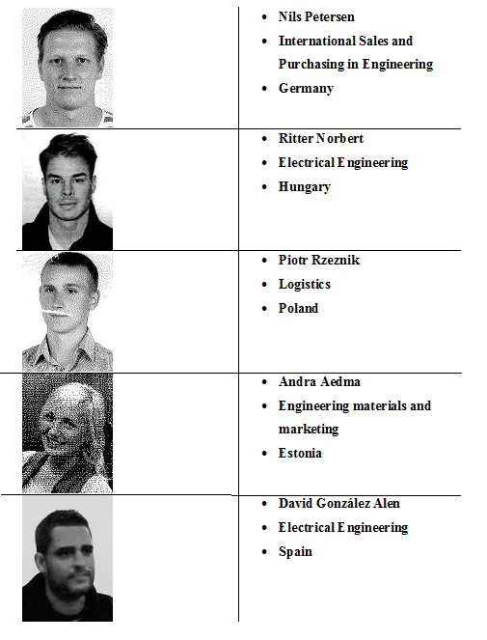

1.2 Motivation
There were 15 proposals to choose. At first we were thinking about the projects like Travel Logging System and Clicker Voting System, but found that the knowledge required to handle these subjects was missing, so it was necessary to find a new project. Looking through the proposals again, we focused on the Modular LED Lamp which matched a bit with some team members` knowledge and studies. It also seemed to be an interesting project because for the last hundred years, the incandescent light bulb has been part of our daily lives. Today this humble invention is facing obsolescence due to global government regulations mandating increased energy efficiency for lighting. In an incandescent lamp, less than 10 percent of the input power is actually converted to visible light. The rest is non-visible infrared and heat, so incandescent lamp is not efficient. We have to search for other alternatives, like light-emitting diode which came in the markets five years ago, because of dramatic efficacy improvements in technology [1]. LED lamp is worth to develop, because it has a long lifespan, durable quality, zero ultraviolet emissions, design flexibility, light disbursement, low-voltage and it is energy efficient, ecologically friendly and operates in extremely cold or hot temperatures.
1.3 Problem
In the past and even at present incandescent lamps have become very popular. The positive aspect of these lamps is that they are cheap, but there are more disadvantages than advantages. For example, incandescent lamps are low efficient. For an incandescent light bulb to work, electrical energy has to pass through a filament for it to be converted to heat. It is when the filament becomes hot enough that light is produced. Since this process generates more heat, about 90 percent of its output, than light, a great deal of electrical energy is wasted. Also they have negative impact on the environment. Environmental lobbying groups have labelled incandescent light bulbs as harmful not only because of the electricity they waste in producing heat, but also because of the substantial amounts of carbon dioxide they emit. Thirdly, incandescent lamps have short lifespan. The lifetime of a standard incandescent light bulb can range from somewhere between 700 to 1,000 hours. This means that, if used regularly, it will burn out in less than a year. Furthermore, incandescent lamps in general are vulnerable to vibrations. It means that we need some kind of alternative to replace incandescent lamp. LED lamp seems to be good solution of that problem. According to this project, Modular LED lamp has to build which has to be compatible with actual lamps, to be compatible with present day lamp bushings, it should be possible to replace only one LED at a time in order to have a real low cost and long duration, give different colour tones to the Light bulb and to the environments where it will be used [2]. Of course it should have low cost.
1.4 Objectives
Design and prototype development of a Modular LED lamp should be compatible with present lamps. The idea behind this project proposal is the development of a “Light Bulb” that is fully constituted by light emitting diodes (LED). The set of LED should be assembled in this “Light Bulb” in such a way that it is totally compatible with present day lamp bushings, either mechanically and electrically. Furthermore it should be possible to replace only one LED at a time in order to have a real low cost and long duration “Light Bulb”. This implies that there should be an easy way to detect which LED is damaged and an easy way to replace it. Considering the design, it could be possible to assemble all LED of the same colour or having distinct coloured LED in order to give different colour tones to the “Light Bulb” and to the environments where it will be used. The geometry of the “Light Bulb” could also vary, according to the target market niche that is intended to attain.
1.5 Requirements
Requirements to LED lamp which we have to consider while developing our project:
- Fit to universal lamp socket (E27);
- Change colours with remote control (radius 10 m);
- Easy construction to change the LED;
- Include an automatic brightness control system (maximum radius 4 m);
- Reuse provided components or low cost hardware solutions;
- Use open source and freeware software;
- Adopt the International System of Units (NIST International Guide for the use of the International System of Units);
- Be compliant with the Machines Directive (MD), Low Voltage
- Directive (LVD) and Restriction of the use of certain Hazardous Substances (RoHS) Directive.

1.6 Functional Tests
Tests which are necessary to carry out of the completed LED lamp prototype:
- Have to try if LED light bulb fits to E27 lamp socket
- Have to try remote control. For that it is necessary to connect light bulb with a grid and when turning the button of remote control light bulb should change colours (in 10 m)
- Have to try take out some LED or only one LED and replace them by another LED or LED. Also have to connect light bulb to the grid to see if changed LEDs are working.
- Have to connect light bulb to the grid, then move towards to the light bulb, when being at the distance of maximum 4 m it should reduce the brightness. Also when moving further than maximum 4 m from lamp, it should increase the brightness again.
1.7 Project Planning
After choosing the project the team talked about their skills and knowledge. Discussion gave better overview who is more familiar with each topic. At first, to get into this project, it was necessary to make a research on the current market and then divide tasks according to each team member knowledge. Andra and Nils are studied marketing before, so they got marketing chapter. Piotr has some knowledge about Ethical and Deontological concerns. Norbert and David are both electrical engineers, they got the technical tasks of the project. You can find further information about our tasks in Table 2 and Table 3.
Table 2: Project planning
Task | Responsible
Proposal Research | Nils Petersen, Piotr Rzeznik, Andra Aedma, David González Alen, Ritter Norbert
State of art | Nils Petersen, Piotr Rzeznik, Andra Aedma, David González Alen, Ritter Norbert
Marketing plan | Nils Petersen, Andra Aedma
Introduction | Andra Aedma
Ethical and Deontological concerns | Piotr Rzeznik
Material planning | David González Alen, Ritter Norbert
Prototype | Nils Petersen, Piotr Rzeznik, Andra Aedma, David González Alen, Ritter Norbert
Project Developement | David González Alen, Ritter Norbert
Eco-eficency Measures for sustainability | Nils Petersen, Piotr Rzeznik, Andra Aedma

Table 3: Project planning 2
Task | Responsible
Video | Nils Petersen, Piotr Rzeznik
User manual | Piotr Rzeznik
Website | Piotr Rzeznik
Poster, leaflet | Nils Petersen, Piotr Rzeznik, Andra Aedma, David González Alen, Ritter Norbert
Conclusions | Nils Petersen, Piotr Rzeznik, Andra Aedma, David González Alen, Ritter Norbert
Final presentation | Nils Petersen, Piotr Rzeznik, Andra Aedma, David González Alen, Ritter Norbert
In Figure 1 presents the Ganttchart that gives a better visual overview of our activities:
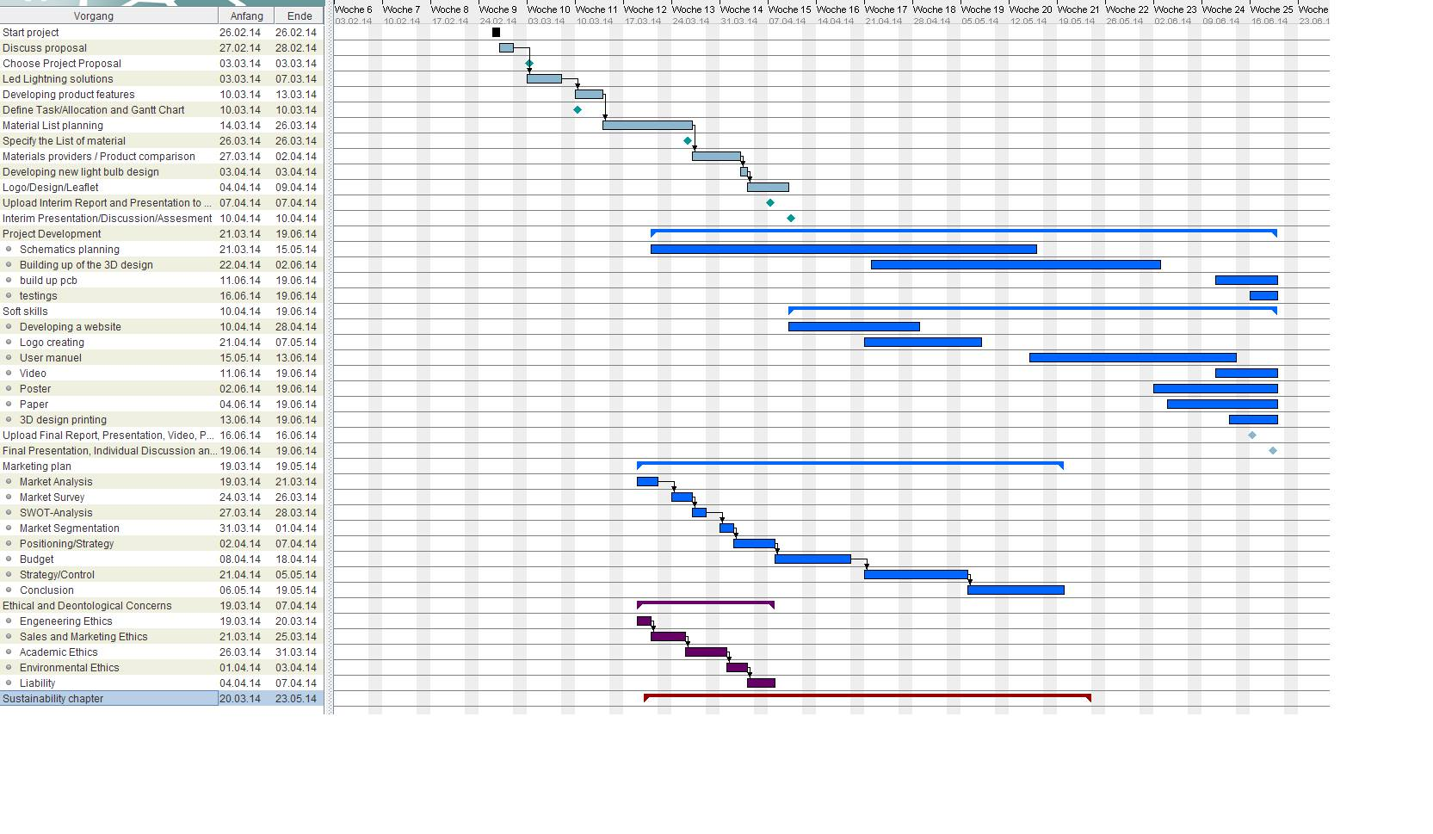
Figure 1: Ganttchart
1.8 Report Structure
This report is structured in seven different chapters. In the first chapter, LED Lightning Solutions, different LED products and remote controls are described. These are on the market now. As overview of our product technologies has also been included. Chapter two, “the Marketing plan,” presents the Market analysis, positioning and segmentation, as well as strategies and marketing mix. In the third chapter the Eco efficiency Measures for Sustainability are presented, highlighting the importance of sustainability in the engineering area and including a life-cycle and energy consumption analysis. The fourth chapter describes the Ethical and Deontological concerns of our project. The fifth chapter focuses on the project management, main tools of managing time and human resources are described. The sixth chapter of the report concerns the Project development where the proposed solution is explained. Lastly, in the conclusion chapter, the discussion about project is included as well as reference to possible further developments.

2. LED Lighting Solutions
2.1 Introduction
At the beginning the modular system and method for providing power for LED lighting systems are described to get to know more about LED system details. The power source unit comprises a power supply that converts alternate current voltage to regulated direct current (D/C) voltage, a configurable intelligent gateway module that receives the regulated D/C voltage and places it on a power bus to which one or more power node modules and any accessories in need of power, such as motion detectors or cooling units, are coupled, and an intelligent power node module that converts the regulated D/C voltage to a regulated D/C current and provides it to the particular LED Light Module (LLM), and which also receives data from the LLM, such as temperature data, and adjusts the regulated current accordingly. The gateway module also may receive control data from control devices, such as dimmers or wireless controllers, and instruct the power node module to regulate its output current accordingly [3].
In this chapter we are giving overview of application areas of LED, introducing similar products to developed project, studying specifications of lighting system. Short overview of LED applications is included in Table 4.
Table 4: Application areas of LED [3]
Application area | Application examples
LCD backlight | Mobile phones, cameras, portable media players (PMPs), notebooks, monitors, TV
Transportation equipment lighting | Vehicle/train lighting, Ship/airplane lighting
General lighting | Indoor lighting, outdoor lighting, special lighting
2.2 Different LEDs [4]
Today’s LED is available in many different types, shapes, and sizes. These advancements have led to better illumination, longer service life, and lower power consumption. They have also led to more difficult decision making, as there are simply too many types of LED to choose from.

2.2.1 Miniature
Miniature LED are the most common form of LED available today, picture of miniature LED is shown in Figure 2. Miniature LED is considerably small, and usually available in a single shape/colour. They’re used as indicators on devices such as cell phones, calculators, and remote controls.
Given their unique size and simple design, miniature LED can be placed directly onto a circuit board, with no need for a heat-controlling/cooling device. As such, they are also used in sophisticated and technologically intense automated industries.
There are three subtypes of miniature LED: low-current, standard, and ultra-high-output, all of which vary in terms of current, voltage, and total wattage, depending upon the manufacturer. There are 5 and 12 volt miniature LED available.
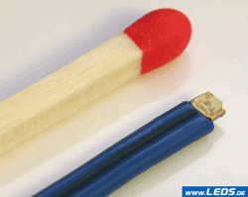
Figure 2: Miniature LED

2.2.2 High-power
Improved diode technology has resulted in this new category of LED, also referred to as a high-output LED as it offers a much higher lumen output than standard LED. Their high-power chips can emit light that registers several thousand lumens. Subtypes of high-power LED are typically characterized by a few parameters, including voltage, wavelength, and luminous intensity.
These lights pose the danger of overheating and so need to be mounted on an appropriate form of heat-absorbent material to allow the heat to cool via convection. This keeps them productive and effective, and helps the light avoid an early burn-out.
Always take heat control into consideration, no matter the type of high-power LED you are purchasing. Just as there are limits to maximum current, there are limits to certain temperatures.
Typically high-power LED is findable in car headlights, high-powered lamps, and various mechanical, industrial, and scientific settings. Figure 3 shows how high- power LED looks like.
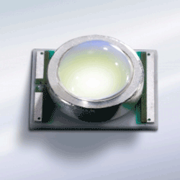
Figure 3: High-power LED

2.2.3 Application-specific LED lights
Typically, the flashing LED (Figure 4) is a standalone light that serves as a form of attention-seeking indication. It may look like a normal LED, but it contains an integrated circuit, in addition to the LED, which flashes the light at a specific frequency. Flashing LED is designed so as to be connected directly to a power supply with no series resistor required.

Figure 4: Flash

A bi-colour LED light has two light-emitting dies in a single casing. It features three leads and is offered with either a common anode or common cathode. The wiring for the bi-colour LED is considered “inverse parallel”; that is, one is forward and one is backward. This means that only one of the dies can be lit at a time. Current flow alternates between dies in order to produce colour variation. If alternate the current at a high enough frequency, it will appear that both lights are on at the same time, and produce a third colour. Appearance of bi-colour and tri-colour LED can be seen in Figure 5.
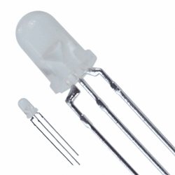
Figure 5: Bi-colour and Tri-colour

Similar to a bi-colour LED, the tri-colour LED (Figure 6) also combines two light emitting dies in one encasing. What’s different, though, is there are three leads instead. There is a centre lead, which is the common cathode for both LED, and on either side are the outer leads, which are the anodes to the separate LED. This design allows for both dies to be lit either separately or together which, when the colours are combined, produce a third colour. While this example describes a common cathode-based design, tri-colour LED is available in either a common anode or common cathode configuration. RGB LED includes red, green, and blue emitters, which allow for it to combine the three primary colours in different amounts to produce new colours with incredible precision. There are literally millions of possibilities of colour combinations with today’s increasingly sophisticated controllers.
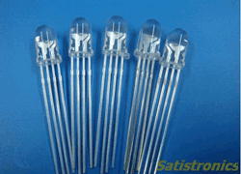
Figure 6: Red, green, blue (RGB) LED

Most RGB LED use a 4-pin connection with a common lead, which is the longest connection (others have just two leads and include a built-in electronic control unit). Since the light requires electronic circuits to control the blending and diffusion of different controls, RGB LED offers users tremendous control of colour emission. As a result, they’re used a wide variety of applications, including light shows, video display, accent lighting, status indicators, and more.
The alphanumeric LED light has fallen in popularity in recent years. While some point to the cancellation of the television show 24, the decline is actually due in large part to the increased sophistication of LCD, which offer greater visual flexibility and much less power consumption.
As the Figure 7 show, there are four subtypes of the alphanumeric display. The 7-segment handles all numbers and only a limited set of letters; 14- and 16-segment displays are referred to as the “starburst” displays: they can cover the full 26-character Roman alphabet in upper case as well as numerals 0-9. Only difference between the two is a break on the top and bottom bars on the 16-segment digit.
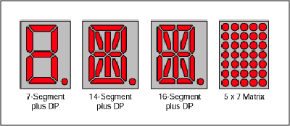
Figure 7: Alphanumeric

Lighting LED (also referred to as LED lamps, LED bars, or illuminators, picture in Figure 8) come in many different shapes and sizes, including the popular Edison light bulb design.
Heat dissipation methods vary based on manufacturer and how the light will be used. As new solutions are discovered though, this particular category of LED will continue to expand.
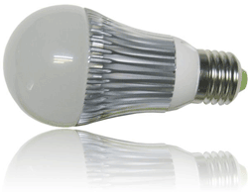
Figure 8: Lighting LED

2.2.4 Advantages and disadvantages of LED
In this paragraph there are Tables 5 to 9 which are explaining LED Lamp advantages and disadvantages in different aspects.

Table 5: Advantages of LED Lamp [5]
Advantages of LED Lamp
Low heating generation to reduce electricity consumption
Saving money on energy bills
Greatly reduce carbon emission
Minimizing drastic climate change
Greatly reduce maintenance cost, long lifespan
Instant start, no flashing, solid state, shockproof
Save up to 90% power compared to ordinary bulbs
Long working hours, 24 hours per day is fine, produce very low heat
No mercury or other hazardous materials, accord with ROHS
Working environment - 20-40°C
No radio frequency interference, no ultraviolet or infrared radiation

Table 6: Environmental benefits [5]
Environmental benefits
The LEDs comply with CE marking and RoHS regulations (“Restriction of Hazardous Substances ”) Restriction of Hazardous Substances Directive 2002/95/EC as
Not contain mercury or other heavy metals
Being more efficient, Led’ s produce less CO₂ emissions to achieve the same illumination
Not generate as much heat as traditional lamps, with consequent savings in air conditioning
Low light pollution because the light emitted by the LED is always addressed, which is avoided in the case of village streetlights illuminate skywards
Its long duration means less need for raw materials for replacement lamps
No IR or UV radiation
Table 7: Economic benefits [5]
Economic benefits
Lower power consumption than the (fluorescent, incandescent, halogen, low power); with reductions ranging from 65% for fluorescent, to over 80 % for halogen and incandescent and 50% in low consumption
Depreciation quite fast within 3 years of the investment by the savings in lighting
High durability from 15 000 up to 50 000 hours, depending on the quality of the LED
Maintenance Light Flow on the original 70 % over its lifetime
Reduced cost of replacement and maintenance accordingly, and we saved the labour to replace it
Immediate start, disappear wasting time waiting for the lamp reaches the right temperature, or light up properly
Setting the backlight to our customer needs and wishes, both in quantity and intensity, there is a possibility to dim the LED
Does not require replacement of existing lamp sockets, it is sufficient to perform simple rewiring
After installation does not require the protective cover, since most of the LED are made of aluminum and plastic, so that in case of breakage, any piece does not fall on food or people

Table 8: Benefits of design and architecture [5]
Benefits of design and architecture
Maximum design flexibility, there are LED of all sizes and with almost any design
The boot is immediately obtained 100 % light output after power
Improving the efficiency of the system used to direct light
Unlike fluorescent lights, LED are more efficient in low temperature environments; LED have no starting problems in cold environments
They are reliable sources of light outside
Robustness and security against vibration
Light scattering outside which is desired is minimal due to the directionality of the LED
Regulation is total no colour change
Ability to change colours in the same lamp
Plastic Optical high efficiency allowing more light can be used
Multiple possibilities for decoration
Table 9: Disadvantages of LED Lamp [5]
Disadvantages of LED Lamp
Greatest enemy is the high temperatures, from 65° C most LED are spoiled
Not many LED lamps marketed substitutability of electronics
Require high thermal dissipation, but generate less heat than conventional, which dissipate heat generated is very important- is vital that the heat sinks are aluminium and very dissipation surface, so longer lamp life would be ensured
The price compared to conventional is quite high
The large supply of these products makes it difficult to purchase choice, care must be taken with the selected suppliers, there is a huge intrusion in the sector
2.3 Related products
There are a lot of similar products in the market. Table 10 and Table 11 are including different kind of LED lighting solutions which are currently in the market.

Table 10: Related products
Product | Features | Price [EUR] | Picture
TurnRound [6] | Available in fixed and adjustable versions; dimmable; 25 and 40° beam angles; high-Power LED technology. | 111 | 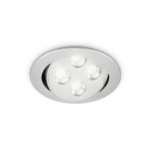
iColor Flex MX [7] | Strand consists of 50 individually addressable LED nodes; each node produces full-colour light output of up to 1.44 candela. Flexible form factor. Multiple lens options: clear dome and translucent dome lenses as standard; clear flat and translucent flat lenses also available. Standard and custom lengths and node spacing. | 352 | 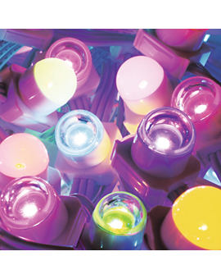
eW Flex SLX [8] | Strand consists of 50 individually addressable LED nodes; each node produces full-colour light output of up to 1.44 candela. Flexible form factor. Works with complete Philips line of controllers, as well as third-party DMX controllers. Multiple lens options: clear dome and translucent dome lenses as standard; clear flat and translucent flat lenses also available. Standard and custom lengths and node spacing. | 300 | 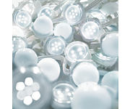

Product | Features | Price [EUR] | Picture
iColour Tile MX – LED light panel for stunning effects and large-scale video [9] | Panel 597 x 597 mm; 144 individually addressable, high-intensity, full-colour LED nodes, light output 599 nits. Designed for recessed and surface mounting on walls or ceilings. Quick set-up. Works with complete Philips line of controllers, as well as third-party DMX and Ethernet controllers. | 133 | 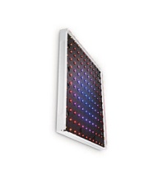
HDE® Remote Control Colour Changing 16 LED Light Bulb with RC [10] | Operates in standard light sockets.5 watt 16 colour LED; colour: red, green, blue and white; adjustable shades and brightness; batteries: CR2025; size: 2.5”/ 6.35 cm; package contents: 1 x LED Light Bulb; 1 x remote. | 7,2 | 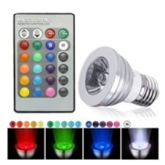
LivingColours Bloom White [11] | Choose among 16.000.000 colours, dimmable, light output 120 lumen, easy-to-use remote control, adjustable colour intensity, automatic colour changing mode, nice diffused light effect, 2 buttons to store your favourite colours. | 72 | 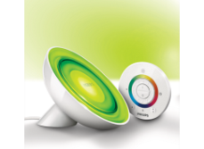
The ColourFuse Powercore [12] | Advanced colour mixing and superior colour consistency. Light output of 380 lumens per fixture. Rotation in 10º increments through full 180º for precise aiming and colour mixing. | 214 | 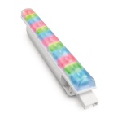
ColourBlast Powercore [13] | Medium beam angle 36º. Colour: white, dimmable. | 431 | 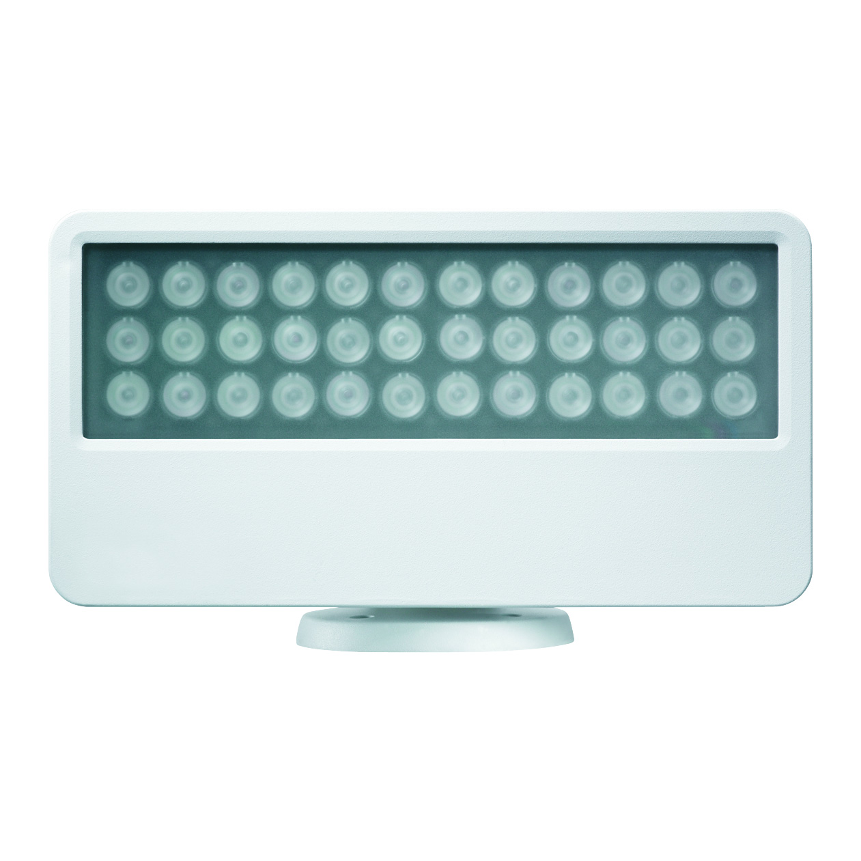
The C-Splash 2 [14] | Long-life LEDs delivering RGB colours and light output of over 500 lumens. IP68-rated: also able to withstand water treated with bromine or chlorine. 10° clear glass lens for extended light projection and 22° frosted tempered glass lens for a soft-edge beam. | 924 | 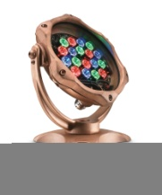
LED A Shape [15] | Provides light similar to natural daylight, lasts 22.8 years, instant on, reduces energy costs, similar shape and size as standard incandescent, dimmable. | 17 | 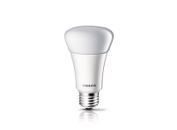
Reflector - Flood [16] | Provides Bright Crisp Light, lasts 22.8 years, instant on, reduces energy costs, similar shape and size as standard incandescent, dimmable. | 17 | 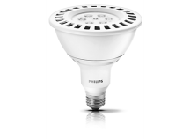
Table 11: Related products 2

As Table 10 and Table 11 show there are many different LED light bulbs and lamps. There are still room for developing mood lighting market, existing products are very expensive and variety of Europe products is not very big. Our team concentrates to mood lighting lamp and takes challenge to make mood lighting more affordable.
2.4 Remote controls
The most common remote control types are WIFI, Bluetooth and Infrared, icons of these types are presented in Figure 9.

Figure 9: Logos [17]

2.4.1 WIFI
Wi-Fi is a popular technology that allows an electronic device to exchange data or connect to the internet wirelessly using ultra high frequency radio waves. Wi-Fi Remote Control is a simple application to control devices via local Wi-Fi network. You need to know Internet protocol address, port, command code to setup your device into menu. It is controllable for example your smart Wi-Fi/Ethernet TV, IP Camera, Arduino+ Ethernet card and other new Wi-Fi, Ethernet devices [18]; [19].
For this type of controller needs to have a smartphone or tablet. It is necessary to download App for Android or IOS. There are many different applications to control LED light bulb. Table 12: Specifications of Wi-Fi box [20] presents specifications of Wi-Fi box and Table 13 specifications of remote.
Table 12: Specifications of Wi-Fi box [20]
SPECIFICATIONS OF WI-FI BOX
Power supply | Adapter or USB DC 5V 500 mA
Wi-Fi connectivity | Direct or via home network
Wi-Fi security | WPA WPA2
RF transmitter | 8 zones 2.4 GHz

In Figure 10 Wi-Fi Interface is shown.
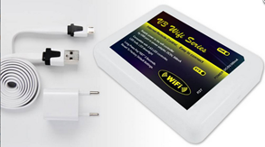
Figure 10: WI-FI Interface [20]

Table 13: Specifications of remote control [21]
SPECIFICATIONS OF REMOTE
Controls | 4 Zone touch screen
Functions | On/off, dimming, colour selection, program selection, effect mode speed
Distance | 20 meters through walls
Batteries | 2 x AAA penlite 1.5 Volt
Dimensions | 110 x 52 x 20 mm
Frequency | RF 2.4 GHz

2.4.2 Bluetooth
Bluetooth is a wireless technology standard for exchanging data over short distances using short-wavelength UHF radio waves in the industrial, scientific and medical (ISM) radio bands from fixed and mobile devices, and building personal area networks. Bluetooth operates in the range of 2400–2483.5 MHz. This is in the globally unlicensed. Industrial, Scientific and Medical (ISM) use 2.4 GHz short-range radio frequency band. Bluetooth uses a radio technology called frequency-hopping spread spectrum. The transmitted data are divided into packets and each packet is transmitted on one of the 79 designated Bluetooth channels. Each channel has a bandwidth of 1 MHz. Bluetooth 4.0 uses 2 MHz spacing which allows for 40 channels. The first channel starts at 2402 MHz and continues up to 2480 MHz in 1 MHz steps. It usually performs 1600 hops per second, with Adaptive Frequency-Hopping (AFH) enabled. A master Bluetooth device can communicate with a maximum of seven devices in a piconet (an ad-hoc computer network using Bluetooth technology), though not all devices reach this maximum. The devices can switch roles (for example, a headset initiating a connection to a phone will necessarily begin as master, as initiator of the connection; but may subsequently prefer to be slave) [44]. Below there is picture of Bluetooth interface (Figure 11) and also table of Bluetooth properties (Table 14) [22].
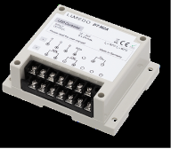
Figure 11: Bluetooth Interface [23]

Table 14: Bluetooth properties [23]
PROPERTIES
Up to 24 V and 2 A per channel
5 Channels (Red, Green, Blue, Warm, White, Cold White)
Low Stand-By Consumption
Up to date Bluetooth 4.0 Chip
Easily accessible Terminal for connecting LED stripes
Temperature resistant from 0°C to 50°C
Automated shutdown on overheating
Suitable for DIN rail mounting
Easy integration of up to 5 controllers into one network
Free iPhone App

2.4.3 Infrared
The signal between a remote control handset and the device it controls consists of pulses of infrared light, which is invisible to the human eye, but can be seen through a digital camera, video camera or a phone camera. The transmitter in the remote control handset sends out a stream of pulses of infrared light when the user presses a button on the handset. A transmitter is often a light emitting diode (LED) which is built into the pointing end of the remote control handset. The infrared light pulses form a pattern unique to that button. The receiver in the device recognizes the pattern and causes the device to respond accordingly. In following there are pictures about IR remote controls in Figure 12 [24].
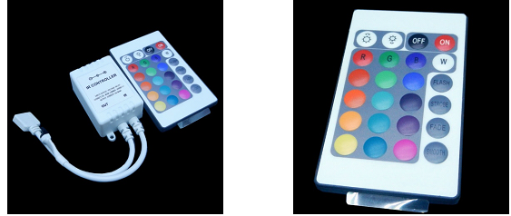
Figure 12: IR interface and Remote controller [25]

2.4.4 Advantages and disadvantages of remote controls
Everything has a two sides, disadvantages and advantages. In Table 15 are shown different kind a remote controls positive and negative sides.

Table 15: Advantages and disadvantages of remote controls
REMOTE CONTROLLERS
Type of controller | Advantages | Disadvantages
IR | - Easy function  - Cheap  - Simple  - Easy for buy a new controller | - Distance to use only 10 m  - Can’t create scenes.
WIFI | - Can control 5 lamps  - 20 meters through walls | - Needs smartphone  - Needs router
Bluetooth | - Control of multiple lights  - Automatically switches the light on/off to deter intruders | - Necessary to open the App always  - Battery could die quickly

2.5 Brightness sensors
For brightness sensors, we were considering using ultrasonic sensor or laser sensor. In the following there are descriptions of these sensors and also comparison between them.

2.5.1 Ultrasonic sensor
Ultrasonic sensors (Figure 13) work on a principle similar to radar or sonar which evaluates attributes of a target by interpreting the echoes from radio or sound waves respectively. Ultrasonic sensors generate high frequency sound waves and evaluate the echo which is received back by the sensor. Sensors calculate the time interval between sending the signal and receiving the echo to determine the distance to an object. This technology can be used for measuring wind speed and direction (anemometer), tank or channel level, and speed through air or water [26].
Transducers
Systems typically use a transducer which generates sound waves in the ultrasonic range, above 18 000 Hertz, by turning electrical energy into sound, then upon receiving the echo turn the sound waves into electrical energy which can be measured and displayed. An ultrasonic transducer is a device that converts energy into ultrasound, or sound waves above the normal range of human hearing. While technically a dog whistle is an ultrasonic transducer that converts mechanical energy in the form of air pressure into ultrasonic sound waves, the term is more apt to be used to refer to piezoelectric transducers or capacitive transducers that convert electrical energy into sound. Piezoelectric crystals have the property of changing size when a voltage is applied, thus applying an alternating current across them causes them to oscillate at very high frequencies, thus producing very high frequency sound waves. The location at which a transducer focuses the sound can be determined by the active transducer area and shape, the ultrasound frequency, and the sound velocity of the propagation medium [26].
Use in industry
Ultrasonic sensors are used to detect movement of targets and to measure the distance to targets in many automated factories and process plants. Sensors with an on or off digital output are available for detecting the movement of objects, and sensors with an analog output which varies proportionally to the sensor to target separation distance are commercially available [26].
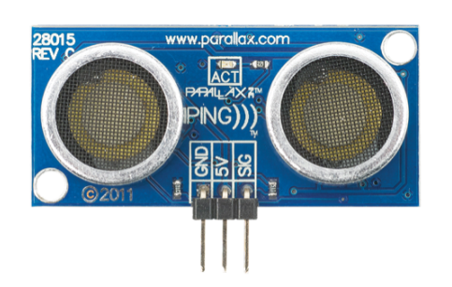
Figure 13: Ultrasonic sensor [26]

2.5.2 Laser sensor
Laser sensors are used where small objects or precise positions are to be detected. They are designed as through-beam sensors, retro-reflective sensors or diffuse reflection sensors.
Laser light consists of light waves of the same wave length with a fixed phase ratio (coherence). This results in an important feature of laser systems that is the almost parallel light beam. The result: Long ranges can be achieved thanks to the small angle of divergence. The laser spot which is also clearly visible in daylight simplifies the alignment of the system [27].
Distance sensors
Sensors for distance measurement (Figure 14) operate according to the time-of-flight principle. A light beam is emitted and reflected by an object. The time the light beam takes for the distance from the unit to the object and back from the object to the unit is measured. Since the speed of light is constant, the distance can be calculated on the basis of the time of flight [27].
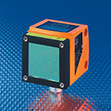
Figure 14: Distance sensor [27]

2.5.3 Comparison
In order to compare different options of brightness control sensors, there is a Table 16 which explains sensors positive and negative sides.

Table 16: Comparison of Ultrasonic and Laser sensor
Product | Advantages | Disadvantages
Ultrasonic sensor | Response is not dependent upon the surface colour or optical reflectivity of the object; sensors with digital outputs have excellent repeat sensing accuracy, it is possible to ignore immediate background objects; the response of analogue ultrasonic sensors is linear with distance, by interfacing the sensor to an LED display, it is possible to have a visual indication of target distance ; cheap (0,96 €); small | Must view a surface squarely to receive ample sound echo; sensors are likely to falsely respond to some loud noises, like the “hissing” sound produced by air hoses and relief valves; ultrasonic sensors have a minimum sensing distance; changes in the environment, such as temperature, pressure, humidity, air turbulence, and airborne particles affect ultrasonic response
Laser sensor | Distance measure at light speed (depends on the processor speed also); ideal for near real time positioning of an object | Depends on weather; visual path should be clear; dusty air, rainy or cloudy day will affect the accuracy; expensive (100€); big
2.6 Conclusion
There are many different LED Lamps with different range of application in the market right now. For example LED is used in supermarket refrigerators, for disco club illumination, in toys, mobile devices, intelligent houses, for garden illumination, road lighting, in regular household and so on. Our idea is to create Modular LED Lamp, which fits to universal lamp socket, user can change colours by using remote control, lamp has intelligent automatic brightness control system, dynamical dimming system and LED Lamp has easy construction to change the LED. There are many colour changing lamp offers, but automatic brightness control system is not common for lamps, so it Modular LED Lamp is innovative with this feature. In the following there is final decision about materials which is presented in Table 17. Closer look of our ideas, strengths and weaknesses you can find on the following chapter, called marketing.
Table 17: Materials advantages
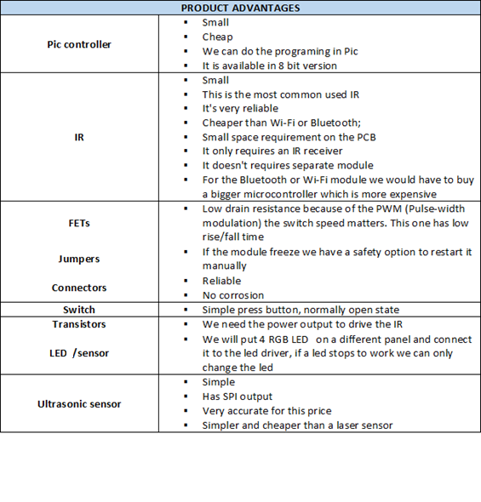

3. Marketing Plan
3.1 Introduction
So far lighting has been considered largely a functional issue. End consumers have questioned whether the quality, type and location of lights were conducive to worker productivity, an attractive home or office environment and perhaps even a personal or corporate image. At the same time, producers viewed the lighting industry as a mature industrial market. Keys to success were lowering manufacturing costs through large-scale production and low cost capital and labour inputs, while maintaining a strong position in relevant distribution channels. Less attention was paid to innovation and development. Nowadays customers, large-scale producers and start-ups are increasingly aware that lighting is as much an energy issue as it is a matter of functionality. Lighting in all segments (residential, commercial, industrial, and outdoor) consumes almost 20% of the energy in the built environment, internationally. The market for light emitting diodes (LED) has a high potential in the global general lighting market. Light management systems and colour control of LED light, which can affect the mood of the end users enabling a purpose-friendly ambience, will shape the market into a new sphere.
We are entering to the LED lighting market, for which ResearchMoz is predicting in its market research report “Global LED Lighting Market 2012-2016” 35.6 percent growth over the period 2012-2016. One of the key factors contributing to this market growth is the declining average selling price of LED. The Global LED Lighting market has also been witnessing an increasing adoption of LED. The worldwide high-brightness LED market surpassed $14 billion in 2013, with 10 companies accounting for more than 68% of the market. Lighting, which doubled revenues since 2012, now accounts for 30% of the market [28]; [29].
According to the prediction of LED increasing market, we have good prospects to enter to the market. Our product is Modular LED Lamp, which has several features:
- Fits to universal lamp socket;
- Change colours with remote control (radius 10 m);
- Easy construction to change the LED;
- Include an automatic brightness control system (maximum radius 4 m)
We are aware that we have many competitors who are offering LED lighting (day lighting, mood lighting), but we offer among other features automatic brightness control system, which is not so common in current market products. Our product is concentrated more to mood lightning market.
Following chapter discuss about our product market size, possible market increase or decrease. Also identify our strengths and weaknesses, identify competitors and target market. There is description about our strategies and price.
3.2 Market Analysis

3.2.1 Macro Environment
A Macro Environment Analysis is a review of factors that a company is unable to control. Companies may conduct this to stay ahead of the issue in the current business world. A common tool for this is the PESTEL framework, but in this analysis we use PESTO tool, which includes factors from political, economic, social, technological and other (legal, ecological) environments. We evaluate the level of dependency of our business area to each PESTO environment.
Political environment
Nowadays green politics is a rising trend. Green politics is a political ideology which is trying to create an ecologically sustainable society rooted in environmentalism, social justice, and grassroots democracy. By now Green parties have developed and established themselves in many countries across the world and have achieved some electoral success [30].
European Union promotes environmental friendliness as well, for example European Commission is worried about energy efficiency. On 8 March 2011, the European Commission adopted the Communication “Energy Efficiency Plan 2011” for saving more energy through concrete measures. The set of measures proposed aims at creating substantial benefits for households, businesses and public authorities: it should transform daily lives and generate financial savings of up to 1000€ per household every year. It should improve the European Union´s industrial competitiveness with a potential for the creation of up to 2 million jobs [31].
Energy efficiency is not an issue for only Europe, but it concerns organizations worldwide. Canadian Industry Program for Energy Conservation and Natural Resources Canada can help your organization cut costs, improve energy efficiency and reduce industrial greenhouse gases [32]. Latin America and the Caribbean, energy efficiency may offer the greatest impact at the lowest cost of all the untapped sources of clean energy. Inter- American Development Bank researchers have estimated that the region could reduce its energy consumption by 10 percent over the next decade and save tens of billions of dollars by adopting existing technologies to increase efficiency. [33] China had plan for medium-and-long-term energy conservation for the 11th five-year period (2006-10) where country set its focus of energy saving in the industrial sector, transportation and construction industries, as well as commercial and civil power use [34].
Connecting our work with this subject, we provide energy efficient lighting. LED lamps are today`s most efficient way of illumination and lighting, with an estimated energy efficiency of 80%-90% when compared to traditional lighting and conventional light bulbs. This means that about 80% of the electrical energy is converted to light, while a ca. 20% is lost and converted into other forms of energy such as heat [35].
Economic environment
Macroeconomic influences are broad economic factors that either directly or indirectly affect the entire economy and all of its participants, including our business. These factors include such things as interest rates, taxes, inflation, currency exchange rates, consumer discretionary income, savings rates, consumer confidence levels, unemployment rate, recession. For example if company is established, it is necessary to pay property tax, excise taxes (paid by a business for certain types of consumption and activities), business income taxes, sales tax, self-employment tax (paid by sole proprietors and partners for social security and medical care, based on the income of the business), employment taxes/ payroll taxes (these taxes include social security/medical care, federal/state unemployment, and federal/state worker's compensation taxes) [36].
Coming back to LED lighting, then the LED lighting market is anticipated to grow 45 percent per year through 2019. The LED lighting market at 4.8 billion dollar in 2012 is anticipated to go to 42 billion dollar by 2019. The reason of the growing market is the declining price, the increased interest by the channel in pushing LEDs to consumers. In this moment LED is the best lighting solution. The phase out of incandescent lights has begun, the onset of LED command of the market is upon us. Figure 15 shows LED lighting expansion in recent years [37].
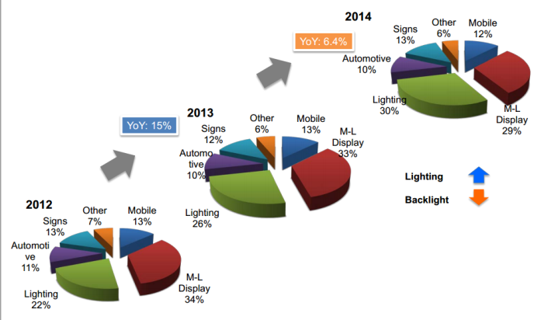
Figure 15: LED lighting expansion [37]

Social environment
“Green thinking” is getting more and more popular among people. More people are becoming accepting of the reality of climate change, the impact humans are having on the planet and realization that something needs to be done to improve our natural environment. Nowadays recycling is a common action, people buy more second hand clothes, they use hybrid and electric cars instead of diesel or gasoline, also renewable energy usage have improved. People are started to think how to save money by using sustainable energy.
Technological environment
It is 21st century, technology is changing very fast. Most of work is done by high level machinery, businesses and shops are available online. This project provides LED lighting, which is currently the most energy efficient lighting in the market. Also there is combined several features, like colour changing and automatic brightness control system to light bulb. Nowadays people like to own multi featured products. There is some room for development as well. In order to stay alive in the middle of competitors, it is necessary to be better, innovative and invest to product development. In future Modular LED Lamp remote control would be improved. For example we would use smartphones, which are very popular among people, instead of remote control. For that is necessary to develop and design application.
Because of widely spread Internet usage, Internet marketing has developed. Internet marketing or online marketing refers to advertising and marketing efforts that use the Web and email to drive direct sales via electronic commerce, in addition to sales leads from Web sites or emails. Of course traditional types of advertising like radio, television, newspapers and magazines are still there too. Furthermore, as people use a lot social media, have developed marketing through social media networks. We have to consider consistent development and create web page and online store to our products, also need to pay attention to different marketing trends.
Legal, ecological environment:
The basic legal environment of a business is controlled and regulated through national, or international law. It is also connected to the political and economic environment, which are already explained before. When creating company it is necessary to get trading licence, pay taxes and so on. Luckily many countries are promoting entrepreneurship, creating online registrations for companies and offering financial starting support. Also there are many institutions in several countries who help young people to develop their ideas and to create start-ups.
Our world has limited resources, so it is important to be sustainable. LED light bulb is the most energy efficient lighting of existing options. Also our lamp has easy construction to change LED, so it not necessary to throw away hole light bulb, you can replace old LED to new ones. LED lights contain no toxic materials and are recyclable, also will help reduce your carbon footprint by up to a third. The long operational life time span mentioned above means also that one LED light bulb can save material and production of 25 incandescent light bulbs.

3.2.1 Micro Environment
Microenvironment contains factors that affect a company's ability to serve its customers, such as the company itself, suppliers, marketing intermediaries, customer markets and the public.
Internal
We are 5 international students from Poland, Estonia, Hungary, Germany and Spain with different background. We have knowledge of logistics, engineering materials, marketing and electrical engineering. We don't have any experience of leading or managing company, as well we don't have large funds to our project development or marketing. At first place we don't have large scale production, because at the beginning we need to inform market about our product and to recruit a customer base. It is important that all of us are participating in manufacturing, marketing, advertising and general business. Considering our specializations, we made the departments distribution according to our skills.
Logistics department - Piotr Rzeznik
Product development department- Norbert Ritter, David González Alen
Purchase and sales department- Andra Aedma, Nils Petersen
For production we would need more manpower as well as for other departments like IT, accounting, materials and personnel. Luckily because of the different nationalities we have connections and knowledge how to act in different markets. This is certainly bonus for a start-up company.
Suppliers
Nowadays companies are not focused to a local market anymore, they want to be global. Prohibitions and political barriers are relaxed and global trading has become possible. Furthermore, the majority of manufacturers are available online. There are a lot of technical products available in different web sites. To develop our project we are using Mouser Electronics and InMotion online stores. In the future it is not definitely a problem to find a supplier. It is possible to choose among different quality, price and reliability.
Intermediaries
As our main target is B-to-B market, then with bigger projects we would like to make a contract directly with customer. But as we like to be available for regular clients as well, we are considering having partners like lighting and technical stores.
Customers
Observations of the LED lighting market show a surging LED package market value for lighting application in 2014, in which growths in industrial, commercial and outdoor lighting markets are most evident. Figure 16 in is showing in which areas LED market is growing and what are the biggest areas of LED lighting.
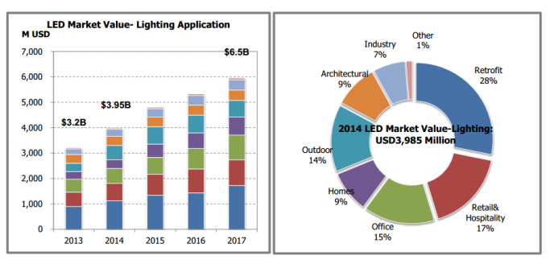
Figure 16: LED market value [37]

As the chart shows, retrofit occupies the biggest part of market. In every kind of business everyone wants to be better than competitor, even it means modern lighting. As home usage is only 9% of whole market, then we would rather concentrate to B-to-B market. Our product, Modular LED Lamp, has several advantages comparing to usual light bulb. It changes colours and brightness, fits to universal socket and LED is changeable. We would find it useful to use such product in hotels (rooms, hallways, bathrooms), restaurants, pubs, bars, children's play centres, cinemas, clubs, spas, gyms and swimming pools. These are places, where people want to create nice and cosy atmosphere. Comprehensive study of our target market is described in segmentation paragraph.
Market survey
Furthermore we decided, based on our market-analysis, to create a certain market-survey, to understand the customers` needs and wishes. To be a successful company, it is absolutely necessary to include the customer needs in the product features and services. In addition to that, innovation, transparency and reaction rate are the attributes which compose a successful company. To achieve this attributes we prepared a market-survey, which aims to find out 5 different tasks to create our own LED and separate the market into different market segments. Research was carried out in Estonia, Poland and Germany. Survey was sent to the different companies and was spread in social media. There were 20 respondents. Questions and answers of the market survey are shown in Figure 17-23.
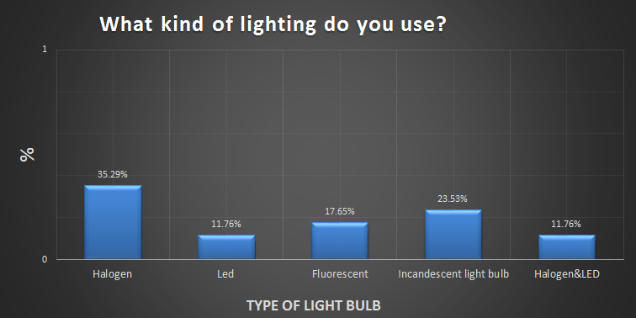Figure 17: Question 1 Market Survey

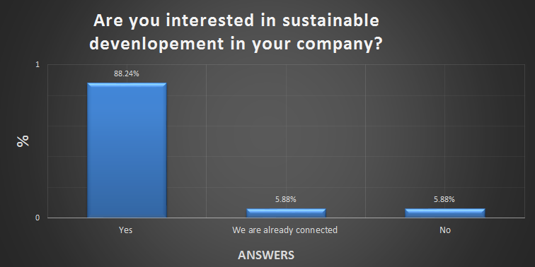Figure 18: Question 2 Market Survey
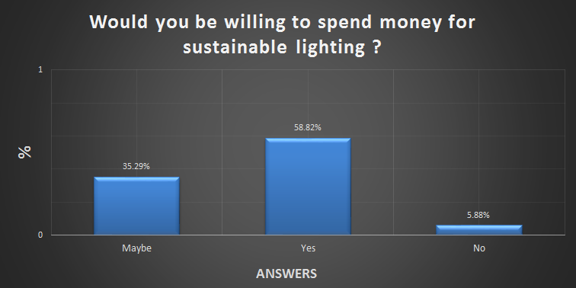Figure 19: Question 3 Market Survey

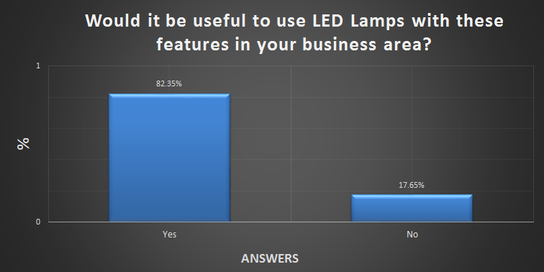Figure 20: Question 4 Market Survey

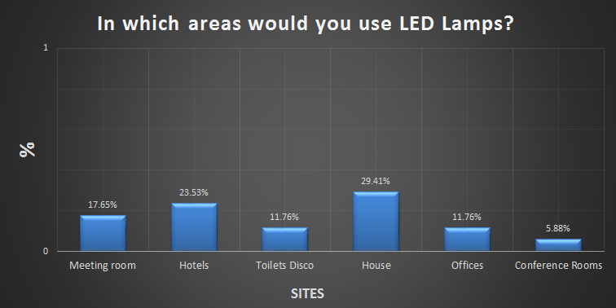Figure 21: Question 4.1 Market Survey

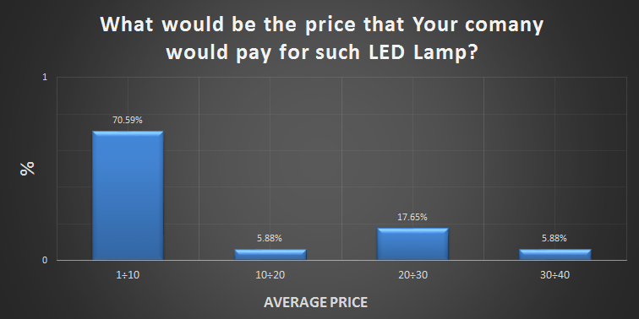Figure 22: Question 5 Market Survey
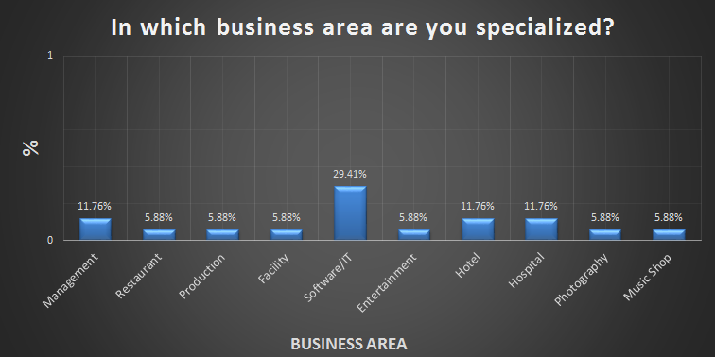Figure 23: Question 6 Market Survey

Out of this market survey it was possible for us to gain certain information and to create our own market image. As a result of the market survey we found out that the LED area is an increasing and unexplored market, because exclusive 12% of our respondent companies are using LED solutions. Many companies are absolutely interested in change the current state to new innovative Led solutions, but they are afraid of spending excessive money. Therefore we decided to create an image with an innovative and not existing design and developed a new feature (brightness control system) and the price will be between 10-15 €.
Competitors
In competitors paragraph there are 7 important LED lighting companies observed, assessed their products and marketing approach, determined their strengths and weaknesses.
1) Lemnis Lighting
Product strategy - Lemnis Lighting rely to LED sustainability and advantages. They are offering indoor, outdoor and greenhouse LED lighting. In addition Lemnis Lighting combines LED technology with solar power for occasions where there is limited access to electricity.
Price strategy - Registered clients can see the prices in their online store, they see last orders and gets newsletters. Registered clients have more opportunities compared to regular clients.
Sales support strategies - They sell products in online store, also they have special websites to Australia and Asia. Lemnis Lighting promotes its products through Facebook. They are also available in biggest Asian sales websites.
Strengths / weaknesses - They have good position in Asian and Australian markets. They have several reputed partners and a lot of media coverage. They have website and online store, all thought it is very difficult to find the place where to register in order to see the prices. Lemnis Lighting has not been updating its Facebook profile since 30.10.2012, so there is only old information.
2) Philips
Product strategy - Philips has many technological products on the market and their approach is to make the world healthier and more sustainable through innovation. In lighting side they are offering indoor and outdoor LED lamps and bulbs for different use. Also they provide car and halogen lighting. In addition to daylight lamps Philips is offering mood lighting and colour therapy lamps.
Price strategy- Registered clients can see the prices in their online store, they see last orders and gets newsletters. They have section with promotions and outlet, where are deals of the month and clearance. Philips have 28 days return guarantee.
Sales support strategies- They sell products in online store. Philips is very active in social media: Facebook, Youtube and Twitter. Posting information there about its projects, posting motivating pictures and organizing awarded competitions.
Strengths / weaknesses- Philips has long history, so there is a loyal clientele and good reputation. They have a website and an online store. It is easy to register; you can even register through your Facebook account. Website has too much information and it is hard to navigate there. They are not represented in the biggest worldwide sales websites.
3) Osram
Product strategy- Osram wants to offer clients modern lighting, energy efficiency and relaxing atmosphere. Osram provides clients mostly indoor and outdoor LED lighting, all thought they have a specialty lighting category, where you can find LED modules and luminaires, also LED vehicle lighting.
Price strategy- There are products on the website, put no prices. Also there are no notes about online store.
Sales support strategies- They are sending newsletters to their customers. Osram is represented in social media: Facebook and Youtube. They are posting their newest information about their products and development. Also in their website you can find many applications for mobile phone and a tool what is suggesting you better lighting than you are using currently.
Strengths / weaknesses- Similar to Philips has Osram long history as well, so there is a loyal clientele and good reputation. They have website, but there is no online store. It is impossible to see the prices of products.
4) Illumitex
Product strategy- By refusing to settle for the losses associated with secondary optics, their breakthrough LED technology incorporates fundamental physics principles to maximize light extraction at the source. Illumitex is offering controlled environment horticultural LED, horticultural LED lights for indoor gardening, industrial LED Lighting and architectural LED lighting. Also they are offering LED components.
Price strategy-There are products on the website, put no prices. Also there is no note about online store. When You want to buy something, You can send them e-mail or choose a nearest shop where to find the product. Illumitex is offering newsletter of their products and good prices.
Sales support strategies- They are offering personal communication and personal offers. Illumitex is very active in Facebook and Youtube, also clients can find their products in several technical e-stores. They have had several media coverage.
Strengths / weaknesses- Illumitex have website, but it don’t have online store. Good approach is to communicate with people personally, but still it would be good to see prices. In their website they have posted clients feedbacks, which is good to read in order to getting know the company. Webpage is simple, everything is easy to find, but there are no notes about partners or biggest clients. Their market is oriented basically to the US. All thought Illumitex is active on Facebook, they have only 113 followers.
5) Sharp
Product strategy- Sharp has two main directions- consumer products, business and industrial products. Consumer products categories: audio-visual, home office, mobile, home appliances, solar, LED lights, plasmacluster. Business and industrial- office and commercial, solar, electronic components, LED lights, plasmacluster. About LED lighting, mostly they are offering indoor lighting.
Price strategy- They have different webpage for online store. You have to be registered to buy products. If you are registered then you have several advantages like easier order tracking, faster checkout, creating and managing your address book, comprehensive view of your order history, it provides a quick access to products saved in your shopping cart. Customers` mobile numbers are required by Sharps delivery partners so they can arrange convenient delivery dates and also send SMS messages with delivery information.
Sales support strategies- Sharp has an online store, also company is active in Facebook and has 64201 followers. Sharp introduces themselves in fairs and expos. Also there is lot media coverage of them.
Strengths / weaknesses- Sharp has loyal clientele, they have been on the market for a long time, so they know what customers` expectations are and how to act on the market. They have webpage for different countries, as well as online store. At first place online store could be difficult to find, so the webpage structure is not good. They are doing publicity in social media and have had lots of followers.
6) Bridgelux
Product strategy- Bridgelux develops high power LED Arrays and Chips in cool, neutral and warm-white lighting solutions. Bridgelux is revolutionizing light with LED solutions for retail, home, office and outdoor installations. Connect with knowledgeable teams that can help you be successful with solid-state lighting.
Price strategy- Bridgelux has a website where they are introducing their products, but there are no prices. There is list of shops all over the world where you can buy their products. No information about personal offers.
Sales support strategies- Bridelux has social media accounts, like Facebook, and they update their page constantly. Sadly, they have only over 500 followers. Company is presenting themselves in several technical websites, magazines and newspapers.
Strengths / weaknesses- Bridelux don’t have online store, difficult to find prices. On website there is no information about partners or biggest clients. They are more oriented to American market than global (still they are presented in Europe and Asia).
7) Toshiba
Product strategy- Toshiba has wide product list. They provide computers, tablets, TV and electronics, hard drive and storage, industrial products. Toshiba illuminates the world through lighting technology that is ready for the way we live and work today. They are offering indoor and outdoor lighting.
Price strategy- Registered clients can see the prices in their online store, they see last orders and gets newsletters. There are special offers for registered clients.
Sales support strategies- They sell products in online store. Toshiba is very active in social media: Facebook, Youtube and Twitter. They have large amount of followers. Company is sending newsletters to their customers. Toshiba is represented in biggest online e-stores, they are participating in fairs and expos. Also press has written about Toshiba a lot.
Strengths / weaknesses- Toshiba has long history, so there is a loyal clients all over the world, also they have good reputation. They have website and online store which is easy to find and orientate. They know how the market acts, what customers are expecting.

There is also chart in Figure 24 of LED Lighting market share:
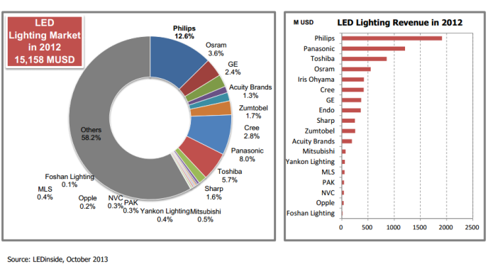
Figure 24: LED lighting market share [37]
LED lighting industry has developed very quickly in past few years, so there are many strong competitors. Observed companies have been in a market for a while, so they have advantages comparing to us. They have studied the market and already gained customers trust. Comparing these companies products to ours, then Philips is offering the most similar product - mood lighting. Still these products are not totally the same, Philips offers mood lighting lamp, but we are developing universal LED light bulb. Modular LED Lamp has also automatic brightness control system which observed lighting companies does not offer. We have new feature which might arouse the curiosity of clients. All previously described companies have webpage, but there was no ideal one. Some of them were too difficult, there were too much information or information was missing, online store wasn’t findable or did not exist at all. We can learn from the mistakes of our competitors and create simple, but informative website with online store. We are young people with different nationalities, so we can find from different countries partners or institutions who are helping start-ups, also we have connections and knowledge our countries markets, which helps us more easily integrate into the market.
3.3 SWOT Analysis
A SWOT analysis includes all underlying information for the two analyses of the Threats / Opportunities analysis (external factors) and the analysis of the Strengths / Weaknesses (internal factors). The aim of the strengths and weaknesses analysis is to identify the services and expertise that you can specifically use to your advantage in the competition. This market advantage can help increase customer relationships and further enhance the market position against the closest competitors. It also gives you an overview in which areas company have weaknesses and how to avoid the resulting dangers. Our strengths and weaknesses are presented in Table 18.
Table 18: SWOT analysis
Strengths |  | Weaknesses
International young company- with different experiences in engineering, international contacts, knowledge of different countries market behaviour, various language skills |  | Do not have loyal customers
(Service) Direct relationship with our costumers |  | No management experience and sales experience
Lower price concerning the competitors with the same features |  | Building up a new image
The LED uses less energy |  | Limited financial methods
(Product) Easy handling and improved recycling |  | Advertising/Publicity
Opportunities |  | Threats
Increasing market |  | Market barriers
Financial support from the government |  | High amount of similar products
Changing market from Lamp bulb to LED bulb |  | Strong competitors
Co-operations

3.4 Strategic Objectives
To make our strategy succeed, we have to define objectives that our organization must achieve.
  - To create well-known brand and get 5% of the market share in Europe by the year 2016.
  - To develop client friendly webpage and support system; to develop remote control application for smartphones by the year 2015.
  - Obtain lower production costs to offer clients cheaper products than rivals.
  - Intensity to company´s effort to develop products that our business clients need and want.
  - Boost firm’s reputation with customers.
  - Become leader in automatic brightness control system introductions.
  - Annual growth in earnings per share of 15%, or better.
  - Achieve net sales growth rate per year of 10%, or better.
3.5 Segmentation
In the marketing analyses chapter we introduced a survey which was carried on in 3 different countries. Among other questions we asked if Modular LED Lamp would be useful in their business area and in which industry respondents acted. Survey showed us, that this kind of light bulb would be useful in many business areas, like catering, entertainment, accommodation, wellness, photography and stores. Figure 25 in page 49 shows variety of segmentation variables.
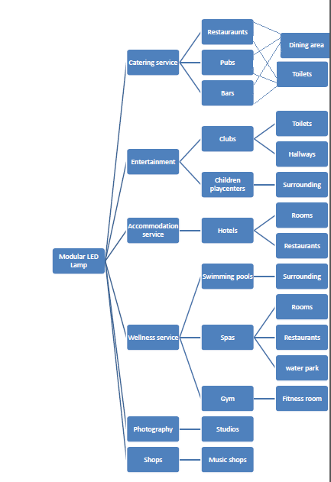
Figure 25: Segmentation

The first variable considered is a business description- Modular LED Lamp, which splits the potential market into catering service, entertainment, accommodation service, wellness service, photography and shops. Then, for each broad group, we brought out special business areas and places where our product would be useful.
Geographic location
Nowadays people don´t use candles for lighting, due to electricity we are able to use different kind of lighting. Fact is that people around the world are using some kind of lighting, so final orientation would be to get into the international market. To achieve this, we are starting from Europe (if our brand has good position in Europe market it is easier to enter to international market).

3.5.1 Segments descriptions
Catering service
Business area- Companies who are offering catering services to people and organizes various events to customers.
Turnover- Firms turnover don´t have to be very high. Our product is targeted from companies with medium turnover to high turnover businesses. Modular LED Lamp is cheaper than other similar products, it is not a luxury item, rather we would like to see it as a simple commodity.
Products/Services- Restaurants, bars and pubs are definitely buying groceries, furniture, lighting, cleaning service and entertainment service. In these days it is necessary to buy advertising service as well, in magazines, newspapers or web.
Decision makers- Usually company board is making decisions and in final decision owner can express his/her opinion as well.
Frequency of purchase- Most expensive things such as furniture and lighting they don´t buy very often. According to the demand they are buying groceries, cleaning service is used every day and average advertising once a month.
Importance of purchase- Purchase importance is high, because clients want to have modern, cosy and clean atmosphere, enjoy good food. Also it is important to advertise themselves in order to get new customers. There is big competition in catering service field, so it is important to be better than competitor.
Media use- Our client uses a lot of media in order to advertise themselves in every possible way. They are using Internet, television and also radio.
Values- Catering services values good quality, positive results, hard work, excellence and team work.
Entertainment
Business area- As we brought out two different entertainment types, then we will describe them separately. Clubs main goal is to entertain grown up people with good music, atmosphere and drinks. Children play centres are providing attractions and funny activities to children.
Turnover- Our product is targeted from companies with medium turnover to high turnover businesses. Modular LED Lamp is cheaper than other similar products, it is not a luxury item, rather we would like to see it as a simple commodity.
Products/Services- Clubs: In clubs very important is lighting system, also they buy furniture, drinks, cleaning service and advertising service. Children play centres: They buy attractions, lighting, furniture, event management service, cleaning service and advertising service.
Decision makers- Usually company board is making decisions and in final decision owner can express his/her opinion as well.
Frequency of purchase- They don´t buy so often, only when needed.
Importance of purchase- It is very important to give best service to customer, so it is relevant that they have all the things they need.
Media use- They are using Internet, various publications, television, radio.
Values- Clubs: They want to provide best service thereby providing best quality products. Children play centres: Positive relationships, learning and development.
Accommodation services
Business area- The main activity is to accommodate people; also they rent out rooms for different events and usually offering catering service too.
Turnover- Usually hotels turnover is medium to high.
Products/Services- Mostly hotels are buying furniture, dishes, technology, lighting, textile, uniforms and so on. They buy cleaning, advertising and designing services. It is very important for hotel to be step forward from competitor, that’s why hotels want to have good quality and something different from others.
Decision makers- Usually company board is making decisions and in final decision owner can express his/her opinion as well.
Frequency of purchase- Purchase frequency is high, because there are many customers in bigger hotels. Dishes, bedclothes and towels needs to be changed into new ones, rooms have to be tidy, lighting bulbs go out, they have to buy food and so on. Also they need to advertise themselves consistently.
Importance of purchase- Without described products and services it wouldn´t be hotel. It is important that client gets everything he/she needs. Every purchase must have high quality, because with one disgruntled client hotels can lose more than one potential client. By advertising they have to make them visible to public.
Media use- Hotels use media largely. In every day work they use Internet. Bigger hotels are full of TVs and speakers; also it is possible to read newspapers and magazines there. Also company board is using definitely Internet, for example read business newspapers
Values- To give personalized, warm and consistently exceptional service, memorable experiences for every guest, teamwork and quality.
Wellness services
Business area- Swimming pools: provides swimming, bathing and sauna services to people; Spas: provides accommodation, swimming, sauna, catering and health services to people; Gyms: provides work out equipment, personal training and group training to people.
Turnover- Wellness services turnover is medium to high.
Products/Services- Swimming pool: furniture, baths, pools, saunas, swimming equipment, lighting, lockers, water, cleaning and advertising service; Spas: furniture, dishes, technology, lighting, textile, uniforms, waterpark equipment and so on. They buy cleaning, advertising and designing services; Gyms: free weights, exercise machines, cardio machines, furniture, lighting, cleaning and advertising service.
Decision makers-Usually company board is making decisions and in final decision owner can express his/her opinion as well.
Frequency of purchase-Gyms and swimming pools buys bigger things once in a year or when needed; for spas purchase frequency is higher, because there are many customers in bigger spas. Everyday items need to be changed into new ones, cleaning service is needed every day, they have to buy food and so on. Also they need to advertise themselves consistently.
Importance of purchase- Like in every industry you have to beat you competitor with better service or product in order to survive. To offer clients good service you have to have best equipment and good quality products.
Media use-They use Internet, television, radio and other paper publications.
Values- Wellness service values good service and quality.
Photography
Business area- Taking pictures of people or environment.
Turnover- Our clients can be small to big business, because studios are not usually very big and don´t need so many lamps - so it is affordable for different size and with different turnover companies.
Products/Services- Buys cameras, furniture, lighting, photo accessories, photo printing equipment, design and advertise service.
Decision makers-Usually company board is making decisions and in final decision owner can express his/her opinion as well.
Frequency of purchase- Buys often smaller things, like photo paper. Larger equipment once a year.
Importance of purchase- In order to have good quality pictures must have good camera and lighting.
Media use- They use Internet, television, radio and other paper publications.
Values-Provide exceptional service and quality, to give best effort to every task, to maintain discipline and make sacrifices in order to achieve personal and business goals.
Shops
Business area- Music shops are selling musical instruments, CDs and vinyls.
Turnover- Small company to big business, cause music stores are not usually very big and don´t need so many lamps - so it is affordable for different size and with different turnover companies.
Products/Services- Buys musical instruments, CDs, vinyls, lighting, advertising service.
Decision makers- Usually owner is making decisions.
Frequency of purchase- They don´t buy very often, depends on customer needs and demand.
Importance of purchase- It is important to provide customer newest and good quality products.
Media use-They use Internet, television, radio and other paper publications.
Values- To provide high quality products and good service.
We are oriented Business to Business segments. We are considering described industries as a target market. In the next chapter we will define our position among competitors and give some explanations about our strategies.
3.6 Strategy/Positioning
Positioning or product positioning is an important aspect of a marketing strategy, particularly when the company acts in a highly competitive market, as our company does. Positioning includes the act of designing the company’s product and image to differ the offer from other similar competitive offerings in this market segment. To differ your product from the main competitive products there are the following major positioning categories which are useful to be silhouetted against your competitor. For example, positioning by attribute (product feature), positioning by user, positioning vs competition or positioning by quality or price. Therefore we based our positioning on a certain market research and market survey. As result of the market research, we received the awareness that our market includes many and strong competitors. Our strongest competitors in this market segment will be Philips. Philips hold 12.8%, Panasonic 8% and Toshiba 5.7% market share in this market segment. Furthermore we attained the information out of our market survey, that the most successful positioning will be to differentiate our product in this market segment with a positioning by attributes and positioning by price. Due to the request of many companies they are willing to change their current state, but exclusively in a certain price categories 10 to 20 €. Conclusion of our positioning can be seen in Figure 26.
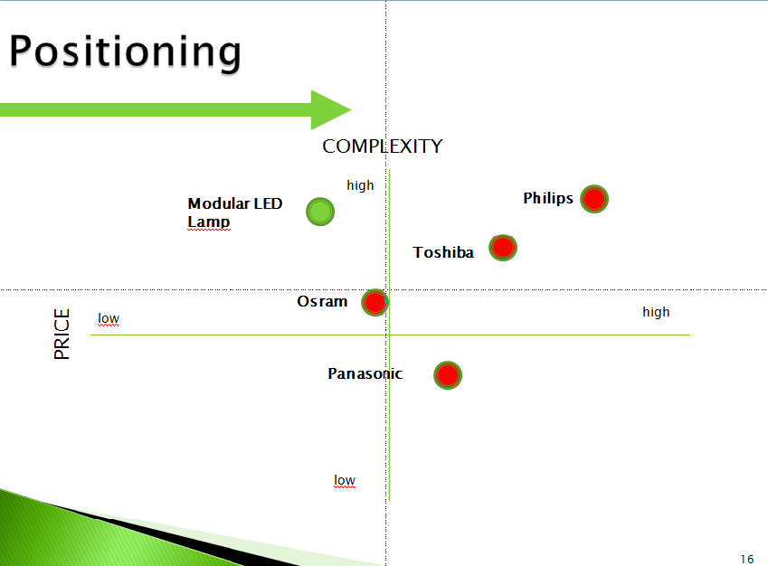
Figure 26: Positioning

This graphic show you the positioning by attributes and prices. As you can see out of this graphic, we are able to compete against Philips relative to the complexity of a product. Furthermore we developed special components, which allowed us to decrease the price dramatically. Through this development we were able to place the product in a successful position to start our business. In addition to that, we decided to reinforce the current state to develop a completely new design of a LED Lamp. The outcome of this is to overcome the market barriers and create a recognizable image and product. Thereby we do not have to compete against other similar products and to convince the consumer behaviour. We are able to establish a new advertisement strategy, which stays not in comparison with existing advertisement. The resultant of this is to obtain an advantage against our competitors and to development a successful customer relationship, which will be consolidating trough customer relationship marketing.
Blue-Ocean-Concept
Another opportunity to stand out in the daily competition is the “Blue Ocean Concept”. This model describes a totally new and attractive market, where the company has low or no competitors. In this market it is possible to gain quickly new customers and through the isolation of value and use are highly profits achievable. The customer is not able to attach the use a monetary value, therefore the company is free in the configuration of price and offer.
The company’s focus in the “Blue Ocean Concept” is on cost and quality orientation, to hold the customer in the market segment and to assemble their own market barriers. Furthermore to keep the focus on the definition of new industries to further use innovation and increase in profit.
To enter this market, the management of a company needs to improve their usual decision-making process, because only through the conscious departure and break of standard strategies it is possible to create innovative and from competitors different solution concerning price and quality of a product. This can be realized, by the company deliberately departure from the industry-specific competitive factors or to define completely new factors. Through the development and the adaptation of the competitive relevant factors it is possible to gain sustainable profits and to implement a successful “Blue Ocean Concept” in the market.
For the implementation of our product it could be possible to realize a higher quality image, in combination with more features as existing products. Furthermore we could offer service-contracts, by the assistance given by our customer relationship team. Therefore it would be possible to stand out with a higher quality as our competitors, shows a directly working customer relationship service and it allows to sell service quantities as well, which offer as a new source of income.
  - Adapted Marketing-Mix

3.7.1 Product
Our company will offer two different types of LED lamps to the market. The LED lamps will only differ by their design. This aims to achieve the largest possible target group and it is a benefit for the company. In order to differentiate from the market, we have installed various features into the LED lamp.
LED lamp includes the following features:
- Fits to universal lamp socket (E27);
- Change colours with remote control (radius 10 m);
- Easy construction to change the LED;
- Include an automatic brightness control system (maximum radius 4 m)
- Fix and flexible design which can be change by customization
As we mentioned before, two different kinds of LED lamps are offered, pictures of them are shown in the following. Figure 27 represents fancy design to fit different surroundings and Figure 28 is more common LED bulb design.


Figure 27: Fancy design

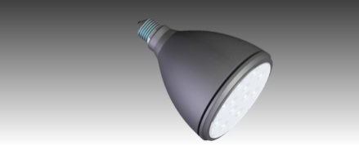
Figure 28: Common design

The aim of these LED is to win the customer attention with an innovative design and not existing features on the market. The customer will be able to dim the light, change the colour and design LED bulb for his own needs. We are using a special material which allows the customer to change the LED appearance to fit it into their environment. For instance in a restaurant it is possible to dim the light when the customer is sitting on the table, could fit the colour into the atmosphere, change the bulb design suitable to the environment of the restaurant and to raise the light intensity when the customer is leaving the place. In addition to that we are offering a special repair service if anything is damaged or the entire LED system is not working and the customer is not able to change it.
Regarding that we are a new company which is unfortunately not equipped with high amount of customers, we need to keep the focus on a direct and individual service. In comparison with other bigger companies we are not going to use call centre and the customers will be able to contact us directly. Thereby we can react on the customer’s needs and problems instantly. Concerning to achieve a satisfied and successful relationship, efficient way is to create a long-term client relationship and overcome the first barrier of a costumer.
In additional to that we are developing an innovative brand, so new brand strategy will be used. It includes creating a logo and a slogan. The slogan will be “LED leads you in a green Future”. In Figure 29 there is a sketch of our company logo.

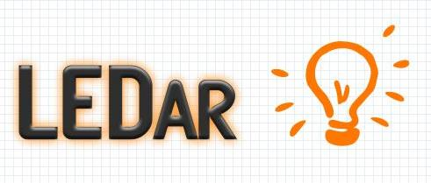
Figure 29: Logo

To create a new and innovative logo, the name “leader” was thought about. Every company wants to be the best in his market and every customer wants to buy the best product.
Concerning our packaging we will use a standard case. As mentioned before, we are specialized for the B2B market and in this area we have to keep our focus on other parts of the marketing.
To follow the EU terms of labelling, we will indicate for the packaging the relevant topics. For instance: fire, temperature and recycling. During the transportation is no need for a special packaging, the weight will be low enough and the LED bulbs will fit perfectly in the packaging form.

3.7.2 Price
At our current stand it is hardly possible to define a concrete product price. To take care of defining a reasonable price and the most successful penetration point, it is rather necessary to include every part of materials and specify the product profit. Unfortunately we are still planning the material list and haven’t got special calculation to give an overview about our fix and possible costs of our product. To keep in mind that we would like to earn as much as possible of market share in the first years and overcome the strong market barriers easily, we are going to use an adjusted penetration strategy. Thereby we are able to link our brand into the customers’ minds and initiate an efficient relationship with our customers.
To satisfy the customer needs and desires as well as our expectation of the profit, we are going to offer of a special pricing strategy. As mentioned before, our goal is to enter the market with lower price in comparison to our competitors to penetrate the market. The most important risk, which is important to care about, is that it will be affect the company’s profit if the entering price is too low. The breakeven point of our company will be probably reached in the first years. Company will be losing customers and market shares, if the price will rise too high. To be as successful as possible, special offers during the first year are presented in Table 19.
Table 19: Special offer
Euro | Discount | Time
20€ | 30% | 31.12.2014

Out of that possibility it will allow to penetrate the market with a special higher price and still satisfy the customer needs. After one year of earning a lot of experiences and increasing the market share, we are able to change the pricing strategy. For instance highlighting the quality and the customer satisfaction with our products and increase the price to 20€ or more.
After the first year the discounts may reduce to a minimal level, we are going to offer our next price strategy. Regarding to our satisfied customer and the quality of the product, it is scheduled to offer the customers a discount depending on the amount of the LED’s (all these prices are assumptions and need to be approved in the near future). Table 20 shows idea of discount system.
Table 20: Discount
Amount | Discount | Unit costs | Total EUR
50 | 10% | 20€ | 900€
100 | 20% | 20€ | 1600€

The aim of this strategy is to increase the sales numbers and the market share. Furthermore, we would like to achieve contracts with useful customers for instance hotels or restaurant, to attach those customers on the company. As a result of it the relationship will consolidate and allow us to increase the price in the next years again.

3.7.3 Promotion
Promotion goal is to guide customer behaviour, influence potential customer's decision to purchase or attracting existing customer to make a new purchase and increase sales that way. Promotion consists of five promotional mix or promotional plan. These elements are personal selling, advertising, sales promotion, direct marketing, and publicity.

Advertising includes print ads, radio, television, billboard, direct mail, brochures and catalogues, in-store displays, posters, web pages and banner ads.

As we are new company it is important to make ourselves visible, so we should use as many effective advertising channels as possible in order to make a mark of our brand. In advertising we have to consider business to business market. Print ads, brochures and product catalogues, which contain information about products, special offers and contacts, are made and posted to the target market companies. Of course we would use direct mail. Direct mail is sent to customers based on criteria such as location, business area, buying pattern, turnover, etc. Segmentation chapter describes our customer criteria well. Direct mail includes advertising circulars, catalogues, special offer and contacts. Nowadays it is important to be online that everyone from everywhere could reach you. We are making web page with online store, it has professional appearance and it is easy to follow. There are available English, Portuguese, German and Polish languages. To make a web page we are using free online software like Wix. As people use much Google search then it is necessary to use Google Adwords to be top of the search results to guide potential customers to our web site. Also it is important to buy advertisement space on other websites, for example popular science web pages, lighting solution forums and business newspapers. At first we are not able to use such advertising much, only cheaper web pages, but later when we have more financial resources we would definitely buy banners and ads to more popular and expensive web sites.

Television is also used in the future advertisement plan. As television time is very expensive then at the beginning this option is not available for us, but when gaining more profits and turnover it is possible to buy time in television in order to advertise ourselves. At first we have to buy cheaper television time, but when our company grows it is possible to buy more expensive television time in middle of the popular shows in the evening. Future plans include LED lamp advertising in radio as well, right now we have very limited budget and we cannot afford everything. Every Europe country has different popular radio channels, so these channels will be used. Big posters of LED lamp are going to set up to the bus stations, stands and billboards.

We are using personal selling, because it has more advantages comparing to other promotional methods. Every personal sale allows paying individual attention to customer and forwarding immediately, as necessary, the significant and diverse information. It means it is possible to sell more flexible: agree on a price, make product improvements, to adjust the conditions of service, etc. Also efficiency of personal sales is bigger, because target audience is contacted directly. We would prepare sales presentations and make sales meetings. Also it is important to make trainings for sales people. We are using both- face to face selling and via telephone. At first we are going to contact personally biggest catering, accommodation, entertainment, wellness, photography and music service providers. In Estonia for example Vapiano catering, Viru hotel, Radison SAS hotel, Viimsi Spa, Laulasmaa Spa, Sushi Silk and etc. Later we are going to expand sales to smaller companies as well.

We would like that customer can reach directly with us, with mobile phone, e-mail, web site, Skype. Our web site has direct link to contact as well.
Furthermore, if we have succeeded to gather some loyal customers we would expand. For the newer buildings and starting target market companies we would use intermediaries such as intelligent houses companies and interior designers.
Media and non-media marketing communication are employed for a pre-determined, limited time to increase consumer demand, stimulate market demand or improve product availability. Social media has big power in these days, so we would use advantages of social media to promote LED lamp. Organizing competitions in Facebook and Twitter where prizes would be our own products. We would provide special offers to loyal clients when there are different events or large orders. In different lighting and electronic fairs and expos we would demonstrate our product and definitely increase amount of potential clients. As exhibition stands are too expensive for us at this stage then we would just join the event and hand out flyers and brochures. For example fair in Stockholm, Sweden called Northern Light Fair which is going to take place from 03 February to 07 February 2015.
Also we are planning to give out some free samples for major target market companies for some advertisement. We provide free samples and companies are informing customers about lighting company. Rebates are also made, for example after Christmas.

We are fresh entrepreneurs and customer is not familiar with brand, label and product. So it is important to do publicity through different channels. Press releases are very important to starting company, because it is more reliable than commercials and it creates positive emotions to business customers. As we are multicultural team it is good to publish press release in different countries (Estonia, Germany, Spain, Hungary, Poland) to gain more recognition. Young entrepreneurs are mostly supported and inspired to work. We could make cooperation with different media publications to publicity our activities. Also we are going to organize low-cost seminars about LED and mood lighting in order to raise people knowledge.

3.7.4 Place
At the beginning of planning distribution system we are considering direct marketing. Nowadays it is necessary to be available in Internet. If company is not available in the Internet then it is like the company doesn’t exist. As we are starting firm and want to be reached to everyone from different countries then we are selling our items in online store. We have web page which contains information about product, contacts, possibilities and online store. Web page is professional and easy to follow. Interested potential customers can find relevant information about company and products. We are making contacting us very easy by adding fixed contact button on every page which leads client directly to the contact form. We are findable in social media as well, we are using Facebook to guidance people to our web site and online store. Also we are taking part of electrical and lighting fairs in Europe. For example fairs called Strategies in Light or Light+Building in Germany, Northern Light Fair in Stockholm and Euroluce in Italy. Products features and innovation will be presented to the public.

When loyal and long-term customers have gained, intermediaries could be involved as well. Making studies and analysing previous direct marketing purchasing statistics it might be useful to do cooperation with intermediaries. Possible options for intermediaries are lighting stores, intelligent house and interior design companies
  - Budget
To reach goals which have set, it is essential to make budget plan for marketing. In order to increase awareness of product and brand 5000 euros are given for the year 2015. As budget is not very big, most important things which help to gain people´s trust and the joy of recognition have to carry out. Also certain actions have to be done for reaching the break-even-point after three years.
Table 21 shows how budget is divided into several actions.

Table 21: Budget plan
 | Website | Fair  (Transport, stands) | Travel  (CRM) | Leaflet | Brochure | Poster | Video | Branding
January | 30.- |  |  | 400.- |  |  |  | 100.-
February |  |  | 200.- |  | 500.- |  |  | 100.-
March |  |  | 200.- |  |  | 500.- | 400.- | 100.-
April |  |  | 200.- |  |  |  |  | 70.-
May |  |  | 200.- |  |  |  |  | 50.-
June |  |  | 200.-
July |  |  | 200.-
August |  |  | 200.-
September |  |  | 200.- | 300.- |  |  |  | 50.-
October |  |  | 200.- |  |  |  |  | 50.-
November |  |  | 200.- |  |  |  |  | 100.-
December |  |  | 200.- |  |  |  |  | 50.-
Total  5000 EUR | 30 EUR | - | 2200 EUR | 700 EUR | 500 EUR | 500 EUR | 400 EUR | 670 EUR

In January web page will be published. As we use free online website creator it is not necessary to buy website creating service, we only have to pay 30 euros per year for domain. Also we are printing leaflets for company introduction. Second edition of leaflets is coming in autumn, when daylight decreases. For supporting leaflets, in next months’ brochures and posters are also released.
Our business strategy is personal approach, therefore it is necessary to create budget plan where are shown traveling costs for every month. In order to create trustful and reliable business it is important to have good customer relationship.
Video about Modular LED lamp is also in plan. Video will give more illustrative overview of our product, at first it goes to the web page, Youtube and Facebook.
Every month, except in summer (people don’t use much lighting in summer cause then we have longer period of daylight) branding actions are carried out. We definitely use Google Adwords to reach people.

As television, radio, public screens would be used in next years, as well as fair stands and web adverts, marketing budget must increase in time.
  - Strategy Control
In previous chapters different strategic objectives were set. To make sure that company´s actions are moving towards the goal, it is vital to get feedback and make statistics of previous period.
Objectives which were set considering this project are presented in chapter 4 called Strategic objectives.
Market share increase, sales per year or month, return on investment, profit and so on should be controlled and assessed in every month, year or in fixed period. If data and set goals are matching then developed strategy is effective, if not strategy plans and actions can be adjusted. For making sure that firm is moving in right directions it is possible to use different tools, for example Google AdWords to get feedback of interested people, sales figures and customers feedback. As we would like to have good customer relationship it is important to get feedback from our clients where they assess product quality, appearance and service. Clients’ opinion is very important in order to make improvements and developing our product and service.
  - Conclusion
Ledar is lighting company which is created by international students. Our mission is to be the main choice for customers who are looking for functional and innovative solutions in lighting area. The marketing plan is written in 2014 considering the current global economic condition and the nature of society.
As mentioned, our goal is to produce lighting products, especially LED lamps. Advantages of other LED lamps are functions like fitting to universal socket, it is possible to change the LED, it is changing colours with remote control and also lamp has automatic brightness control system.
We are focused to business to business target market, main idea in marketing is using direct communication and close relations with customer that client would get the best personalized offer, also fast and smooth connection with us.

In marketing we are mostly using PR and articles (different public releases, press notice, direct mail) also Internet advertising (web page, Google AdWords, banners).

When examining the competitors’ price strategy, we are offering high-quality and innovative design with less money.

Implementing a marketing plan, our goal is to create well-known brand and get 5% of the market share in Europe by the year 2016. We would like to offer client satisfaction, good quality and innovation thereby providing the best service.

4. Eco-efficiency Measures for Sustainability
4.1 Introduction
Sustainability in business represents flexibility over time. These businesses who are connected to healthy economic, social and environmental systems can survive crises. These kind of businesses create economic value and support healthy ecosystems and strong communities. For the businesses, sustainability is not only mere window-dressing. By using sustainable practices, companies can gain a competitive advantage, increase their market share and shareholder value.
To be sustainable in business, companies needs to follow the principles of sustainable development. According to the World Council for Economic Development (WCED), sustainable development is development that meets the needs of the present without compromising the ability of future generations to meet their own needs. Furthermore, over the years “going green“ and “green thinking“ has become less of an option and more of a necessity. Demand for “green“ products increase all the time, so this demand has created major new markets. According to that it is very important to add sustainable activities into manufacturing.
For industrial development to be sustainable, it must address important issues at the macro level, such as: economic efficiency (innovation, prosperity, productivity), social equity (poverty, community, health and wellness, human rights) and environmental accountability (climate change, land use, biodiversity) [38]; [39].
4.2 Environmental
There is one earth, where are limited resources. Every kind of manufacturing activity or some product usage has influence to the environment. Of course it is impossible to produce something with no impact to the environment, but using sustainability principles it is possible to be less harmful. This paragraph is discussing ways of making LED light bulb mass production more sustainable.

4.2.1 Materials
First of all, every product is made of something, so it is necessary to have some materials in our production. As we are producing LED lamps it is not necessary to create components ourselves, we will use suppliers and only assembly pieces. In order to be more environment friendly we would use suppliers who are providing recycled materials. It is wrong to think that recycling has no effect on the environment; there is a carbon cost to recycling although it is less than manufacturing a new item. If our company is carbon neutral we are offsetting the amount of carbon dioxide what we produce by providing a positive impact on the environment. All thought is not possible that all Modular LED Lamp materials are recycled. In LED Lamp there is a lot of miniature technology which is not recyclable, vice versa they are hazardous. Still some parts of LED Lamps are recyclable, like glass, aluminium, circuit boards and plastics. In our production it is possible to use recycled aluminium for the socket, plastic for the bulb and circuit boards for the technical design. Packaging and manuals are produced of recycled cardboard and paper.
This project requires using hazardous materials, when choosing a suppliers and components we definitely pay attention to RoHS symbols and prefer components with this labelling. Any RoHS compliant component is tested for the presence of Lead (Pb), Cadmium (Cd), Mercury (Hg), Hexavalent chromium (Hex-Cr), Polybrominated biphenyls (PBB), and Polybrominated diphenyl ethers (PBDE). For Cadmium and Hexavalent chromium, there must be less than 0.01% of the substance by weight at raw homogeneous materials level. For Lead, PBB, and PBDE, there must be no more than 0.1% of the material, when calculated by weight at raw homogeneous materials. Any RoHS compliant component must have 100 ppm or less of mercury and the mercury must not have been intentionally added to the component [40].
When buying materials it is important to buy in bulk, because of the transportation energy. Components will be stored in warehouse. Also our goal is to give jobs to local people, so it is important to buy local (if possible), positive side is also lower energy costs.

4.2.2 Processes
As mentioned in previous paragraph new components are not created. Components are bought from suppliers and assembled together. According to that we will have different assembly lines, machines that automatically are putting together PCB boards and packaging line. We have both automatic and men power lines. Also quality inspection line to make sure that our product has promised quality. As we are not producing components for ourselves water use will be minimal in our production processes. In production we would try to cause as less waste as possible, still it is normal to generate some waste. If possible generated waists are used in production again or they are recycled.

4.2.3 Technology
In order to have more efficient production there is great importance to use new technology, usually newer technologies are more energy and work efficient, so it is possible to save money, time and environmental resources. It is vital to develop production, but also it is important to follow responsible and eco-friendly behaviour in company´s every day actions. Our company changes office equipment in every 2 years. Machinery exchange depends of available technology and how reasonable the change would be.

4.2.4 Transportation
To reduce the footprint of our product we will use ecologically friendly transportation. Where it is possible we are using electrical trains, but hybrid trucks are also used. As we buy components in bulk we also sell them mostly in bulk to save energy and money.

When mass producing Modular LED Lamp these points have to be considered to be more sustainable and eco-friendly.

4.2.5 Energy
Our production is taking place in southern Spain, where are good conditions to use solar power. There are more and more researches to improve solar energy nowadays, to make it more efficient and affordable. Solar panels are expensive to build, but it has many advantages. Solar energy does not cause pollution. It is possible to create energy without producing global warming pollution. However, solar collectors and other associated equipment / machines are manufactured in factories that in turn cause some pollution. Also solar power provides energy independence, lasts forever and creates jobs.
4.3 Economical
"Economic growth can and should occur without damaging the social fabric of a community or harming the environment"
US President’s Council on Sustainable Development [42]

Economic sustainability forces to look on the internal and external implications of sustainability management in order to make it possible to use available resources to their best advantage. Managing economic sustainability following subjects has to consider.
The most common indicators in economic area are Productivity and Business efficiency measures.

4.3.1 The financial performance of a company
In our actions we will consider customers and stakeholders expectations, also ensure that our activities won´t harm society and we move towards society well-being. We would like to be company who is sustainable and financially strong. In order to improve environmental and social sustainability in our company we have to have sufficient financial resources.

4.3.2 Intangible assets
We want that our label and brand give customers safe feeling, feeling that they can trust us. Our brand presents eco-friendly and high quality products.
Our company values intangible resources like employees’ qualification, technical knowledge and designing new systems. We will organize regularly trainings to the employees that they would have relevant knowledge of their subjects. Also we will educate ourselves to keep up technical updates and therefore make corrections in our systems.

4.3.3 Influence on the wider economy
Our goal is to stimulate the economy by offering competition to existing companies, buying from suppliers and giving jobs to the local people. We try to spread sustainable way of thinking and acting in our everyday actions.
4.4 Social

4.4.1 Definition
“The ability of a community to develop processes and structures which not only meet the needs of its current members but also support the ability of future generations to maintain a healthy community [41].”
Social sustainability means that work within a society and the related institutional arrangements:
- satisfy an extended set of human needs
- are shaped in a way that nature and its reproductive capabilities are preserved over a long period of time and the normative claims of social justice, human dignity and participation are fulfilled [42].
Nowadays, the social sustainability is important way of management which takes care of meeting the expectations of customers and employees, maintaining quality relationships with their partners and local communities. Thanks to such approach, it is possible to add the value to whole supply chain by increasing the productivity indexes, company reputation, minimising production cost and, by the way, reducing harmful impact on the environment.

4.4.2 Supporting the society
As a social responsible company, it is important that indigenous dwellers should be the main workforce in the manufacturing system. When we stimulate local community and cooperate with local suppliers, we raise the quality throughout the entire value chain. We can gain the favour of the municipality governing body, press corps and people associated with science. The company can participate in a number of social activities, such as sponsoring the cultural and sport events, supporting animal shelters or planting trees in the residential area.
Lighting has a positive effect on greater sense of safety and aesthetic of the public spaces while lower environmental impact.
The LED lamp manufacturer can fit into these ideas, for example, by providing lighting for one of pets from a town zoo, fund the equipment for university electrical laboratory or rent the stage lamps to organiser of a charity concert. Thanks to that, we can increase the Level of Contribution to Charities.
We can measure event and cultural activity of the company comparing Activity Days per year or using the Number of Community Consultations indicator.

4.4.3 Care about surrounding
Big factories generate a lot of wastes and unpleasantness. The main goal is to reduce the nuisance to the populace which comes from the industrial plant (pollution of the environment in which they live, no unpleasant odours in the atmosphere, access to clean and drinkable water, dense smoke around the city, disturbing the peace by industrial noises). Workers would like to take a rest in calm after spending many hours in factory, so that is very important to take care about their living conditions.
The best solutions are minimising the impacts of production for environment by using the non-toxic materials and depuration of the air outgoing from factory.

4.4.4 Well-being of customers
The advantage of using Modular LED lamp is the ability to create a specific atmosphere, for instance, for romantic evening together. This is a power of mood lighting which can be used for guests of hotels or restaurants. Additionally, it is performed with minimal power consumption and enhanced efficiency.
Demanding customers can gain improved conditions for learning, reading books. First of all, the visibility increases.
We are going to do research of the Customer Satisfaction via surveys or just by tracking feedbacks and complaints.

4.4.5 Employees healthcare and working conditions
The most important issue for every industrial plant is to care about health of workers. Companies should improve quality of working conditions continuously. They should design ergonomic workstations, provide their employees with Occupational Health and Safety training and perform health safety programmes.
If inside the plant, there are working many noisy appliances, the personnel should have work wear, earmuffs or earplugs.
Industrial hygiene is very important problem to be considered by the plant owner. It affects the well-being, health and productivity of the employed staff. In the future, it can prevent the occupational illnesses.
Workplace training should be performed to show proper way of using the machines and to prevent the potential accidents. Production engineers can implement some best practises from manufacturing experts, such as poka-yoke (mistake-proofing) or redesigning the workplace in order to be more efficient and much safer.
Respect for people is crucial matter, because everyone wants to be treated fairly. Companies should have implemented the protection of workers' rights policy.
Employees are counting on the job security and fringe benefits, for example, severance package, trainings, holidays or shares in a company.
They want to have the guarantee of their job with long-term fair agreements with legally regulated working hours.

We want to improve the Frequency of Meetings with Employee Representatives, and that is why we will register the information about every meeting with staff leaders.
The company would like to decrease the Injury Frequency Rate, which shows how often accidents are happening inside the plant.

4.4.6 Consistent improvement of skills
Factories have to provide their workers with trainings to keep improvement of professional qualifications. Japanese philosophy called kaizen (continuous improvement) enables to educate the leaders who thoroughly understand the work, live the general concept of business and are be able to teach others. LED lamp production requires employees who are well prepared for the job. For management crew there are required engineering and electrical knowledge.
The company is able to succeed when her crew is well motivated for better work and enabled to further professional development. They have to derive satisfaction from their work.
It will be regularly performed the on-line self-assessment survey to check the loyalty level of workers, group’s performance and career progress of employees. We will collect the information about amount of promotions for managers.

4.4.7 Equality in diversity
Main issues of equality:
- provide diverse work environment,
- equal opportunities, fair treatment without regard to race, beliefs and other prejudices
- better representation of women in leadership roles
- recruitment of trainees, students, people with disabilities
- various suppliers
We use 2 indicators that will show in percentage women and minorities contribution within number of people employed in total.
For instance: Employed women * 100% / Total employment.
That is also important to collect the figures that are comparing the wages and salaries gained by each gender.

4.4.8 Corporate culture
Companies should put on:
- consent to third-party audits, certification
- transparency, publication of the reports presenting dangers that occurred; not hiding inconvenient data
- maintenance of standards, implementation of ISO policies (e.g. ISO 9004 for management systems, ISO 14001 for environmental issues)
- open dialogue with employees
- human rights respect, especially when it is used the labour force from Asian countries (LED supply chain often reaches to this region)
- offering well paid, decent work
4.5 Life Cycle Analysis
The world needs meaningful innovations to respond to today’s dramatic global changes. Almost one-fifth of global electricity consumption is used for lighting [43]. Light-emitting diode products for general lightning have the potential to save energy and improve lighting quality and performance in comparison to many conventional lighting technologies, for examples in comparison to existing halogen lightning solution. In order to accurately gauge the full energy and environmental impacts of any lighting product, its materials and energy resources must be evaluated over its entire life-cycle.
As a result of the marketing research we earned the information that the Led market will increase in the next few years significantly. The existing products will stop being supported through the governments. Therefore we can prognosticate that the production and sales will increase in the following years.

The Figure 30 illustrates and shows a possible way of a life cycle assessment:
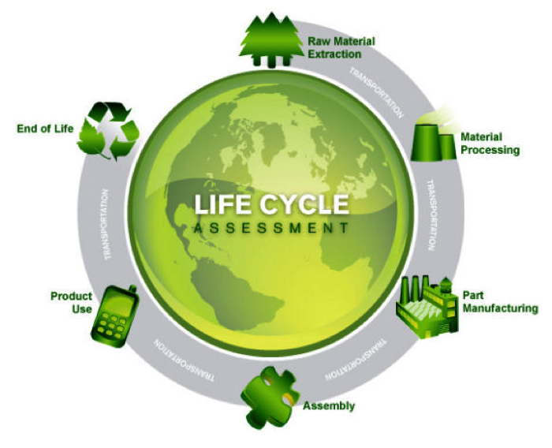
Figure 30: Life cycle assessment [46]

4.5.1 Material Processing, part manufacturing and assembly
To establish a successful and efficient way of a life cycle assessment, you have to find a solution to keep the economic prosperity, environmental protection and social equity into balance. As mentioned in the chapter 4.2.1 and 4.2.2 the value added chain will kept on a minimum level. The components will be bought from suppliers and assembled together. The disadvantage of a less value added chain is the hardly influence on the delivered materials, for that reason to be more environment-friendly we will use suppliers who are providing recycled materials.
Furthermore we try to use local suppliers for our materials to keep the logistic impact and the transportation distance as low as possible. To be as ecological as possible we will order the materials in bulk try to use eco-friendly transportation and to sell the product in bulks again, as you can see in the chapter 4.2.4.
Through the low value added chain is it possible to reduce the wastage of water on a minimum level. In addition to that we try to use recyclable materials or reusable materials, which allow us to keep the cause of waste as low as possible.

4.5.2 Product use
We will offer the customer two different kinds of the LED, one which is based on existing products on the market and the other one with an innovative and new design. Both models include an easy construction to replace the LED. In comparison to existing halogen lamps, the customer does not need to buy a new lamp, through our solution the customer can change the LED and use the lamp father.
Furthermore the lamp includes an automatic brightness control system, thereby the customer is able to reduce the intensity about 10%, to create a warmer atmosphere and save energy. As a result out of this features we are able to reduce the impact, save energy and producing less waste.
In addition to that we created a design to separate the socket, PCB and bulb from each other to recycle the components.

4.5.3 End of life
The recycling and disposal of the materials is mentioned in the chapter 4.2.1. In LED Lamp there is a lot of miniature technology which is not recyclable, vice versa they are hazardous. Still some parts of LED Lamps are recyclable, like glass, aluminium, circuit boards and plastics.

- The LED and PCB is recyclable and need to put in the electronic trash
- The socket is out of metal (aluminium)
- In our production it is possible to use recycled aluminium for the socket, plastic for the bulb and circuit boards for the technical design.
- Packaging and manuals are produced of recycled cardboard and paper
4.6 Conclusion
Social responsible company is able to:
- improve the organization, taking care of the development of their own people and partners
- develop outstanding people and teams, which perform general concept of the company
- gain the respect from wide network of partners and suppliers.
Integrity and diverse working conditions pull us together and have a positive effect on energy consumption and general mood.
Thanks to sustainability responsible investments, companies can maximise their profits over long-time period.

5. Ethical and Deontological Concerns
5.1 Introduction
Ethical problems concern many aspects of everyday life. Lighting is one of them.
Lux is an inseparable part of human, animal and Earth co-existing. Our project deals with the artificial lighting, which is very important as well as the natural one. Each of us needs a well-lit working, living and study conditions. As a result, people feel better and achieve more satisfying scores.
We need to focus on all implications of the ethical issues that are related to product development, proper production system, marketing strategy, legal aspects and environmental impacts. These ethical issues are very important and cannot be missed because it is necessary to care about position, reputation and future condition, not only the current profits.
“A reputation for ethical decisions builds trust in business among business associates and suppliers. Strong supplier relationships are critical to a successful business [45].”
Ethics help us to make us better people just because it is based on the philosophical examination of particular issues in private and public life that are matters of moral judgment.
Thanks to that, we can use philosophical methods to identify the morally correct course of action in various fields of human life.
5.2 Engineering Ethics
What is an engineering ethics?
Engineering ethics is study of moral issues and decisions confronting individuals and organizations involved in engineering, also considered as a study of related questions about moral conduct, character, ideals and relationships of peoples and organizations involved in technological development [46].
Ethical behaviour deals with making business decisions based on an established Code of Ethics. Employers should write their own code of ethics which can serve as a framework for supporting decisions to be made by them and employees.
In case of building the LED bulb, we need to be sure that our product will fulfil the demand and the final customer will not feel deceived.
There are few ethical problems that are connected with lighting market and deals with engineering:
- life-duration: limitation of turn-on cycles,
- not obeyed EU directives,
- lack of important technical information in catalogues, leaflets, user manuals,
- respect the principles of intellectual property, patents for inventions and designs.
These issues need to be considered during creating professional code of ethics for our project. There are plenty of universal policies created by worldwide engineering associations which can be easily adapted in multinational environment.
Code of Ethics
We would like to use some rules created by Institute of Electrical and Electronics Engineers (IEEE) that are setting the duties in relation with colleagues, engineering community and also for customer:
- “To accept responsibility in making decisions consistent with the safety, health, and welfare of the public, and to disclose promptly factors that might endanger the public or the environment [47]. ”
Engineers are responsible for their decisions, because they create objects which are used by other people (electronic appliances, other devices). If someone noticed any defect in existing system which could be harmful for environment or society, it should be announced to the public immediately. Never try to withhold such information.
- “To be honest and realistic in stating claims or estimates based on available data [47].”
Transparency is a key aspect of trust. Our client wants to know what he is buying, how does it work and what are the limitations in usage.
This sentence applies also to the relations between employees.
- “To improve the understanding of technology; its appropriate application, and potential consequences [47].”
Employees should share their knowledge with others. The employers should provide the trainings in order to have well-educated staff. That issue can be also connected with providing our clients full technical specification of product. User manual should contain all information relevant to the finished product and instruct, how to proceed in case of malfunction. When the customer understand action of product, he will be able to use it longer without a flaws.
- “To maintain and improve our technical competence and to undertake technological tasks for others only if qualified by training or experience, or after full disclosure of pertinent limitations [47].”
Wrong help can hurt - we can support only if we really know what we are doing. Taking part in extra courses (self-development) or projects is recommended, but it should be done in proper way, in compliance with our health conditions, skills and interests.
- „To treat fairly all persons and to not engage in acts of discrimination based on race, religion, gender, disability, age, national origin, sexual orientation, gender identity, or gender expression [47]. ”
Treat another person the same way that you expect to be treated. As an employer we should provide our staff equal opportunities. We have to provide our employees a fair work and remuneration, as well as safe and healthy working conditions, stimulating the creative attitude, self-discipline and openness towards other people. It should be in force without regard for employee's origin, colour of skin, etc.
- “To avoid injuring others, their property, reputation, or employment by false or malicious action [47].”
This is very important to remember that we are not alone and our improper operation can damage other person. Especially, when we are working in the production line. In many countries companies are obliged to make a training of Occupational Safety and Health and fire prevention regulations. Thanks to that, the employees are aware of the possible threats.
- “To seek, accept, and offer honest criticism of technical work, to acknowledge and correct errors, and to credit properly the contributions of others.”
“To assist colleagues and co-workers in their professional development and to support them in following this code of ethics [47].”
We are aware that various people can have different problems. That is why we should be open-minded, helpful and provide advice if it is needed. What is important, criticism should be accepted with humility. Do not hesitate to correct the mistakes of your co-workers when someone does not perceive it. If we cooperate as a team, we can gain a “synergy effect” and then, a performance will increase significantly.
5.3 Sales and Marketing Ethics
Launching the product into the market has to be preluded by the deeply analyses of opportunities and threats. In the Marketing part of our project we did a research in which we got know the main competitors and we compared existing models of lamps in terms of not making fakes. There were also examined customer needs.
For our customers it is important to get a product which is comply with advertised guarantees. We are the opinion that people deserve an utmost esteem and the companies should provide the good of our community.
In case of light bulb market the common practice of companies is relatively short warranty period for lighting equipment. Guaranteed period is much lower than the assumed life of the bulb.
The problem of this area could be also a market supremacy of big companies (GE, Philips, Osram), which hold all the cards. It can be a barrier for running new business and developments and lead to misconceptions or overuses.
Sellers politics consisting in overstate the lighting parameters or intentional lowering power consumption has become a standard in the majority of retailers who offer their products on the Internet.
Our code of ethics will include these sentences:
- Providing customers with high quality products.
- Developing relationships with clients that go beyond the mere sale of a product and is based on an honest dialogue.
- Respect and appreciation of all stakeholders, taking care of their well-being and possibly for its multiplication, in order to win their trust.
5.4 Academic Ethics
Working in groups requires mutual respect, understanding and trust. As a result, we are able to support ourselves at every step. Each of us is a student coming from different academic background and everyone contributes a part into project.
Academic ethics deals with tribute to existing patents, inventions, designs and developed projects. We cannot infringe the terms of use of external materials which we are basing on.
In each case regarding to this project, we are using the references in educational and non-commercial purposes. What is more, we are using open-source software to avoid computer programs license problem.
As a part of student community we have rights and responsibilities. Sentences below are the examples of a negative behaviour in this community.
Plagiarism is intentionally or unintentionally using someone else’s words or thoughts, without giving proper credit.
- A direct quotation must be acknowledged and documented properly. The sources of information must be outlined in a list of works cited.
- The source of all paraphrased or summarized material must be acknowledged.
- The work of others, whether in the form of ideas, laboratory results, artistic work, computer programs, etc., must be acknowledged.
- False or misleading citations of sources constitute plagiarism.
- Cheating is attempting to present as one’s own, work that one has not performed, or using improper means to pass an examination.
- Falsification of research data
Student may not submit work she has not done herself, including papers, projects, homework assignments, computer programs [48].
5.5 Environmental Ethics
Nowadays, many people think in category “here and now”. It is not proper behaviour for condition of environment and for all the society.
We cannot forget that we are not the only people on this globe. Next generations also would like to live here in calm and benefit from all the goods of our planet.
Eco-friendly and sustainable development are the popular issues that are related to climate changes and global warming. Hence, there might begin an ethical problem, when the companies will abuse operating empty slogans, applied to environment, without coverage in reality, figures, results (double talks), etc.
Modern factories should have minimized CO2 emission, for example by using filters on chimneys. There are plenty of harmful materials using in lighting sector, like mercury, which should be reduced in material list. Company can introduce Environmental Stewardship schemes in order to act in responsible way for community and green fields.
It is a long term investment which will bring yields in the future.
“Environmental stewardship is the responsibility for environmental quality shared by all those whose actions affect the environment [49].”
Policies for producing the light bulbs:
- We are not using harmful materials.
- We take care of recycling policy.
- We are going to act with due diligence to the recycling policy. Final product boxes will be designed from recyclable cardboard which is friendly to environment.
5.6 Liability
LED lamp, like most of electrical devices, may be harmful for health condition of final user. In the leaflets we will publish detailed information about the proper use of the appliance in order to not cause any damage.
We cannot stretch the health requirements. We have to be responsible for our workers assembling the lamps. We need to produce in comply with European Union restrictions and other international standards.
Energy labels
The European Union (EU) Energy Label rates products from A to G in terms of energy consumption, with A being the most efficient and G being the least efficient.
By law the label must be shown on all light bulbs [50].
CE mark
It is also obligatory to mark all the LED bulbs with a Conformité Européenne sign.
The CE marking indicates a product’s compliance with EU legislation and so enables the free movement of products within the European market [51]. Unethical aspect in lighting market is counterfeiting of European Union CE mark by China Exporters.

5.7 Intellectual property
The most important ethical issue is that competitors should respect trademarks of other companies and don't manufacture false products. Important matter is to avoid the unfair competition.
We have made every effort to respect the registered brands. We had to create our own trademark which will distinguish us and will be associated with a brand. Our logo is not a copy nor refers to the appearance of the existing one and it does not include wrong symbols or emblems (religious, government or organisations’ signs).
The logo is shown on Figure 29, page 60.
Moreover, the “Ledar” name is not forbidden in lighting production sector and it does not include an offensive phrases. Both, the name and trademark, are acceptable to be used on the market.
Whenever we are using someone else’s intellectual property, we always make a source footnotes. The same applies to borrowings used in the bibliography, like graphics, surveys, studies and analyses. All the existing patents used in project are listed in the end of report. We need to register an innovative design of modular LED lamp as soon as it is possible in order to protect our intellectual property. It is possible thanks to activity of institutions like Portuguese Institute of Industrial Property (INPI) which takes care of market fair competition. Next stage is to check the trademark in each country that we sell our product, in domestic patent office institutions.
5.8 Conclusion
Applying ethics policy benefits to many companies because they are better perceived either by people beyond the company (customers, contractors) and the employed staff who will feel worthily. Pleased and well-motivated employee is the one who is treated humanely, not exploited, receives remuneration at time and sees growth opportunities ahead. If a firm wants to take care of the welfare (profits, further investments), it is needed to put on trust, honesty (transparency) and respect the privacy of individuals.
Many companies use rules of proceeding in the relationships between employees and that is why they have numerous Labour Codes regulating approach to people. Principles make it easier to communicate among ourselves and achieve our goals, without disturbing to other people. This establishes an order in interpersonal life. In addition, when manners are standardized, it is simpler to obey them. Therefore, we all claim that ethics is necessary in human life and is very effective investment.
Company's goal should focus on achieving financial success at demonstrating concern for natural environment and sense of responsibility for society.
When we are acting in ethical way, we not only succeed, but also we will be able to have some use of it. After we get the peak of popularity or money it would be great if we could share it with others, not staying alone. We have to remember it during project development and our private and professional life.

6. Project Management
6.1 Scope management
Requirements to LED lamp which we have to consider while developing our project:
- Fits to universal lamp socket (E27);
- Change colours with remote control (radius 10 m);
- Easy construction to change the LED;
- Include an automatic brightness control system (maximum radius 4 m);
- Reuse provided components or low cost hardware solutions;
- Use open source and freeware software;
- Adopt the International System of Units (NIST International Guide for the use of the International System of Units);
- Be compliant with the Machines Directive (MD), Low Voltage
- Directive (LVD) and Restriction of the use of certain Hazardous Substances (RoHS) Directive.
6.2 Time management
To be successful team it is necessary to plan our tasks and time. According to our skills and knowledge tasks are assigned. Ending dates are based on deadlines which has been set by supervisors and lecturers, also by our own opinions. In the following there are Table 22 and Table 23 which shows tasks and its descriptions with starting and ending points as well people who are responsible for those tasks.

Table 22: Tasks
Start | End | Task | Description | Who
27.02 | 28.02 | Discuss the proposals | Reading the proposals, to relate our knowledge with our abilities, consulting with other experts | Ritter Norbert, David González Alen, Andra Aedma, Piotr Rzeznik, Nils Petersen
28.02 | 03.03 | Make the final selection and gather information about it | Search information on the Internet, in books and from other persons | Ritter Norbert, David González Alen, Andra Aedma, Piotr Rzeznik, Nils Peters
6.03 | 12.03 | LED lightning solutions | Search LED products and remote controls | Ritter Norbert, David González Alen, Andra Aedma, Piotr Rzeznik, Nils Petersen
7.03 | 17.03 | Introduction | Fill the paragraphs of introduction | Andra Aedma
10.03 | 11.03 | Product features | Discussion about our product features | Ritter Norbert, David González Alen, Andra Aedma, Piotr Rzeznik, Nils Petersen
10.03 |  | Gantt Chart | Filling the Gantt Chart | Nils Petersen
14.03 | 18.03 | Material list | Search necessary components and calculate price | Norbert Ritter, David González Alen
19.03 | 12.06 | Marketing plan | Divide chapters, made a survey | Andra Aedma, Nils Petersen
19.03 | 12.06 | Ethical and Deontological Concerns | Think and write about ethical concerns | Piotr Rzeznik
21.03 | 27.03 | Products comparison | Comparison of different LEDs, remote controls | Ritter Norbert, David González Alen
31.03 | 12.06 | Sustainability chapter | Fill the introduction, environmental, social and life-cycle part of Sustainability chapter | Andra Aedma, Piotr Rzeznik, Nils Petersen

Table 23: Tasks 2
Start | End | Task | Description | Who
03.04 | 07.04 | Word document formalizing | Document formalizing as rules requires | Andra Aedma
03.04 | 09.04 | Powerpoint presentation | Make a Powerpoint presentation | Ritter Norbert, David González Alen, Andra Aedma, Piotr Rzeznik, Nils Petersen
03.04 | 15.05 | Design | Make a 3D picture of design | Andra Aedma
03.04 | 15.05 | Logo | Make a logo graphic | Nils Petersen
04.04 | 15.05 | Leaflet | Make a leaflet | Ritter Norbert, David González Alen, Andra Aedma, Piotr Rzeznik, Nils Petersen
25.05 | 30.05 | Website | Design of website | Piotr Rzeznik
04.04 | 12.06 | Project development | Fill the project development chapter | Ritter Norbert, David González Alen
4.06 | 6.06 | User manual | Create instruction | Piotr Rzeznik
28.04 | 12.06 | Video | Make a video of project development | Nils Petersen, Piotr Rzeznik

The main tasks which are important and crucial to the project success are LED lighting solutions, project management, marketing plan, ethical and deontological concerns, eco-efficiency measures for sustainability, product development. Those specific tasks require special attention and need to be more carefully planned and developed so that the requirements of the different topics can be achieved.
6.3 Cost management
Our project has limited financial resources. We have to manage these resources as effective as possible to achieve the best solution. To give you a brief overview, we are showing how our costs are divided during the project.
Our maximum budget will be 200 euros for the total product costs. Our materials cost was about 50 EUR. Furthermore, we need to add a profit in the price to keep the company running. This profit will be less in comparison to existing companies in the market, because we want to rise our market share and overcome the strong market barriers. In addition to that our price for the product will be between 15-20 €, plus a profit margin.
Additionally, we have 5000 € for our marketing advertisement and that will be explained in the marketing budget chapter.
6.4 Quality management
Tests which are necessary to carry out of the completed LED lamp prototype:
- Have to try if LED light bulb fits to E27 lamp socket
- Have to try remote control. For that it is necessary to connect light bulb with a grid and when turning the button of remote control light bulb should change colours (in 10 m)
- Have to try take out one LED and replace it by another LED. Also have to connect light bulb to the grid to see if changed LED is working.
- Have to connect light bulb to the grid, then move towards to the light bulb, when being at the distance of maximum 4 m it should reduce the brightness. Also when moving further than maximum 4 m from lamp, it should increase the brightness again.
Besides of technical quality control it is important to pay attention to communication control in terms of teamwork quality. In order to change information and thoughts it is necessary to meet every week, so we can be sure that everyone has same knowledge and information about current situation. Also to make sure if our work is done correctly and in time it is necessary to ask supervisors feedback in the weekly meetings. Also if any problem occurs them we should contact with teachers by e-mail.
When we don’t have enough competences or knowledge, we are consulting each other the problems and try to solve it together and with supervisors.
6.5 Procurement management
There are few issues that should be controlled during purchasing process. Main goals of procurement management area are listed below:
    - monitoring the timeliness of delivery (not tolerate any delay on the dates)
    - Inventory control, preventing the lack of inventory (not exceeding the specified limits for the products), stock replenishment (restocking),
    - placing the orders, making the purchases
    - condition management of goods between institutions (quality control)
    - maintaining relationships with suppliers in accordance with the company's strategy, negotiations
    - information management, inf. flow, maintaining the contractors database (catalogues, indexes, rates), communication between other departments (warehouse, transport, trade, production)
    - planning supply needs, forecasts
    - selection of mean of transport

Suppliers’ selection and assessment
The main criteria to be considered before deciding which material supplier we choose are: the quality of product, location, implemented quality system, total cost, production and shipment time, potential, trust, financial stability, further technical support and service and also the discounts.
We tried to choose a one source for supplies in order to provide integrity of every electronic part. In most cases, we made orders in on-line store that has a warehouse in Portugal.

Communication channel
There are many ways of placing the orders, like traditional letter, phone, e-mail, Web form, integrated information system – WMS, B2B, MRP and personally. The best way for us would be using one of the electronic systems which are the fastest means of communication.

Transport decisions
  - branch and mean of transport
  - transport unit (container, palette) and packaging
  - insourcing / Outsourcing of delivery
  - maintenance of our own fleet
  - hiring the shipping service
There are listed few transport decision issues which need to be consider during developing the project in the greater scale.
6.6 People management
In order to be successful and organized team we decided to separate our main targets into different topics. To achieve the targets we divided several group roles, concerning our skills, knowledge and characteristics.
- Technology - Norbert, David
- Tasks Coordinators - Andra, Nils
- Information/Database – Piotr
To be cooperative and get connected to each other, it is important to carry on several activities besides the university. We have organizes some team building activities like surfing together, discovering the city and making barbecues. To be informed about current state of our projects we are having meetings in every week in order to prepare for supervisors meetings and change the information.
We don´t find that team members performance assessments is necessary.
6.7 Risk management
A company needs to keep an eye not only on the positive aspects, like the profit and the strength. It is also important to keep in mind, that there are also many risks and problems which can influence the final results of the project. To solve this risks and be able to react against current risks, it is important to be prepared as best as possible. Table 24 and Table 25 introduces the main risks of our project, probabilities and impact, also it will give a possible brief solution how to react.

Table 24: Risks
Main risk | Risk probability and impact | Risk response
Prototype may not work | We haven’t any experiences for building LED lamp so it is possible do not fit with requirements.  Our final grade depends of it, so it has great impact to our final assessment. | To make prototype earlier to make sure if it is working. Also do some functional tests.

Table 25: Risks 2
Main risk | Risk probability and impact | Risk response
Team member sickness, accident | Different climate and other active hobbies can be the cause of sickness or injuries. His/her tasks may be delayed. | To assign sick person tasks to other team members.
Communication problems, do not get quick response | May happen that someone does not have internet connection or cannot answer quickly. It may cause delays. | Change the numbers of mobile phones, arrange regularly meetings.
Supplier mistakes | Could happen that supplier does not provide us right products or shipping is taking too long, this may cause delay of prototype development. | Direct contacts, early orders  Keep in mind other suppliers, not focusing on one.
Low competences of team members | It may happen that demands are growing over our competences. In may cause misunderstandings, delays, mess. | We can learn from books ourselves, search in Internet or ask help from the teachers to solve this kind of problems.

6.8 Communication management
To keep the project running and be updated of the current stand, it is important to use different and efficient communication methods.
In our project we are using 2 different communication methods: face to face and internet communication.
All team members are used to the social media, therefore we decided to use this method to stay in contact. For example we made a Dropbox folder to upload and share the documents. Also as we all have an account in Facebook we created a group where we can discuss the targets and share information according to the project.
On the other hand it is important to communicate with the team members from face to face, to overcome misunderstandings and keep the group in the same line. Therefore we decided to meet each other every week and to prepare the supervisor meeting as well as discuss important steps for the future. If any problem occurs then we use brainstorm method for solving problems. Besides of our own team we are meeting and changing information with supervisors and lecturers too. We have supervisors meetings and classes where we share our development improvements.
6.9 Stakeholders management
In stakeholders management we bring out the important parties who has influence on our project. The main stakeholders are team members, supervisors and lecturers. They all have different expectations for the project, which we have to take responsibility of. In the following we are giving a brief overview of several expectations.
- Team - To finish project successfully and get the best grade, to get additional knowledge of LED lamps, learn new experiences of working in team, improve English, to handle with different culture, discover the Portugal nature and cities, make useful contacts
- Supervisors - To create working prototype, which could compete in the market, fancy design of the light bulb, precise information about work, relevance of project and professionalism
- Luis Castanheira, teacher of Eco-efficiency Measures for Sustainability - In the end of this experience, the team level of engineering competences as risen, and in particular the one related with sustainable design of products and services has been acquired.
- Alberto Peixoto Pinto, teacher of Project management and teamwork - understand the complexity of planning and developing a group project sustained on a truly team work; perform a project from the initial idea until the final results and learn the lessons involved; contact with the Portuguese culture and people in terms of a potential global future career.
6.10 Conclusions
To keep project running it is important to pay attention to previously described project management aspects. In order to keep project continuously developed, we have took into account all these nine points. Teamwork doesn’t lead and plan itself, so it is necessary to manage human resources and work activities to keep actions running. Good relationships with employees and good quality of work leads to expected profits. That is why we are supposed to keep in mind the value of management plans.
Nine project management tools were very helpful for us in terms of managing people, sources, time, funds, goals and risks. They helped us to build leading and strong team which is capable of solving problems together. Now, we are aware that acting as a team generates more profits than individually proceedings.
If targets, deadlines and goals are set visually it is better to follow them, they are always more noticeable and it is easier to coordinate them.
Correctly managed teamwork results and know-how are able to be sold with profits or shared with other intellectual property developers.

7. Project Development
7.1 Introduction
There are many different LED Lamps with different range of application in the market. Our project is to make unique LED lamp and keep the budget as low as possible. We chose to design a lamp which has an E27 socket, so it can be used everywhere. For remote control Infrared receiver is included, because this method is the cheapest. Also Ultrasonic sensor is added to the lamp. This sensor increases or decreases the brightness of the LED according to your position of the lamp.
In the remote controller and the LED driver PIC microcontrollers are used. We will control the colours and brightness of the LEDs through PWM modulation with three MOSFETs.
We will connect the LED to the PCB without soldering analogue LED clip cables, so it is possible to change the LED into new ones without soldering.
In this chapter is introduced how LED works, Modular LED Lamp design and prototype development which is compatible with actual lamps. There is overview of architecture, components and functionalities, also final results of tested products and some ideas to future development.
7.2 What is LED?
LED (light–emitting diode) is semiconductor device that produce visible light when an electrical current is passed through them. LED is a type of Solid State Lighting (SSL), as are organic light–emitting diodes (OLED) and light–emitting polymers (LEP). LED lighting products use light emitting diodes to produce light very efficiently. An electrical current passed through semiconductor material illuminates the tiny light sources we call LED. LED that is packaged individually looks similar to the Figure 31 below. The cathode (–) lead is typically shorter and it has flat side or spot, anode (+) is longer. The heat produced is absorbed into a heat sink [52]. Below there is also Figure 32 which shows inside design of LED.
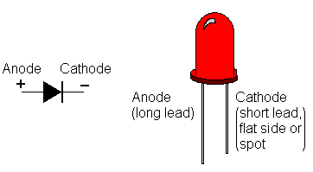
Figure 31: LED [53]

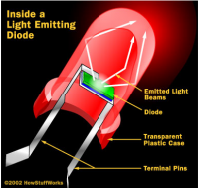
Figure 32: Inside of LED [53]

Ideal situation

A diode is a two-terminal nonlinear device, with the (+) terminal called the anode (a), and the (–) terminal called the cathode (k). In an ideal diode, current flows in only one direction (from anode to cathode internally). When a forward voltage is applied, the diode conducts; and when a reverse voltage is applied, there is no conduction. Diodes are the electrical version of a valve and early diodes were actually called valves. An ideal diode has the following i-v characteristic in Figure 33 [53].
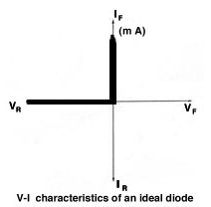
Figure 33: Ideal diode [53]

7.3 Architecture
To create Modular LED Lamp we need to develop LED driver (PCB) and remote control schematics. PCB is an interactive printed circuit board editor for Unix, Linux, Windows, and Mac systems. PCB includes a rats nest feature and schematic/netlist import, design rule checking, and can provide industry standard RS-274X (Gerber), NC drill, and centroid data (X-Y data) output for use in the board fabrication and assembly process, as well as photorealistic and design review images [54].

7.3.1 LED driver and panel
In our Modular LED lamp we are using 12V power supply, because it will give enough tension to the system to drive 4 red, 3 blue and 3 green LEDs.
We have to include a regulator guarder by a diode to get the right amount of voltage to drive the PIC microcontroller. To the PIC output 3 MOSFETs are connected, one for each colour of LED. It is necessary to control the colour and intensity of the LED with PWM modulation. IR receiver is connected to the PIC microcontroller for the communication between the remote control. Ultrasonic sensor is also connected to the PIC for distance detection. Figure 34 shows our LED driver block diagram, which is simplified version of the schematics in Figure 35 and Figure 36.

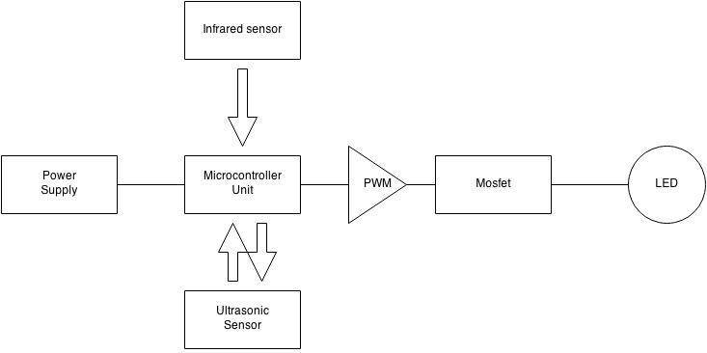
Figure 34: Block diagram
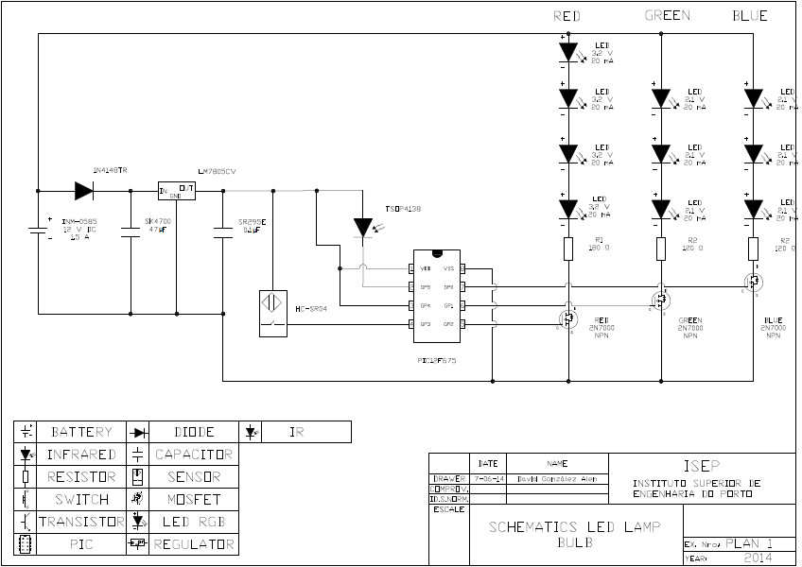
Figure 35: Led driver schematics

In Figure 36 there is also scheme for LED panel. As already mentioned with 12V power supply we can connect 4 red, 3 blue and 3 green LED to the PCB.
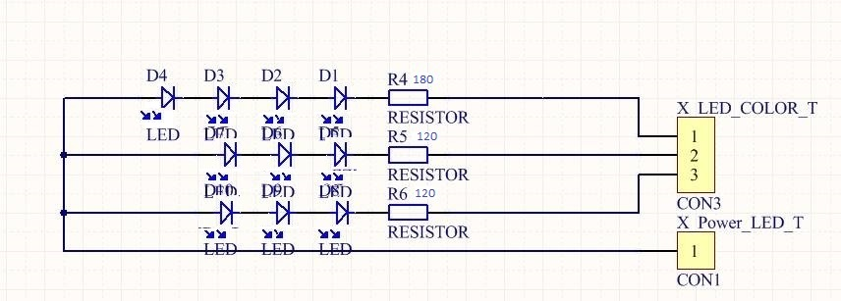
Figure 36: LED panel

7.3.2 Remote control
As it was necessary to do schematics to LED panel and driver, it is necessary to do circuit design to the remote control as well, so it would work like required. Main idea in remote control schematics is to have 5 buttons for different functions. Remote control scheme is presented in Figure 37.
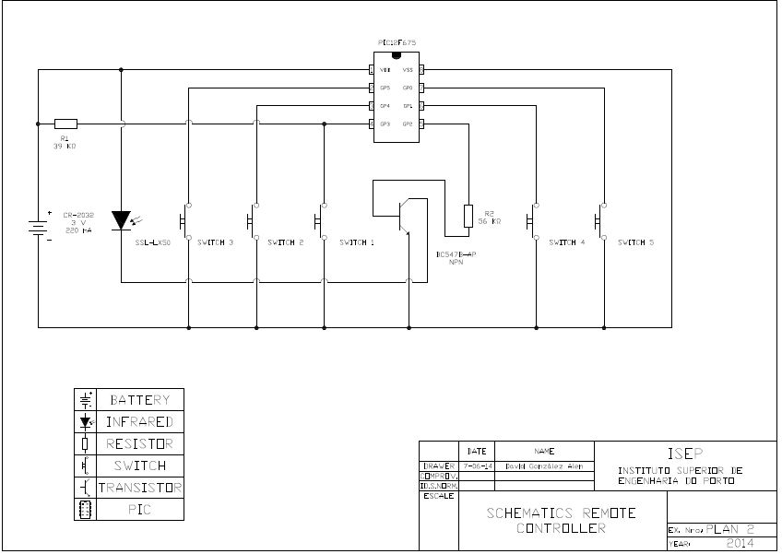
Figure 37: Remote Control schematics

7.3.3 Calculations
To operate the LEDs it is necessary to limit the current to the recommended level to avoid destruction of the device. This way it is possible to adjust the supplied voltage a little and still keep the current within bounds. Therefore resistance calculation has to be done.

Resistance calculation
Power supply Up = 12 V
Number of LEDs in series n = 2
Forward current If = 20 mA
Forward Voltage Uf red = 2,1 V Uf green = 3,3 V Uf blue = 3,3 V
Formula R= (Up-n×Uf)÷If

Results
Rred = ( 12 - 4 × 2,2 ) ÷ 0.02 Rred = 180 Ω
Rgreen = ( 12 - 3 * 3,3 ) ÷ 0.02 Rgreen = 120 Ω
Rblue = ( 12 - 3 * 3,3 ) ÷ 0.02 Rblue = 120 Ω
The calculation result shows required resistance for each colour of LED.
Transistor
Up = 3.5 V
Ube= 0,7 V
Ib = 0,0005 A
R= ( Ut - Ube )/ Ib = 5.6 kΩ
The calculation result shows required resistance for the transistor.
Regulator
We have 12V for the circuit, but for the microcontroller it is necessary to regulate voltage to the optimum level. Therefore it is important to use regulators. We don´t need any calculations, because datasheet gives us exact information about size of the condensators.
We are using the L78 Series of fixed voltage regulators, which are designed with thermal overload protection that shuts down the circuit when subjected to an excessive power overload condition, internal short-circuit protection that limits the maximum current, the circuit will pass, and output transistor safe-area compensation that reduces the output short-circuit current as the voltage across the pass transistor is increased. It is recommended that the regulator input be bypassed with capacitor if the regulator is connected to the power supply filter with long lengths, or if the output load capacitance is large. Regulator is presented in Figure 38.
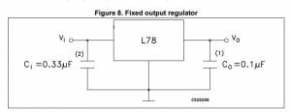
Figure 38: Regulator
7.4 Components
To make Modular LED Lamp several components has to be bought and installed together.
In the following there are descriptions and pictures of necessary materials to give reader better overview and understand better Modular LED Lamp project.

    - Power supply
A power supply is a device that supplies electric power to an electrical load. The term is most commonly applied to electric power converters that convert one form of electrical energy to another [55]. Power supply can be seen in Figure 39.

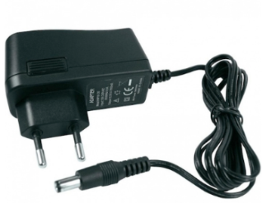
Figure 39: Power supply [55]

    - Diode
In electronics, a diode is a two-terminal electronic component with asymmetric conductance; it has low (ideally zero) resistance to current in one direction, and high (ideally infinite) resistance in the other [56]. Illustrative picture of diode is shown in Figure 40.

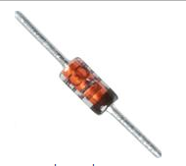
Figure 40: Diode [56]

    - Capacitor
A capacitor is a passive electronic component that stores energy in the form of an electrostatic field. In its simplest form, a capacitor consists of two conducting plates separated by an insulating material called the dielectric. The capacitance is directly proportional to the surface areas of the plates, and is inversely proportional to the separation between the plates [57]. Capacitor is presented in Figure 41.

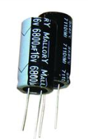
Figure 41: Capacitor [57]

    - Regulator
A voltage regulator is designed to automatically maintain a constant voltage level. A voltage regulator may be a simple "feed-forward" design or may include negative feedback control loops. It may use an electromechanical mechanism, or electronic components. Depending on the design, it may be used to regulate one or more AC or DC voltages [58]. Figure 42 introduces regulator.
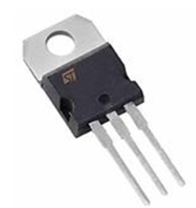
Figure 42: Regulator [58]

- Infrared receiver
This device receives IR waves from remote controller [59]. IR receiver is shown in Figure 43.

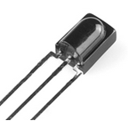
Figure 43: IR receiver [59]
- Ultrasonic sensor
Ultrasonic sensors work on a principle similar to radar or sonar which evaluates attributes of a target by interpreting the echoes from radio or sound waves respectively [60]. Ultrasonic sensor is presented in Figure 44.

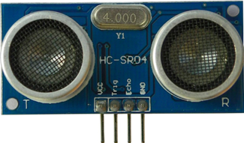
Figure 44: Ultrasonic sensor [60]

- Mosfet
The metal–oxide–semiconductor field-effect transistor MOSFET is a transistor used for amplifying or switching electronic signals [61]. Illustrative picture is presented in the following Figure 45.
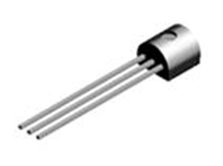
Figure 45: Mosfet [61]
- Resistor
Resistors act to reduce current flow, and, at the same time, act to lower voltage levels within circuits [62]. Figure 46 shows resistor´s appearance.

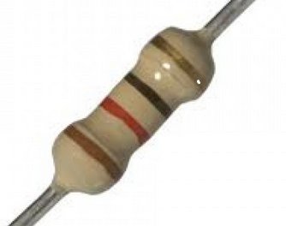
Figure 46: Resistor [62]
- LED
A light-emitting diode (LED) is a two-lead semiconductor light source that resembles a basic pn-junction diode, except that an LED also emits light [63]. Illustrative picture of LED is in Figure 47.
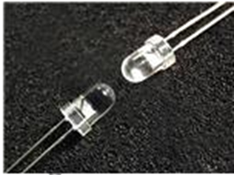
Figure 47: LED [63]
- Batteries
It is a device consisting of one or more electrochemical cells that convert stored chemical energy into electrical energy [64]. Battery witch we use in our project is presented in Figure 48.

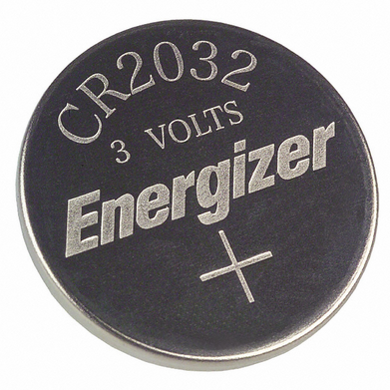
Figure 48: Battery [64]

- Battery holders
In Figure 49 is device to fix the battery in the remote control.
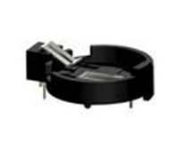
Figure 49: Battery holder [65]

- Switch
In Figure 50 there is an electrical component that can break an electrical circuit, interrupting the current or diverting it from one conductor to another [66].
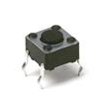
Figure 50: Switch [66]

- Transistor
It is a semiconductor device used to amplify and switch electronic signals and electrical power. Transistor is introduced in Figure 51.

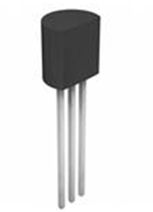
Figure 51: Transistor [67]

- Infrared
Infrared (IR) light is electromagnetic radiation with longer wavelengths than those of visible light, extending from the nominal red edge of the visible spectrum at 700 nanometres (nm) to 1 mm [68]. Appearance of Infrared can be seen in Figure 52.

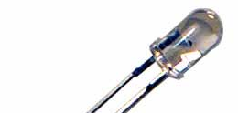
Figure 52: Infrared [68]

- Terminal blocks
In Figure 53 there is a device for joining electrical circuits as an interface using a mechanical assembly.

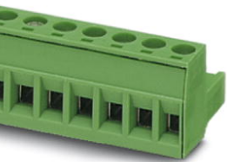
Figure 53: Terminal block [69]

7.5 Functionalities
Comparing to the other similar products, our developed LED Lamp has more features. Modular LED lamp contains features, like:

- Fits to universal lamp socket (E27);
- Change colours with remote control (radius 10 m);
- Easy construction to change the LED;
- Includes an automatic brightness control system (maximum radius 4 m).
Remote control functionalities:
Our developed remote control has several functionalities. It offers different operating modes and can be configured by the user.
Remote control allows to choose and change colours like red, orange, yellow, green, blue, cyan, white. And has 5 different buttons for different application.
1) Increase brightness
It is possible to increase brightness manually.
2) Decrease brightness
It is possible to decrease brightness manually.
3) Static mode
It is possible adjust fixed colour manually.
4) Lamp On / off button
Turns off and turns on the lamp.
5) Brightness sensor on/ off button
Turns off and on the brightness sensor.
7.6 Programming
We are using two PIC12F675 microcontrollers, one of them in the remote control PCB and the other one in the LED driver PCB.
The PIC12F675 microcontrollers can be serially programmed in the end of application circuit. This is simply done with two lines for clock and data, three other lines are for power, ground and programming voltage. Figure 54 presents microcontroller programming lines.
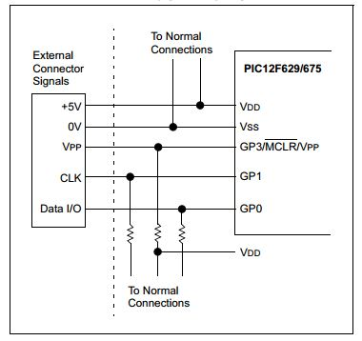
Figure 54: Microcontroller programming [72]

This allows to manufacture boards with unprogrammed devices and then program the microcontroller just before shipping the product. The device is placed into a Program/Verify mode by holding the GP0 and GP1 pins low, while raising the MCLR (VPP) pin from VIL to VIHH. GP0 becomes the programming data and GP1 becomes the programming clock. Both GP0 and GP1 are Schmitt Trigger inputs in this mode.
After RESET, to place the device into Programming/Verify mode, the program counter (PC) is at location 00h. A 6-bit command is then supplied to the device.
Depending on the command, 14-bits of program data are then supplied to or from the device, depending on whether the command was a load or a read [72].
The remote controller use the NEC Infrared Protocol
- A 9 ms leading pulse burst (16 times the pulse burst length used for a logical data bit)
- A 4.5 ms space
- The 8-bit address for the receiving device
- The 8-bit logical inverse of the address
- The 8-bit command
- The 8-bit logical inverse of the command
- Final 562.5 µs pulse burst to show end of message transmission
- Logical '0' – a 562.5 µs pulse burst followed by a 562.5 µs space, with a total transmit time of 1.125 ms
- Logical '1' – a 562.5 µs pulse burst followed by a 1.6875 ms space, with a total transmit time of 2.25 [72]

For uploading the program we used Microchip’s PIC kit 3 In-Circuit Debugger/Programmer which is shown in Figure 55.
.
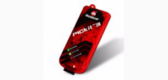
Figure 55: Microchip’s PIC kit 3 In-Circuit Debugger/Programmer [72]

It uses in-circuit debugging logic incorporated into each chip with Flash memory to provide a low-cost hardware debugger and programmer.

The MPLAB PIC kit 3 allows debugging and programming of PIC® and dsPIC® Flash microcontrollers at a most affordable price point using the powerful graphical user interface of the MPLAB X Integrated Development Environment (IDE). The MPLAB PIC kit 3 is connected to the design engineer's PC using a full speed USB interface and can be connected to the target via an Microchip debug (RJ-11) connector.
The connector uses two device I/O pins and the reset line to implement in-circuit debugging and In-Circuit Serial Programming™ [72].
7.7 Light bulb design
As our team wanted to create something unique, special light bulb design was made. Light bulb is inspired from nature and has similarity with wood branch.
In the design, there is one main tube where three other tubes are coming out. Three tubes are meant for LEDs and one for Ultrasonic sensor to sense movements. Also near to the socket, where goes power supply, there are cuts inside material for cooling. For fixing the electronic parts certain inner design was made as well. Two kinds of hallows were cut into the walls to slide there different PCB-s, we are wiring power supply to the lattice which is in the leg where goes also ultrasonic sensor. For ultrasonic sensor there are 2 round holes, we are placing sensor into the holes and screw it to the tube wall. Tubes have removable covers to make LED changing easier. LED is pressed into the removable covers where LED-shape holes are.
Prototype is made of blue polylactic acid with 3D printer.
Figure 56 and Figure 57 are presenting 3D pictures of Modular LED Lamp design and in Figure 58 real printed bulb is shown.

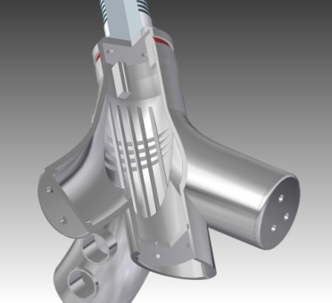
Figure 56: Inner design

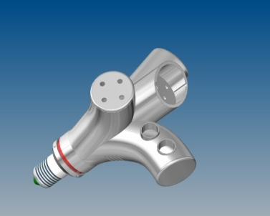
Figure 57: Outside design

Figure 58: Real bulb

We also consider offering regular shape light bulbs to our customer, which is described in chapter 3.7.1.
7.8 Packaging
For Modular LED Lamp package was designed. Package is made of cardboard and there are used 2 colours (black and orange). Black is used in outside and orange inside. Two different colours cardboards are glued together in order to achieve stronger surface. Package is 20*20 cm sized square.
Outside of box are energy label, logo, picture of real lamp, quick response code, bar code and safety instructions. Inside of box are two illustrative pictures and extra surface for holding lamp. Figure 59 presents box design.

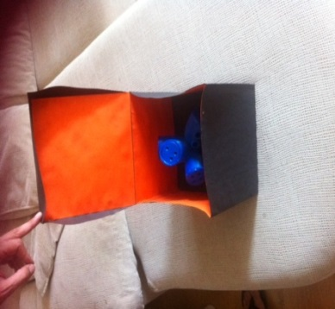
Figure 59: Box
7.9 Tests and Results
As it is described in first paragraph certain tests have to carry out to be sure if lamp works properly. Tests which are necessary to make are described in the following:
  - Have to try if LED light bulb fits to E27 lamp socket
  - Have to try remote control. For that it is necessary to connect light bulb with a grid and when turning the button of remote control light bulb should change colours (in 10 m)
  - Have to try take out some LED or only one LED and replace them by another LED or LED. Also have to connect light bulb to the grid to see if changed LEDs are working
  - Have to connect light bulb to the grid, then move towards to the light bulb, when being at the distance of maximum 4 m it should reduce the brightness. Also when moving further than maximum 4 m from lamp, it should increase the brightness again
After assembling technical parts, we tried to make previously described tests. First test was successful, Modular LED Lamp fits to E27 socket. For second test it was necessary to try remote control. In figure Figure 60 team member presses the button to control if it is working. Sadly remote control did not work.

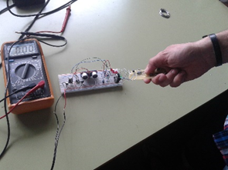
Figure 60: Testing remote control

Third test was about changing the LED which is presented in Figure 61. We were able to change LED, but we don’t know if LED is working. We were not successful making Modular LED Lamp work.
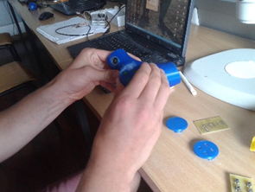
Figure 61: Inserting LED

It means that other tests which needed to have connection to the grid failed. Reason is wrong PCB boards and programming. To carry out these tests we need to design new PCB boards and correct the programming. After that process it is necessary to repeat the tests.
7.10 Conclusion
We chose Modular LED Lamp project, because it sounded interesting (more energy effective lighting) and we had two electrical engineer students in our group. Although, they had knowledge about electricity, there have been still appearing some complications.
First of all, to hand in list of materials, it was necessary to present correct schematics for the LED lamp and remote control. As we didn’t have much experience with LED lamp specialities, completion of schematics and material list was delayed. This led us to the situation that we got materials too late. We had 2 days to assembly product and make the tests. Sadly some problems occurred and prototype didn’t work. Reason was wrong PCB and programming. For making the prototype work it is necessary to reproduce PCB and correct the program.
In order to have unique product, we made a special design for the light bulb. We created 3D drawings with software called Solid Edge. Our light bulb is inspired by nature and resemble a bit wood branch. Drawings were converted to the suitable version to use a 3D printing option that was by school. The bulb prototype was made of plastic. Also there was made a package. As we are focusing on business clients, it was not necessary to pay so much attention to the packaging. Our package is made of 2 colour cardboard (black and orange) and on the package surfaces are presented all important labels.

8. Conclusions
8.1 Discussion
From the beginning we have tried to create the most effective team, therefore we used Project management tools like tasks distribution, found several solutions for communication and we set deadlines to ourselves. In our work we want to be precise an always give our best. It is important to hand in deliverables in time, unfortunately there was delay concerning some materials. While we were not able to build prototype we were focused on report, web-page, user manual, packaging, poster, video and bulb design. These parts of deliverables have progressed successfully and what is important, in time. We got materials two days before final assessment, this situation forced us to work faster and more effective. As much as we tried prototype production was not successful, lamp functions did not work. Reason of that problem was PCB which was wrong and also programming. Lack of time didn’t let us to correct these major mistakes.

During all the semester we learned a lot about team work and studied lighting specifications in every field. We tried to create the best product we could considering objectives and advice given.

This experience gave us definitely advantage in future life. We were able to practice English, we studied lighting specifications, learned sustainability and marketing issues as well as improved our communication and cooperation skills.
8.2 Future Development
As prototype of Modular LED Lamp was not successful in testing, new prototype needs to be developed. New PCB and programming improvements has to be done. Nowadays, people want to control everything from their computer and phone. It means an instant access to their devices. Therefore, development considering the remote control could be an option. Instead of using infrared communication between lamp and remote control, we could use Bluetooth or Wi-Fi connection between device and Web application or also design a mobile application for that purpose.
We would like to decrease the size of the lamp. It is necessary to reduce PCB boards and use, for example, other movement detecting sensor in order to achieve smaller bulb dimensions. There are some opportunities for light bulb design development as well. For example, it would be better if there is possibility to move/turn movement detecting sensor. As ultrasound sensor was so big it was very difficult to place it the way that it would move. What is more, different material could be considered, because already used material is sensitive to heat and in high temperatures it could melt. In future design we can use a flexible material.

8. Bibliography

[1] | ThinkExit, “Henry Ford quotes,” 2014. [Online]. Available: http://thinkexist.com/quotation/coming_together_is_a_beginning-keeping_together/146314.html. [Accessed May 2014].
[2] | J. P. a. I. Hsu, “LED Lamp Electronics: Past, Present & Future,” 2014. [Online]. Available: thttp://www.designnews.com/document.asp?doc_id=271309&. [Accessed March 2014].
[3] | DoItYourself Staff, “ 5 Common Incandescent Light Bulb Problems,” [Online]. Available: http://www.doityourself.com/stry/5-common-incandescent-light-bulb-problems#b. [Accessed March 2014].
[4] | M. S. A. S. M. J. Matthew Clyde Wood, “Modular led power system with configurable control interface,” 2013. [Online]. Available: http://www.google.com/patents/WO2013081925A1?cl=en. [Accessed March 2014].
[5] | J. Bausch, “LED 101: Identifying different types of LEDs,” 2011. [Online]. Available: http://www.electronicproducts.com/Optoelectronics/LEDs/LED_101_Identifying_different_types_of_LEDs.aspx. [Accessed March 2014].
[6] | A. E. d. Futuro, “Ventajas y Desventajas de la Tecnología LED,” 2012. [Online]. Available: http://www.alromar-energia.es/blog/ventajas-y-desventajas-de-la-tecnologia-led/. [Accessed March 2014].
[7] | Philips, “TurnRound,” 2014. [Online]. Available: http://www.ecat.lighting.philips.com/l/healthcare/entrance-areas-and-shops/turnround-round/22200/cat/?t1=ProductLis. [Accessed Mmarch 2014].
[8] | Philips, “iColor Flex MX – flexible strands of high-intensity, full-color LED nodes,” 2014. [Online]. Available: http://www.ecat.lighting.philips.com/l/outdoor-lighting/architectural-floodlighting/direct-view-lighting/icolor-flex-mx/55044/cat/?t1=ProductList#. [Accessed March 2014].
[9] | Philips, “eW Flex SLX – flexible strands of intelligent white-light LED nodes,” 2014. [Online]. Available: http://www.ecat.lighting.philips.com/l/outdoor-lighting/architectural-floodlighting/direct-view-lighting/ew-flex-slx/55043/cat/?t1=ProductList#. [Accessed March 2014].
[10] | Philips, “LiColor Tile MX – LED light panel for stunning effects and large-scale video,” 2014. [Online]. Available: http://www.ecat.lighting.philips.com/l/indoor-luminaires/wall-mounted/icolor-tile-mx/55021/cat/?t1=ProductList#. [Accessed March 2014].
[11] | Amazon, “HDE® Remote Control Color Changing 16 LED Light Bulb with RC,” 2014. [Online]. Available: http://www.amazon.com/Remote-Control-Color-Changing-Light/dp/B009UZD81Y/ref=sr_1_20?s=lamps-light&ie=UTF8&qid=1394131590&sr=1-20. [Accessed March 2014].
[12] | Philips, “LivingColors Bloom White,” 2014. [Online]. Available: http://www.usa.philips.com/c-p/709976048/livingcolors. [Accessed March 2014].
[13] | Philips, “ColorFuse Powercore,” 2014. [Online]. Available: http://www.colorkinetics.com/ls/rgb/colorfuse/. [Accessed March 2014].
[14] | Philips, “ColorBlast Powercore,” 2014. [Online]. Available: http://www.colorkinetics.com/ls/rgb/colorblast12pc/. [Accessed March 2014].
[15] | Philips, “C-Splash 2,” 2014. [Online]. Available: http://www.colorkinetics.com/ls/rgb/csplash2/. [Accessed March 2014].
[16] | Philips, “LED A Shape,” 2014. [Online]. Available: http://www.usa.philips.com/c-p/046677425265/led-11w-60w-medium-base-e26-daylight-dimmable. [Accessed March 2014].
[17] | Philips, “Reflector - Flood,” 2014. [Online]. Available: http://www.usa.philips.com/c-p/046677429409/led-13w-75w-medium-base-e26-bright-white. [Accessed March 2014].
[18] | Mobile World, “Bluetooth technology is not a suitable Wi-Fi replacement,IR, WiFi and Bluetooth Remote Control for your PC,” 2011. [Online]. Available: http://mobileworldz.blogspot.pt/2011/05/bluetooth-technology-is-not-suitable-wi.html. [Accessed March 2014].
[19] | Wikipedia, “Wi-Fi,” [Online]. Available: http://en.wikipedia.org/wiki/WIFI. [Accessed March 2014].
[20] | Google play, “WiFi Remote Control,” 2013. [Online]. Available: https://play.google.com/store/apps/details?id=power.wifi.controller. [Accessed March 2014].
[21] | AppLamp, “Wifi Box with APP for AppLamp lighting,” [Online]. Available: http://www.wifiledlamp.com/applamp-wifi-box-with-app-for-applamp-lighting.html. [Accessed March 2014].
[22] | AppLamp, “Wifi Box with APP for AppLamp lighting,” [Online]. Available: http://www.wifiledlamp.com/applamp-wifi-box-with-app-for-applamp-lighting.html. [Accessed March 2014].
[23] | Lomedo, “The LUMEDO iPhone LED Controller,” [Online]. Available: http://www.lumedo.com/. [Accessed March 2014].
[24] | Lumedo, “iPhone LED Controller,” [Online]. Available: http://www.lumedo.com/product/. [Accessed March 2014].
[25] | Wikipedia, “IR remote control,” [Online]. Available: http://en.wikipedia.org/wiki/Remote_control#Other_remote_controls. [Accessed March 2014].
[26] | eBay, “IR Remote Control,” [Online]. Available: http://www.ebay.com/itm/24-Key-IR-Remote-Control-16-Colors-Changing-5050-3528-SMD-RGB-LED-Strip-Colors/111295784297?_trksid=p2047675.c100009.m1982&_trkparms=aid%3D333001%26algo%3DRIC.FIT%26ao%3D1%26asc%3D20466%26meid%3D5369348230301477310%26pid%3D100009%2. [Accessed March 2014].
[27] | Wikipedia, “ Ultrasonic sensor,” 2014. [Online]. Available: http://en.wikipedia.org/wiki/Ultrasonic_sensor. [Accessed March 2014].
[28] | IFM, “Laser sensor,” [Online]. Available: http://www.ifm.com/ifmaus/web/pinfo010_070_040.htm. [Accessed March 2014].
[29] | M. Thoras, “Global LED Lighting Market 2012-2016: Industry Analysis, Size, Shares, Growth, Trends, and Forecast Research Report,” 2014. [Online]. Available: http://www.prweb.com/releases/2014/02/prweb11564707.htm. [Accessed March 2014].
[30] | Strategies Unlimited, “The Worldwide Market for LEDs: Market Analysis and Forecast 2014,” 2014. [Online]. Available: http://www.strategies-u.com/articles/reports/the-worldwide-market-for-leds-market-analysis-and-forecast-2014.html. [Accessed March 2014].
[31] | Wikipedia, “Green politics,” [Online]. Available: http://en.wikipedia.org/wiki/Green_politics. [Accessed March 2014].
[32] | European Commission, “Energy Efficiency,” 2011. [Online]. Available: http://ec.europa.eu/energy/efficiency/action_plan/action_plan_en.htm. [Accessed March 2014].
[33] | Naturan Resources Canada, “Canadian Industry Program for Energy Conservation (CIPEC),” 2014. [Online]. Available: http://www.nrcan.gc.ca/energy/efficiency/industry/cipec/5153. [Accessed March 2014].
[34] | Inter- America Developement Bank, “Energy Efficiency,” [Online]. Available: http://www.iadb.org/en/topics/energy/energy-efficiency,2654.html. [Accessed March 2014].
[35] | Relience, “China outlines ten programs for energy efficiency,” 2004. [Online]. Available: http://www.resilience.org/stories/2004-12-09/china-outlines-ten-programs-energy-efficiency. [Accessed March 2014].
[36] | LEDLuxor, “Top 10 Benefits of Using LED Lighting,” 2012. [Online]. Available: http://www.ledluxor.com/top-10-benefits-of-led-lighting. [Accessed March 2014].
[37] | J. Murray, “All the Taxes Your Business Must Pay,” [Online]. Available: http://biztaxlaw.about.com/od/typesofbusinesstaxes/tp/allbiztaxes.htm. [Accessed March 2014].
[38] | J. Kuo, “2014 LED Market Demand And Supply,” 2014. [Online]. Available: http://www.ledinside.com/download/output/2014_LED_Market_Demand_and_Supply.pdf&sn=0. [Accessed March 2014].
[39] | BSD Global, “Business and Sustainable Development,” [Online]. Available: http://www.iisd.org/business/. [Accessed March 2014].
[40] | Financial Times Lexicon, “Definition of business sustainability,” [Online]. Available: http://lexicon.ft.com/term?term=business-sustainability. [Accessed March 2014].
[41] | RoHS, “RoHS Compliance Definition,” [Online]. Available: http://www.rohscompliancedefinition.com/. [Accessed March 2014].
[42] | “Scribd,” [Online]. Available: http://www.scribd.com/doc/138708848/New-Financial-Approaches-for-the-Economic-Sustainability-of-the-KMML. [Accessed May 2014].
[43] | Business Dictionary, “Social sustainability,” [Online]. Available: http://www.businessdictionary.com/definition/social-sustainability.html#ixzz2xxR9bdv8. [Accessed March 2014].
[44] | Integrated Network for Social Sustainability, “What is social sustainability?,” [Online]. Available: http://clas-pages.uncc.edu/inss/what-is-social-sustainability/. [Accessed March 2014].
[45] | Philips, “Lighting Philips,” October 2012 . [Online]. [Accessed Mai 2014].
[46] | Solidworks, “Solidworks.com,” 2014. [Online]. Available: http://www.solidworks.com/sustainability/design/2722_ENU_HTML.htm. [Accessed Mai 2014].
[47] | PACE, “ETHICAL BEHAVIOR IS GOOD BUSINESS,” [Online]. Available: http://www.entre-ed.org/_teach/ethics.htm. [Accessed March 2014].
[48] | National Society of Professional Eengineers, “What is engineering ethics?,” [Online]. Available: http://www.nspe.org/resources/ethics/ethics-resources/faq#whatis. [Accessed March 2014].
[49] | IEEE, “IEEE Code of Ethics,” [Online]. Available: http://www.ieee.org/about/corporate/governance/p7-8.html. [Accessed March 2014].
[50] | Pine Manor College, “Academic Ethics and Integrity,” [Online]. Available: http://www.pmc.edu/academic-ethics-and-integrity. [Accessed March 2014].
[51] | EPA, “Environmental Stewardship,” [Online]. Available: http://www.epa.gov/stewardship/. [Accessed March 2014].
[52] | Ethical Consumer, “Shopping guide to energy saving light bulbs,” [Online]. Available: http://www.ethicalconsumer.org/buyersguides/energy/lowenergylightbulbs.aspx. [Accessed March 2014].
[53] | European Commission, “CE marking - Basics and FAQs,” [Online]. Available: http://ec.europa.eu/enterprise/policies/single-market-goods/cemarking/about-ce-marking/index_en.htm. [Accessed March 2014].
[54] | Energy Star, “Learn About LEDs,” [Online]. Available: http://www.energystar.gov/index.cfm?c=lighting.pr_what_are. [Accessed 22 May 2014].
[55] | OpenWetWare, “Diodes,” [Online]. Available: http://openwetware.org/wiki/20.309:DiodePrimer. [Accessed 22 May 2014].
[56] | PCB, “Printed Circuit Board Editor,” [Online]. Available: http://pcb.geda-project.org/. [Accessed March 2014].
[57] | InMotion, “Power Supply 12VDC 1.5A EU,” 2014. [Online]. Available: http://www.inmotion.pt/store/power-supply-12vdc-15a-eu. [Accessed May 2014].
[58] | Mouser, “Diode,” 2014. [Online]. Available: http://hu.mouser.com/Search/m_ProductDetail.aspx?Vishay-Semiconductors/1N4148TR/&qs=sGAEpiMZZ1Msc4/H%252bM6WdN%252bFfeaA%252bZFte. [Accessed May 2014].
[59] | Mouser, “Capacitor,” 2014. [Online]. Available: http://hu.mouser.com/Search/m_ProductDetail.aspx?AVX/SR295E104MART/&qs=sGAEpiMZZMsh%252b1woXyUXj1sisocaq0hzCO0KHEWCJIc=. [Accessed May 2014].
[60] | Mouser, “Regulator,” 2014. [Online]. Available: http://hu.mouser.com/ProductDetail/STMicroelectronics/L7805CV/?qs=sGAEpiMZZMsMIqGZiACxISsdOc2pc405xV7Xu93p5sI%3d. [Accessed May 2014].
[61] | Mouser, “IR receiver,” 2014. [Online]. Available: http://pt.mouser.com/ProductDetail/Vishay-Semiconductors/TSOP4138/?qs=sGAEpiMZZMvAL21a%2fDhxMsrzTelhztSjW9KEkoxx9Hs%3d. [Accessed May 2014].
[62] | InMotion, “Ultrasound sensor,” 2014. [Online]. Available: http://www.inmotion.pt/store/ultrasound-sensor-hc-sr04. [Accessed May 2014].
[63] | Mouser, “Fairchild Semiconductor 2N7000,” 2014. [Online]. Available: http://pt.mouser.com/ProductDetail/FairchildSemiconductor/2N7000/?qs=sGAEpiMZZMshyDBzk1%2fWi9bHELEahoDnY1fyKF6A6Ko%3d. [Accessed May 2014].
[64] | Mouser, “KOA Speer MF1/4DCT52R1200F,” 2014. [Online]. Available: http://pt.mouser.com/ProductDetail/KOA-Speer/MF1-4DCT52R1200F/?qs=sGAEpiMZZMsPqMdJzcrNwuBnmYaxrx0H9G5DraXNUp4%3d. [Accessed May 2014].
[65] | Mouser, “Cree, Inc. C503B-GCN-CY0C0791,” 2014. [Online]. Available: http://pt.mouser.com/ProductDetail/Cree-Inc/C503B-GCN-CY0C0791/?qs=sGAEpiMZZMtmwHDZQCdlqaMeoG0BP2KzPHMlDtcG05c%3d. [Accessed May 2014].
[66] | Mouser, “Panasonic Battery CR2032,” 2014. [Online]. Available: http://hu.mouser.com/Search/ProductDetail.aspx?qs=%2fcnINApUglPgybvG%2fLSG7w%3d%3d. [Accessed May 2014].
[67] | Mouser, “Keystone Electronics 1066,” 2014. [Online]. Available: http://hu.mouser.com/Search/ProductDetail.aspx?qs=TMDrOSIpnUfyx7dWA5t7YA%3d%3d. [Accessed May 2014].
[68] | Mouser, “C&K Components PTS645SL43-2 LFS,” 2014. [Online]. Available: http://pt.mouser.com/ProductDetail/CK-Components/PTS645SL43-2-LFS/?qs=sGAEpiMZZMsgGjVA3toVBAOa31dqKfOfSl%2fLvvevLtM%3d. [Accessed May 2014].
[69] | Mouser, “Micro Commercial Components (MCC) BC547B-AP,” 2014. [Online]. Available: http://pt.mouser.com/ProductDetail/Micro-Commercial-Components-MCC/BC547B-AP/?qs=sGAEpiMZZMshyDBzk1%2fWiyxEghVrdFZmXyXqkbTsa%2fI%3d. [Accessed May 2014].
[70] | Mouser, “Lumex SSL-LX5099IEW,” 2014. [Online]. Available: http://pt.mouser.com/ProductDetail/Lumex/SSL-LX5099IEW/?qs=%2fha2pyFadui7ivFq1vSLBwRk4z6P3eQ4cmT8FK0OlCXx38OKoOM6XQ%3d%3d. [Accessed May 2014].
[71] | Mouser, “Phoenix Contact 1757255,” 2014. [Online]. Available: http://pt.mouser.com/ProductDetail/Phoenix-Contact/1757255/?qs=sGAEpiMZZMsDddcp1dBDJOrXMrFmZFLlFAdTuZkvVZ8%3d. [Accessed May 2014].
[72] | Microchip, “PIC12F629/675 Data sheet,” 2014. [Online]. Available: http://ww1.microchip.com/downloads/en/DeviceDoc/41190G.pdf. [Accessed June 2014].
[73] | Microchip, “PICkit 3 In-Circuit Debugger,” 2014. [Online]. Available: http://www.microchip.com/Developmenttools/ProductDetails.aspx?PartNO=PG164130&utm_source=MicroSolutions&utm_medium=&utm_term=&utm_content=&utm_campaign=PICkit+3. [Accessed June 2014].
[74] | Philips. [Online].
[75] | Philips, 201. [Online].
[76] | Philips, “AmazonLED² – reliable beauty,” 2014. [Online]. Available: http://www.ecat.lighting.philips.com/l/fashion-stores/selling-floor/amazonled2/65069/cat/?t1=ProductList#. [Accessed March 2014].
[77] | Philips, “ArchiPoint iColor,” 2014. [Online]. Available: http://www.ecat.lighting.philips.com/l/entertainment/touring-stage/archipoint-icolor/66139/cat/?t1=ProductList#. [Accessed March 2014].
[78] | Philips, “Marker LED – eye-catching,” 2014. [Online]. Available: http://www.ecat.lighting.philips.com/l/outdoor-lighting/architectural-floodlighting/markers-inground-and-underwater/marker-led/22279/cat/?t1=ProductList#. [Accessed March 2014].
[79] | Philips, “ BBS500 LedUplight,” 2014. [Online]. Available: http://www.ecat.lighting.philips.com/l/outdoor-lighting/architectural-floodlighting/markers-inground-and-underwater/leduplight-bbs500/21790/cat/?t1=ProductList#. [Accessed March 2014].
[80] | Philips, “BBS430 LedStep rectangular,” 2014. [Online]. Available: http://www.ecat.lighting.philips.com/l/outdoor-lighting/architectural-floodlighting/markers-inground-and-underwater/ledstep-rectangular-bbs430/21789/cat/?t1=ProductList#. [Accessed March 2014].
[81] | Philips, “ StraightLine – in line with the street,” 2014. [Online]. Available: http://www.ecat.lighting.philips.com/l/outdoor-lighting/road-and-urban-lighting/road-and-urban-luminaires/straightline/55042/cat/?t1=ProductList#. [Accessed March 2014].
[82] | Philips, “Milewide – pure and contemporary,” 2014. [Online]. Available: http://www.ecat.lighting.philips.com/l/outdoor-lighting/road-and-urban-lighting/road-and-urban-luminaires/milewide-led/milewide-led-mini/22417/cat/?t1=ProductList#. [Accessed March 2014].
[83] | Philips, “CitySpirit Street – reveal the spirit of your City,” 2014. [Online]. Available: http://www.ecat.lighting.philips.com/l/cityspirit-led/cityspirit-street-led/22409/cat/. [Accessed March 2014].
[84] | Philips, “SecuriPack – fit the light for life,” 2014. [Online]. Available: http://www.ecat.lighting.philips.com/l/outdoor-lighting/sports-and-area-floodlighting/security-lighting/securipack-bcs200/22475/cat/?t1=ProductList#. [Accessed March 2014].
[85] | Philips, “Stela - revolutionary success on your doorstep,” 2014. [Online]. Available: http://www.ecat.lighting.philips.com/l/outdoor-lighting/road-and-urban-lighting/road-and-urban-luminaires/stela/stela-long-square-wide/71522/cat/?t1=ProductList. [Accessed March 2014].
[86] | Philips, “DayZone – innovative design meets sustainability,” 2014. [Online]. Available: http://www.ecat.lighting.philips.com/l/indoor-luminaires/recessed/dayzone/21947/cat/. [Accessed March 2014].
[87] | Philips, “GentleSpace – taking high-bay lighting to the next level,” 2014. [Online]. Available: http://www.ecat.lighting.philips.com/l/indoor-luminaires/high-bay-and-low-bay/high-bay/gentlespace/58188/cat/. [Accessed March 2014].
[88] | Alibaba, “Camera led flash module,” 2014. [Online]. Available: http://www.alibaba.com/product-detail/camera-led-flash-module_660627298.html. [Accessed March 2014].
[89] | TorchDirect, “LED Lenser P5.2 - 140 Lumen,” 2014. [Online]. Available: http://www.torchdirect.co.uk/professional-torches/led-lenser-p52-140-lumen.html. [Accessed March 2014].
[90] | Amazon, “LEMONBEST 16.4FT SMD 5050 Water-resistant 300LEDs RGB Flexible LED Strip Light Lamp Kit + 44 Key IR Remote Controller,” 2014. [Online]. Available: http://www.amazon.com/LEMONBEST-SMD-Water-resistant-Strip-Controller/dp/B00AJJDLHQ. [Accessed March 2014].
[91] | Amazon, “Romantic Bright Automatic 7 Color LED Shower Head Facut Home Bathroom Water Glow,” 2014. [Online]. Available: http://www.amazon.com/Romantic-Bright-Automatic-Shower-Bathroom/dp/B00ASLSHX8/ref=sr_1_46?s=lamps-light&ie=UTF8&qid=1394131985&sr=1-46. [Accessed March 2014].
[92] | Philips, “eW Profile Powercore – Under-cabinet white light LED fixture with an ultra low profile,” 2014. [Online]. Available: http://www.ecat.lighting.philips.com/l/indoor-luminaires/battens/ew-profile-powercore/58461/cat/?t1=ProductList. [Accessed March 2014].
[93] | Philips, “DecoScene LED BBP521,” 2014. [Online]. Available: http://www.ecat.lighting.philips.com/l/outdoor-lighting/architectural-floodlighting/floodlighting/decoscene-led/decoscene-led-bbp521/910403780212_eu/. [Accessed March 2014].
[94] | Philips, “ColorBurst 6,” 2014. [Online]. Available: http://www.ecat.lighting.philips.com/l/entertainment/architainment/colorburst-6/55029/cat/?t1=ProductList. [Accessed March 2014].
[95] | Philips, “ColorReach Powercore gen2,” 2014. [Online]. Available: http://www.colorkinetics.com/ls/rgb/colorreach/. [Accessed March 2014].
[96] | Philips, “eW Graze MX Powercore,” 2014. [Online]. Available: http://www.colorkinetics.com/ls/essentialwhite/ewgrazemxpowercore/. [Accessed March 2014].
[97] | Philips, “LEDline² – composing with ligh,” 2014. [Online]. Available: http://www.ecat.lighting.philips.com/l/led/wall-washing-grazing/ledline2-bbs713-716/21791/cat/. [Accessed March 2014].
[98] | Philips, “Maxos LED Industry – innovative, flexible solution delivers ideal light output,” 2014. [Online]. Available: http://www.ecat.lighting.philips.com/l/maxos-led/63400/cat/. [Accessed March 2014].
[99] | Onled, “X3B Freezer Light,” 2014. [Online]. Available: http://www.onnled.net/productdetails.aspx?pid=329. [Accessed March 2014].
[100] | Onnled, “X5 Freezer Light new,” 2014. [Online]. Available: http://www.onnled.net/productdetails.aspx?pid=333. [Accessed March 2014].
[101] | Osram, “LUMOS LED,” 2014. [Online]. Available: http://www.osram.co.uk/osram_uk/products/luminaires/indoor-luminaires/luminaires-for-retail-displays/luminaires-for-cold-store-shelves/lumos-led/shelf-luminaire,-light-color-5000-k/led442760/index.jsp?productId=ZMP_1077768. [Accessed March 2014].
[102] | [Online]. Available: http://www.compasscareer.com/wp-content/uploads/Business-Ethics.jpg. [Accessed April 2014].
[103] | [Online]. Available: http://media.tumblr.com/tumblr_lsuke1qcQo1qd9o7r.png. [Accessed April 2014].
[104] | “qgito.net,” [Online]. Available: http://qgito.net/wp-content/uploads/2012/08/etyka-w-biznesie-300x201.jpg. [Accessed April 2014].
[105] | “LANL,” [Online]. Available: http://www.lanl.gov/projects/envplan/images/logo_sm2.png. [Accessed April 2014].
[106] | Kramer Eelectronics, “RC Configuration and,” [Online]. Available: http://www.kramerelectronics.com/downloads/manuals/rc_configuration_and_installation_guide.pdf. [Accessed March 2014].
[107] | ISSP, “Confused about social sustainability?,” [Online]. Available: http://www.sustainabilityprofessionals.org/system/files/Confused%20about%20social%20sustainability_0.pdf. [Accessed March 2014].
[108] | R. Bakshi, “Gross National Happiness,” 2005. [Online]. Available: http://www.alternet.org/story/21083/gross_national_happiness. [Accessed March 2014].
[109] | G. Chaudhary, “NEC Protocol IR (Infrared) Remote Control With a Microcontroller,” 2013. [Online]. Available: http://www.circuitvalley.com/2013/09/nec-protocol-ir-infrared-remote-control.html. [Accessed March 2014].

This paragraph is a shortened version of http://www.electronicproducts.com/Optoelectronics/LEDs/LED_101_Identifying_different_types_of_LEDs.aspx

